Name_________________________________ Date________________________
Morning Routine
Andrew drew pictures to show his routine for getting dressed in the morning.
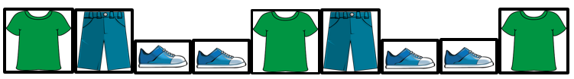
Maria is making a pattern. She wants to create the same type of pattern as Andrew’s pattern using tools, pictures, numbers, or words. What could her pattern look like? Explain your thinking and show your work.

