Task Overview/Description/Purpose:
- The purpose of this task is for students to identify and describe plane figures (circle, triangle, square, and rectangle).
- In this task, students will identify shapes based on their characteristics (including number of sides and number of vertices).

Standards Alignment: Strand – Computation and Estimation
Primary SOL: K.10 The student will identify and describe plane figures (circle, triangle, square, and rectangle).
Related SOL: 1.11
Learning Intention(s):
- Content - I am learning to identify and describe plane figures.
- Language - I am learning to use the language of mathematics to describe plane figures.
- Social - I am learning to describe my thinking and listen as classmates share their mathematical thinking.
Success Criteria (Evidence of Student Learning):
- I can identify shapes based on their characteristics.
- I can describe shapes using their characteristics.
- I can communicate my thinking clearly to my classmates and describe my math ideas.
- I can describe my thinking and listen as my classmates share their math ideas.
Mathematics Process Goals
Mathematical Understanding | - Students will demonstrate an understanding of the characteristics of plane figures.
Problem Solving | - Students will apply their understanding of the characteristics of plane figures and use problem solving strategies to find solutions to the task.
Communication and Reasoning | - Students will work with a partner and use math vocabulary to justify their thinking.
Connections and Representations | - Students will make connections between the names of plane figures and their characteristics. Students will also represent their thinking using models and record their thinking on paper.

Task Pre-Planning
Approximate Length/Time Frame: 45 minutes
Grouping of Students: Begin with a whole class launch of the task. After introducing the task, students begin the task independently. As the task progresses, students will share ideas with a shoulder partner. Students will communicate thinking, by sharing representations during a whole group reflection.
This task is better suited to be given at the end of your unit after students are familiar with the characteristics of the plane figures-circle, square, triangle, and rectangle.
Materials and Technology:  - Virtual Implementation Google Slides  - writing tools (marker, crayon, pencil)  - task paper  - shape cards and/or graphic organizer (optional) | Vocabulary:  plane figures  circle, square, triangle, rectangle  - sides, vertex (vertices)  - round

Anticipate Responses: See the Planning for Mathematical Discourse Chart (columns 1-3).

Task Implementation (Before) 15 minutes
Task Launch:
- Whole Group-Engage students in a “Which One Doesn’t Belong?” number sense routine.
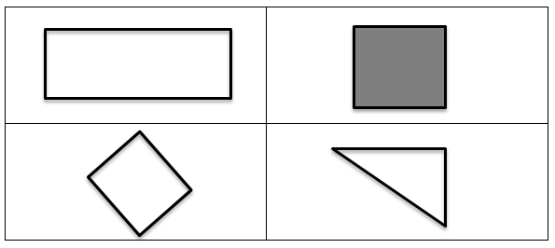
- Encourage students to justify their thinking about which shape doesn’t belong. Record the vocabulary words that come out of the conversation on an anchor chart-circle, square, triangle, rectangle, side, vertex (vertices), and round.
- Share the learning intentions and success criteria with the students. Clarify any vocabulary you think might be difficult for your students.
- Read the task to the students. Explain that they will be drawing a shape based on the clues and will need to name the shape they drew.
- Review the rubric with students. Let them know you are looking for their:
- Mathematical Understanding
- Problem Solving
- Communication and Reasoning
- Representations and Connections
You may choose to just focus on just one or two of the process goals. Make your selected focus goals clear to students before they begin working on the task.
- Tell students they will work on the task independently first and then they will turn to a shoulder partner and share their thinking.
- Implement suggestions for additional student support below as needed.

Task Implementation (During) 15-20 minutes
Directions for Supporting Implementation of the Task
- Monitor – Teacher will listen and observe students as they work on the task and ask assessing or advancing questions (see the Planning for Mathematical Discourse chart on next page).
- Select – Teacher will decide which strategies will be highlighted (after student task implementation) that will advance mathematical ideas and support student learning.
- Sequence – Teacher will decide the order in which student ideas will be highlighted (after student task implementation). The teacher should sequence from the least sophisticated representation to the most sophisticated representation. For example, the teacher may want to start with a student who drew an equilateral gravity based triangle for the shape that had the clue of three vertices. Then move to students who drew gravity based isosceles or right triangles. The most sophisticated representation would be triangles that were not gravity based or scalene representations.
- Connect – Teacher will consider ways to facilitate connections between different student responses.
- Students work independently at first and then in purposefully planned partnerships for 15-20 minutes to share ideas
- As the teacher is monitoring, s/he will look for strategies that are being used and record on Planning Chart.
- The teacher should use questions to assess or advance student thinking.
- Students should be encouraged to explore different strategies for solving and evaluate effectiveness.
Suggestions For Additional Student Support
- For students who are unable to draw the shapes, print off the shape cards and cut them apart. Students can select shapes from the cards to meet the clues given.
- Provide the graphic organizer that already has spots for shape A, B, C, and D for students who need help organizing their work.
- Create an anchor chart to display task vocabulary, include visuals to represent concepts such as plane figures, circle, triangle, rectangle, square, vertex (vertices), sides, and round.
- Use VDOE Word Wall Cards for circle, triangle, rectangle, and square.
- Suggest students use letters to label pictorial representations, such as C for circle, R for rectangle, S for square, and T for triangle.
- Sentence frames can be used to support student thinking:
- The strategy I used to solve is _____.
- First I am going to _____. Next, I will _____. I will know I have solved the problem because _____.
- I noticed _____, so I _____.
- I drew this shape because___________.
- To extend the task, ask the students to come up with their own clues for shapes.
- To extend the task, ask students to draw as many shapes as they can that fit the clues.

Task Implementation (After) 10 minutes
Connecting Student Responses (From Anticipating Student Response Chart) and Closure of the Task:
- Based on the actual student responses, sequence and select particular students to present their mathematical work during a whole class discussion. Some possible big mathematical ideas to highlight could include:
  - A common misconception
  - Trajectory of sophistication in student ideas (i.e. learning trajectories- students who have gravity based equilateral triangles versus students who have scalene triangles or students who have a rectangle for a shape with four vertices compared to a student who has a trapezoid or rhombus, etc.)
  - Connection between squares and rectangles (do both have four vertices?)
- Connect different students’ responses and connect the responses to the key mathematical ideas to bring closure to the task. Possible questions and sentence frames to connect student strategies:
  - How are these shapes alike? How are they different?
  - __________’s shape is similar to ________’s shape because __________
  - How could you describe this shape to someone who is just learning about shapes? How do you know that this shape is a _________?
  - How do these connect to our Learning Intentions?
  - Why is this important?
  - How can you prove (convince us) that your answer makes sense?
  - How do you know that this shape could also work with these clues?
  - Do you agree or disagree? Why?
  - Did anyone think about it in a different way?
  - Who can add onto this idea?
- Highlight student strategies to show the connections, either between different ideas for solutions or to show the connection between levels of sophistication of student ideas (What is similar? Different?). Allow students to ask clarifying questions.
- Consider ways to ensure that each student will have an equitable opportunity to share his/her thinking during task discussion.
- Students can participate in a Gallery Walk to view all strategies prior to coming together to discuss selected strategies.
- Students can “Think, Pair, Share” strategies for solving.
- Close the lesson by returning to the success criteria. Have students reflect on their progress toward the criteria.
Teacher Reflection About Student Learning
- As you reflect, think about whether the learning intentions and success criteria met. Why or why not?
- Teacher will use the chart with anticipated student solutions to monitor which students are using which strategies. This will include: possible misconceptions, learning trajectories and sophistication of student ideas, and multiple solution pathways. Next steps based on this information could include:
- Informing sequence of future tasks. What will come next in instruction to further student thinking in plane figures?
- Informing small groups based on misconceptions that are not addressed in sharing.
- How will the evidence provided through student work inform further instruction? Analyze student work to determine who was unable to demonstrate proficiency with the following mathematical ideas.
- Who had difficulty getting started with the task?
- Who inaccurately labeled shapes?
- Who had difficulty using the clues to draw/select the correct shape?
- Who was unable to complete the task, even when additional support was provided?
- Who was able to accurately complete the task?
- Were students engaged in the task? If not, how could we improve the task so that it is more engaging?
- After task implementation, the teacher will use the Process Goals rubric to assess student understanding in relation to the process goals. The teacher may decide to focus on one category. Next steps based on this information could include:
  - Informing small groups based on current student engagement with the process goal(s) (i.e. think aloud, using specific sentence frames for communication, etc.).

Planning for Mathematical Discourse
Mathematical Task: ___Shape Riddles___ Content Standard(s): __K. 10__
Teacher Completes Prior to Task Implementation |  |  | Teacher Completes During Task Implementation
Anticipated Student Response/Strategy  Provide examples of possible correct student responses along with examples of student errors/misconceptions | Assessing Questions – Teacher Stays to Hear Response  Teacher questioning that allows student to explain and clarify thinking | Advancing Questions – Teacher Poses Question and Walks Away  Teacher questioning that moves thinking forward | List of Students Providing Response Who? Which students used this strategy? | Discussion Order - sequencing student responses  - Based on the actual student responses, sequence and select particular students to present their mathematical work during class discussion  - Consider ways to ensure that each student will have an equitable opportunity to share his/her thinking during task discussion
Anticipated Student Response A:  Student is unable to start. | - Can you tell me what the task is asking you to do?  - Would it help if we reread the task together?  - What is a vertex (vertices)?  - What is a side?  - What does it mean to be round? | - Can you use the anchor chart to help you?  - Is there anything else in the room that might help you think of shapes?
Anticipated Student Response B:  Students draw shapes that do not match the clues given. | - Tell me about your shapes.  - Does that shape match the clue given? How do you know?  - Would it help if we reread the clues together?  - What is a vertex (vertices)?  - What is a side?  - What does it mean to be round? | - Can you use the anchor chart to help you?  - Is there anything else in the room that might help you think of shapes?
Anticipated Student Response C:  Students get some shapes correct but may have two shapes reversed (i.e. draws a triangle for a shape with four vertices and a rectangle for a shape with three vertices). | - Tell me about your shapes.  - Does that shape match the clue given? How do you know?  - What is a vertex (vertices)?  - What is a side?  - What does it mean to be round? | - Can you think of another shape/plane figure that matches that clue?
Anticipated Student Response D:  Student draws the correct shape for the clues but labels the shape with the incorrect name (i.e. labels the shape with three vertices a rectangle but has drawn a triangle). | - Tell me about your shapes.  - What is this shape? How do you know?  - How do you know you have the correct shapes? The correct labels? | - Can you use the anchor chart to help you?  - Can you think of another shape/plane figure that matches that clue?
Anticipated Student Response E:  Students draw two squares for a shape with four equal sides and a shape with four vertices. | - Tell me about your shapes.  - How do you know you have the correct shapes? The correct labels? | - Can you think of another shape/plane figure that matches that clue?  - You are correct, a square does have four vertices. Can you think of a different shape/plane figure that also has four vertices?
Anticipated Student Response F:  Students have all shapes correctly drawn and labeled. | - Tell me about your shapes.  - How do you know you have the correct shapes? The correct labels? | - Can you think of another shape/plane figure that matches that clue?

Name ___________________________ Date ____________________
Shape Riddles
Arthur is playing a game with his friend. Arthur will read clues to his friend. His friend will draw each shape that Arthur describes.

Here are his clues:
- Shape A had 3 vertices
- Shape B had 4 equal sides
- Shape C had 4 vertices
- Shape D was round

What could each shape look like? Name each shape and explain how you know.

Rich Mathematical Task Rubric
 | Advanced | Proficient | Developing | Emerging
Mathematical  Understanding | Proficient Plus:  - Uses relationships among mathematical concepts or makes mathematical generalizations | - Demonstrates an understanding of concepts and skills associated with task  - Applies mathematical concepts and skills which lead to a valid and correct solution | - Demonstrates a partial understanding of concepts and skills associated with task  - Applies mathematical concepts and skills which lead to an incomplete or incorrect solution | - Demonstrates no understanding of concepts and skills associated with task  - Applies limited mathematical concepts and skills in an attempt to find a solution or provides no solution
Problem Solving | Proficient Plus:  - Problem solving strategy is well developed or efficient | - Problem solving strategy displays an understanding of the underlying mathematical concept  - Produces a solution relevant to the problem and confirms the reasonableness of the solution | - Problem solving strategy displays a limited understanding of the underlying mathematical concept  - Produces a solution relevant to the problem but does not confirm the reasonableness of the solution | - A problem solving strategy is not evident  - Does not produce a solution that is relevant to the problem
Communication  and  Reasoning | Proficient Plus:  - Reasoning or justification is comprehensive  - Consistently uses precise mathematical language to communicate thinking | - Demonstrates reasoning and/or justifies solution steps  - Supports arguments and claims with evidence  - Uses mathematical language to communicate thinking | - Reasoning or justification of solution steps is limited or contains misconceptions  - Provides limited or inconsistent evidence to support arguments and claims  - Uses limited mathematical language to partially communicate thinking | - Provides no correct reasoning or justification  - Does not provide evidence to support arguments and claims  - Uses no mathematical language to communicate thinking
Representations  and  Connections | Proficient Plus:  - Uses representations to analyze relationships and extend thinking  - Uses mathematical connections to extend the solution to other mathematics or to deepen understanding | - Uses a representation or multiple representations, with accurate labels, to explore and model the problem  - Makes a mathematical connection that is relevant to the context of the problem | - Uses an incomplete or limited representation to model the problem  - Makes a partial mathematical connection or the connection is not relevant to the context of the problem | - Uses no representation or uses a representation that does not model the problem  - Makes no mathematical connections

Shape Cards
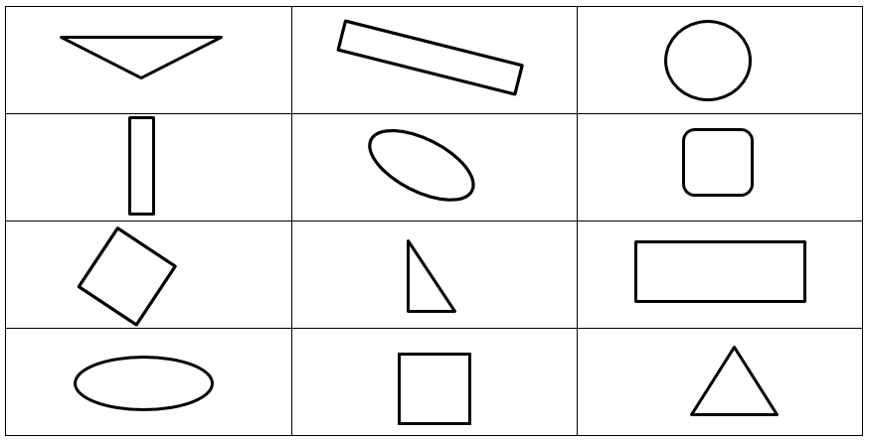

Shape Cards

A | B
. | .
C | D
. | .

Which One Doesn’t Belong?
