Student A

**Building Towers**

Using a set of 13 cubes, create three towers where one tower has more cubes and one has fewer cubes.

Order the towers, based on the number of cubes in each, from greatest to least or least to greatest.

Explain your thinking using pictures, numbers, and/or words.

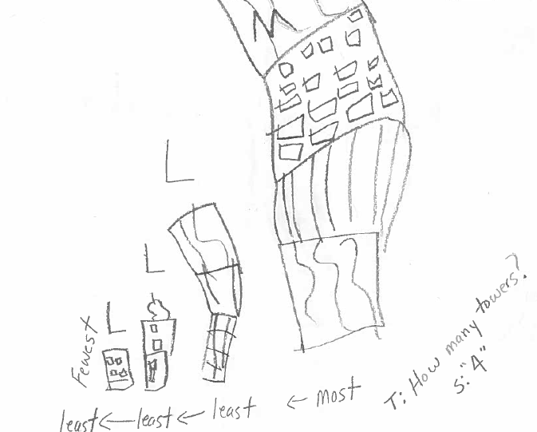

Student B

**Building Towers**

Using a set of 13 cubes, create three towers where one tower has more cubes and one has fewer cubes.

Order the towers, based on the number of cubes in each, from greatest to least or least to greatest.

Explain your thinking using pictures, numbers, and/or words.

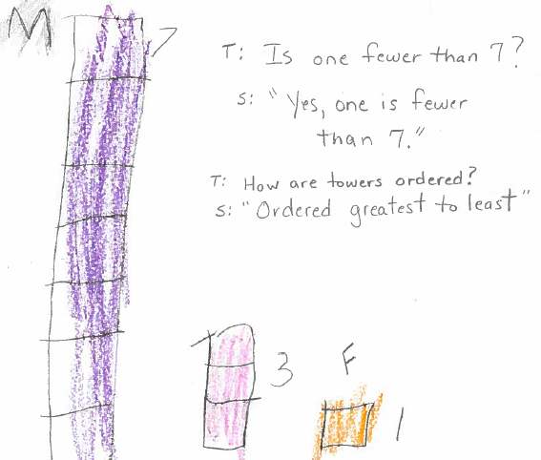

Student C

**Building Towers**

Using a set of 13 cubes, create three towers where one tower has more cubes and one has fewer cubes.

Order the towers, based on the number of cubes in each, from greatest to least or least to greatest.

Explain your thinking using pictures, numbers, and/or words.

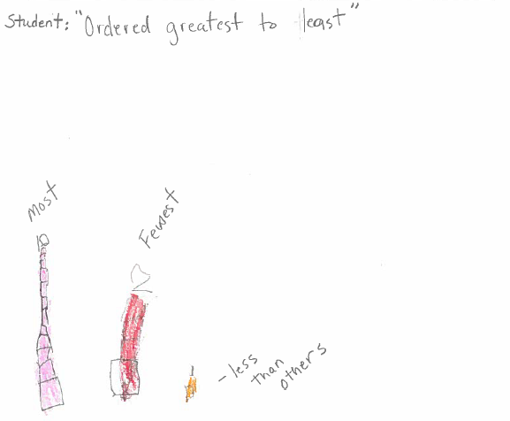

Student D

**Building Towers**

Using a set of 13 cubes, create three towers where one tower has more cubes and one has fewer cubes.

Order the towers, based on the number of cubes in each, from greatest to least or least to greatest.

Explain your thinking using pictures, numbers, and/or words.

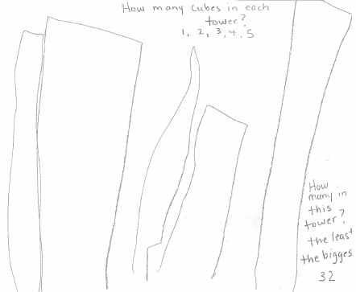

Student E

**Building Towers**

Using a set of 13 cubes, create three towers where one tower has more cubes and one has fewer cubes.

Order the towers, based on the number of cubes in each, from greatest to least or least to greatest.

Explain your thinking using pictures, numbers, and/or words.

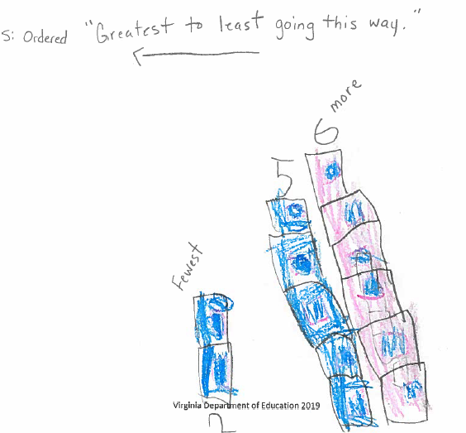

Student F

**Building Towers**

Using a set of 13 cubes, create three towers where one tower has more cubes and one has fewer cubes.

Order the towers, based on the number of cubes in each, from greatest to least or least to greatest.

Explain your thinking using pictures, numbers, and/or words.

