**Coins in Madison’s Pocket**

Madison has some pennies, nickels, dimes, and quarters in her pocket.  She counts the coins and she has a total of $1.63.  Use the following clues to determine how many of each coin Madison could have in her pocket:

* She has an odd number of quarters.
* She has more dimes than nickels.
* She has fewer than 20 pennies.

 Explain your thinking using pictures, words, and/or symbols.

STUDENT A

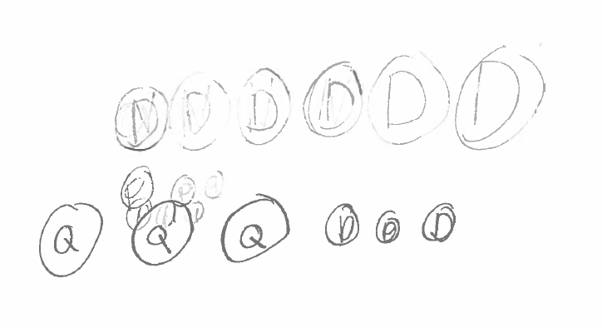

STUDENT B

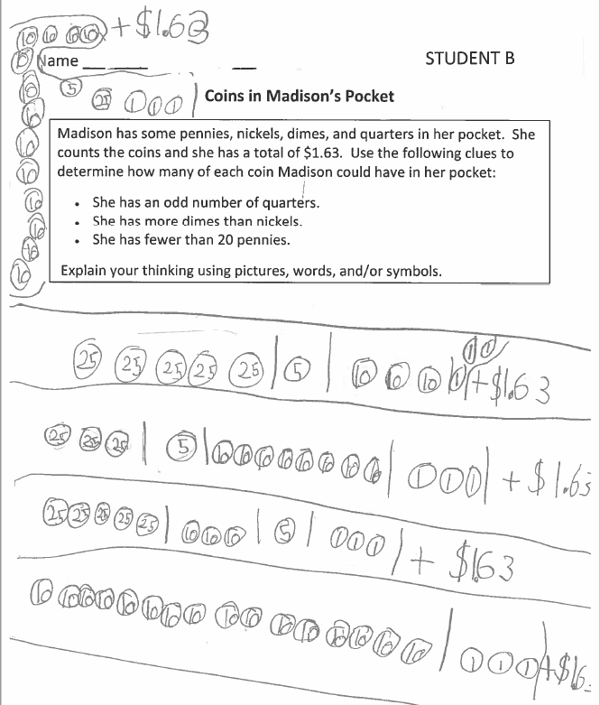

STUDENT C

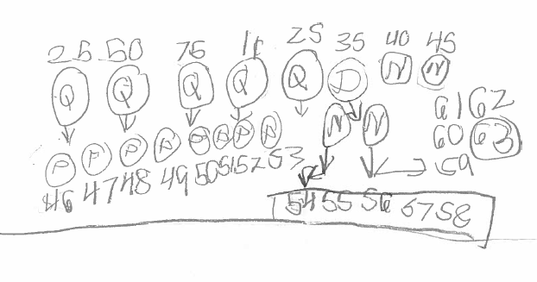

STUDENT D

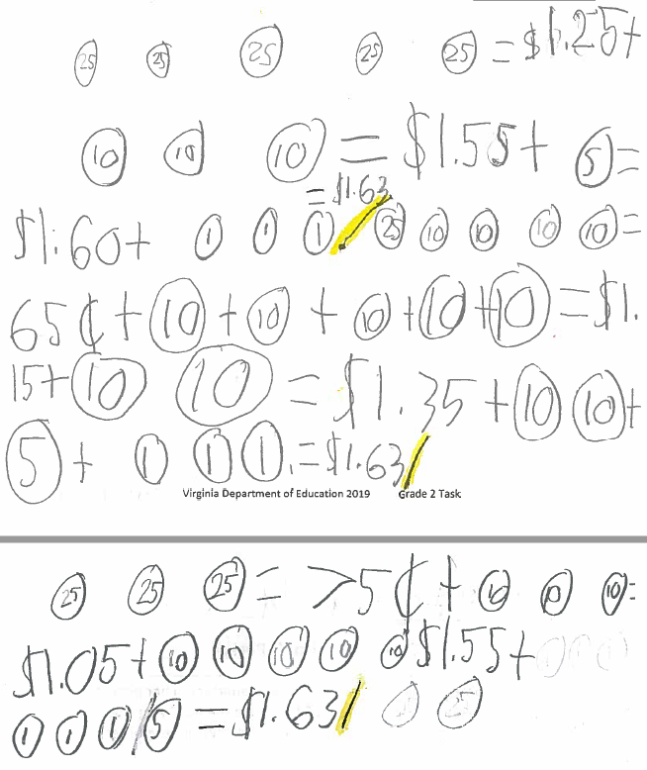

STUDENT E

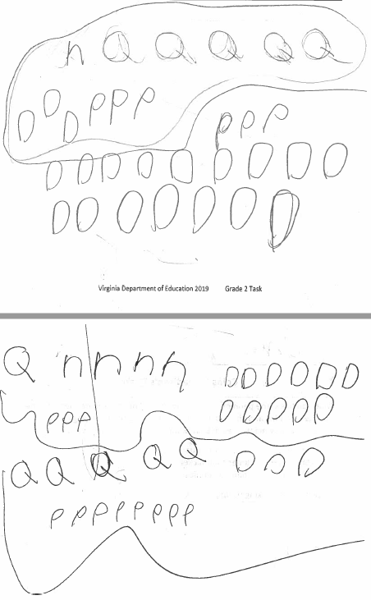

STUDENT F

