Task Overview/Description/Purpose:
- The purpose of this task is to apply knowledge of growing number patterns to deepen understanding of part-whole relationships and compensation.
- In this task, students explore composing and decomposing numbers as they investigate patterns highlighted by part-whole relationships.

Standards Alignment: Strand -Computation
Primary SOL: 2.5 The student will
- recognize and use the relationships between addition and subtraction to solve single-step practical problems, with whole numbers to 20; and
- demonstrate fluency with addition and subtraction within 20.
Related SOL: 1.7, 2.16, 2.17
Learning Intentions:
- Content – I am learning to use patterns to compose and decompose numbers up to 20.
- Language – I am learning to use written math symbols to explain how numbers are related.
- Social – I am learning to give and receive feedback about mathematical thinking.
Success Criteria (Evidence of Student Learning):
- I can compose and decompose numbers to find all the combinations.
- I can use number patterns to find all the number combinations.
- I can record the combinations using mathematical symbols.
- I can give and receive feedback about mathematical thinking.
Mathematics Process Goals
Problem Solving | - Students will investigate and describe the part-whole number relationships that emerge as they compose and decompose the number 17.
Communication and Reasoning | - Students will communicate their solutions and understanding of patterns in the combinations to 17 through pictures, words and symbols.
Connections and Representations | - Students will represent ways that the number 17 can be decomposed using concrete models, pictures and numbers. Through these representations, students will make connections to the patterns that exist in decomposing any number.  - Students will explore using symbols to represent the relationships among numbers and look for connections among equations to develop a deeper understanding of part-whole relationships.

Task Pre-Planning
Approximate Length/Time Frame: 60 minutes
Grouping of Students: Students begin the task independently. As the task progresses, students share ideas with a partner. Students will communicate findings by sharing models and representations during a whole group reflection.
Materials and Technology:  - copy of task recording sheet (one per student)  - manipulatives (e.g., paper strips, base-ten rods, Cuisenaire rods, tiles, cubes) | Vocabulary:  pattern  equal  increase, decrease  part, whole  composing, decomposing

Anticipate Responses: See the Planning for Mathematical Discourse Chart (columns 1-3).
Task Implementation (Before)
Task Launch:
- In a whole group setting, show students a picture or real-life example of “talking sticks”* (i.e., popsicle sticks used for monitoring participation) and ask, “What do you notice? What do you wonder?” to activate prior knowledge. *This can be modified to match the system or manipulatives used in the classroom where the task is being implemented.
- Invite students to connect with the context of the problem by asking, “In our classroom, how do we keep track of which students have shared and those who have not?” After discussing the use of the talking sticks, read the task aloud and invite students to help act out the story problem context.
- While students are gathered, invite them to turn to a partner and describe the pattern in the problem. Each time a single talking stick is added to the table the set increases, or grows, by one. Monitor student discussions to assess understanding and clarify any misconceptions.
- Consider emphasizing that the whole stays the same (17) with questions like: “The sticks are moving from the can to the table, but does the total number of sticks change? How many sticks are there altogether?”
Students need to generalize and be able to explain that as one set increases by one, the other set decreases by one but the total number (17) remains the same.
- Pass out the task to each student to solve independently. Have manipulatives and drawing tools available, as needed.

Task Implementation (During)
Directions for Supporting Implementation of the Task
- As students finish working independently, pair them up with a partner to share their solutions and practice giving each other feedback.
- Monitor – Teacher will listen and observe students as they work on task and ask assessing or advancing questions (see potential ideas on the Planning for Mathematical Discourse Chart).
- Select – Teacher will decide which strategies or thinking that will be highlighted (after student task implementation) in order to advance mathematical ideas and support student learning.
- Sequence – Teacher will decide the order in which student ideas will be highlighted (following the student task implementation).
- Connect – Teacher will consider ways to facilitate connections between different student responses.
Suggestions For Additional Student Support
- Provide students with a variety of manipulatives such as Base-Ten rods, Cuisenaire rods, paper strips or blocks to use to support them in visualizing the task and developing a problem-solving strategy.
- Consider giving students ten frames (see sample attached) to provide a support for seeing the total number of talking sticks. This may also assist them in seeing the pattern that forms as one talking stick is removed from the can and is added to the table.
- Students may find it helpful to record their combinations in a part-part-whole chart (see sample attached).
- Sentence frames to support student discourse may include:
  - There are __ sticks in the can and __ sticks on the table. There are __ sticks altogether.
  - My strategy is the same/different because _______.
- Some students may find it easier to access numbers in a lower range so it may be helpful to differentiate the task by changing the total number of sticks to 10 (or another number below 20). Students ready for an extension can be encouraged to work beyond 20.

Task Implementation (After)
Connecting Student Responses (From Anticipating Student Response Chart) and Closure of the Task:
- Based on the actual student responses, sequence and select particular students to present their mathematical thinking to the whole group.
- Consider ways to ensure that each student will have an equitable opportunity to share his/her thinking during the task discussion.
- The relationship of the parts to the whole and compensation (balancing both parts to keep the whole) are big ideas in this task. Invite students to share patterns that emerged. It may be helpful to chart the solutions students share in sequential order to highlight the number patterns. For example:
14 + 3
13 + 4
12 + 5
- Students may explain that as one side gets smaller, the other side gets bigger (decreases/increases). Ask students, “Why is that happening?” and invite them to model their reasoning using concrete materials.
- Questions to promote student engagement and discourse:
  - How many talking sticks could be in the can and on the table?
  - How could we record your solution using numbers and symbols?
  - How do you know your numbers will work?
  - How is this strategy the same or different from another strategy?
  - Are there other numbers that could work? How do you know?
  - How do you know if you found all the possible combinations?
  - What patterns are you noticing?
  - How does the pattern help you find all the combinations?
- Close the lesson by returning to the success criteria. Have students reflect on their progress toward the criteria.
Teacher Reflection About Student Learning:
- Use the rich mathematical task rubric to evaluate students’ progress toward the process goals.
- Look at the students’ work. Who employed what strategies?
  - Who had trouble getting started?
  - Who attended to the number given in the problem, but was not able to compose or decompose the number?
  - Who was not able to calculate the total accurately?
  - Who struggled to represent their solutions symbolically?
  - Who used a guess and check strategy to find the combinations for 17?
  - Who was able to use a list or similar strategy to organize their thinking?
  - Who used the idea of compensation and the growing pattern to help them find all the possible solutions?

Planning for Mathematical Discourse
Mathematical Task: ____Talking Sticks Task_________ Content Standard(s): ____SOL 2.5a____
Teacher Completes Prior to Task Implementation |  |  | Teacher Completes During Task Implementation
Anticipated Student Response/Strategy  Provide examples of possible correct student responses along with examples of student errors/misconceptions | Assessing Questions – Teacher Stays to Hear Response  Teacher questioning that allows student to explain and clarify thinking | Advancing Questions – Teacher Poses Question and Walks Away  Teacher questioning that moves thinking forward | List of Students Providing Response Who? Which students used this strategy? | Discussion Order - sequencing student responses  - Based on the actual student responses, sequence and select particular students to present their mathematical work during class discussion  - Consider ways to ensure that each student will have an equitable opportunity to share his/her thinking during task discussion
Anticipated Student Response:  Student is not sure how to get started or has only one solution. | - What’s happening in the problem?  - How many talking sticks are there altogether?  - What happens when one student talks? How many are on the table? In the can? | - How could you use the manipulatives to show what’s going on in this story?  - What will happen next if another student shares?  - How could you use numbers and symbols to show what is happening?
Anticipated Student Response:  Student attends to the number 17 and simply adds on to it. | - What’s happening in the problem?  - What happens when one student talks? | - How could you use manipulatives to show what is happening in the problem?  - How could you write a number sentence to show how many talking sticks are in the can and on the table?  - What will happen next if another student shares?
Anticipated Student Response:  Student doesn’t keep the total constant. For example, the student may find the sum of two numbers that do not equal 17 or has to recount to find the total for each solution. | - What happens when one student talks? How many are on the table? In the can?  - How many talking sticks are there altogether in your solution? | - How could you record what you did to help you keep track of the number of talking sticks?
Anticipated Student Response:  Student uses random guess and check strategy to test number combinations that combine to make 17. | - How did you decide to use those numbers?  - What pattern do you notice in your number sentences as one talking stick is removed and added to the table? | - What would happen next if another student shares? Think about how that changes your representation and your number sentence.  - How can the pattern help you find other combinations?
Anticipated Student Response:  Student uses a list or table to find all of the combinations for 17. | - How did you decide what two numbers to combine?  - Did you use the same strategy for all your combinations? | - How can you convince us (prove) that you found all of the possible number combinations?  - Will that work with other numbers (wholes)?

Name ___________________________ Date __________________
Talking Sticks
Mrs. Holland’s class uses talking sticks to call on students throughout the day.
- Each morning, there are 17 sticks in the can.
- As each student shares, their stick is removed from the can and placed on the table. (When the first student shares their stick is moved to the table. When the second student shares their stick is placed on the table.)
If the pattern continues, at any point during the day, how many sticks could be in the can and how many could be on the table?
What are all the possible combinations? How will you know when you have them all?

Rich Mathematical Task Rubric
 | Advanced | Proficient | Developing | Emerging
Mathematical  Understanding | Proficient Plus:  - Uses relationships among mathematical concepts | - Demonstrates an understanding of concepts and skills associated with task  - Applies mathematical concepts and skills which lead to a valid and correct solution | - Demonstrates a partial understanding of concepts and skills associated with task  - Applies mathematical concepts and skills which lead to an incomplete or incorrect solution | - Demonstrates little or no understanding of concepts and skills associated with task  - Applies limited mathematical concepts and skills in an attempt to find a solution or provides no solution
Problem Solving | Proficient Plus:  - Problem solving strategy is efficient | - Problem solving strategy displays an understanding of the underlying mathematical concept  - Produces a solution relevant to the problem and confirms the reasonableness of the solution | - Chooses a problem solving strategy that does not display an understanding of the underlying mathematical concept  - Produces a solution relevant to the problem but does not confirm the reasonableness of the solution | - A problem solving strategy is not evident or is not complete  - Does not produce a solution that is relevant to the problem
Communication  and  Reasoning | Proficient Plus:  - Reasoning is organized and coherent  - Consistent use of precise mathematical language and accurate use of symbolic notation | - Communicates thinking process  - Demonstrates reasoning and/or justifies solution steps  - Supports arguments and claims with evidence  - Uses mathematical language to express ideas with precision | - Reasoning or justification of solution steps is limited or contains misconceptions  - Provides limited or inconsistent evidence to support arguments and claims  - Uses limited mathematical language to partially  communicate thinking with some imprecision | - Provides little to no correct reasoning or justification  - Does not provide evidence to support arguments and claims  - Uses little or no mathematical language to communicate thinking
Representations  and  Connections | Proficient Plus:  - Uses representations to analyze relationships and extend thinking  - Uses mathematical connections to extend the solution to other mathematics or to deepen understanding | - Uses a representation or multiple representations, with accurate labels, to explore and model the problem  - Makes a mathematical connection that is relevant to the context of the problem | - Uses an incomplete or limited representation to model the problem  - Makes a partial mathematical connection or the connection is not relevant to the context of the problem | - Uses no representation or uses a representation that does not model the problem  - Makes no mathematical connections

Task Supporting Documents
Ten Frames

Part-Part-Whole Chart
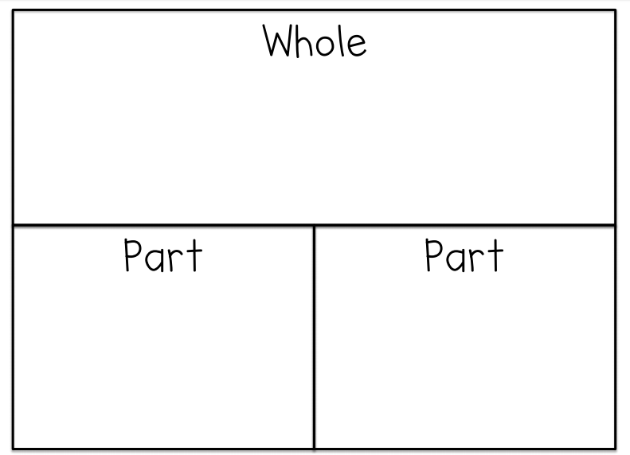

Problem Solving Placemat

