Name_________________________________ Date________________________

How Many Tables?

Lulu is planning a birthday dinner for her mom at a restaurant. The restaurant uses square tables to seat customers. Four people fit around one square table, one on each side. For larger groups, the restaurant pushes same-sized tables together. Two tables pushed together will seat 6 people. In the picture, each square represents a table and each person is represented by a circle.
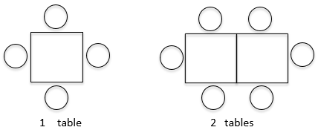
If 12 people come to her mom’s birthday dinner, how many tables will Lulu need the restaurant to push together in a row, so they have enough seats for everyone? What patterns do you notice each time the restaurant adds another table? Show your work and explain your thinking.

