**Bracelet Task**

Lucy wants to make a bracelet for her sister. Her sister’s favorite colors are blue and green. She wants to choose a design in which she can use the same number of blue beads as green beads.

If Lucy uses more than a total of 20 beads, but less than 30, how many beads could she use to make the bracelet with the same number of blue and green beads?

Explain your thinking using pictures, words and/or numbers.

Student A

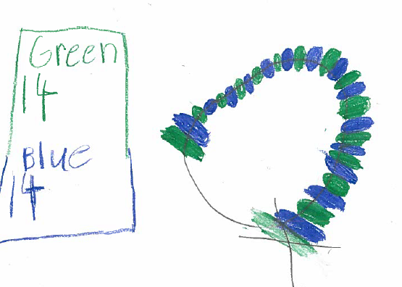

Student A Continued

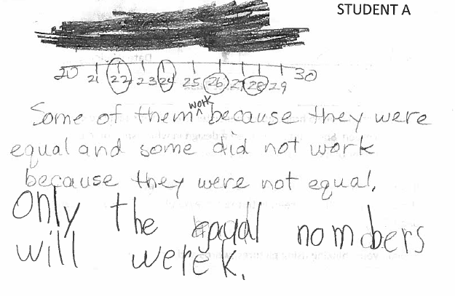

STUDENT B

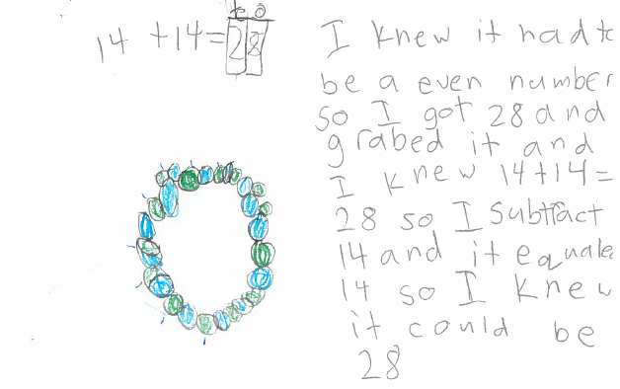

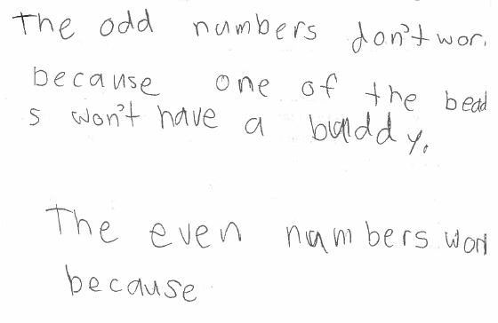

STUDENT C

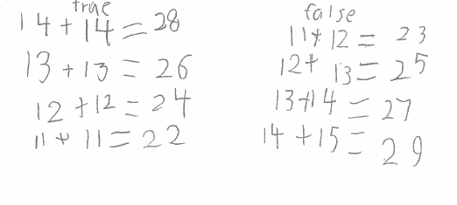

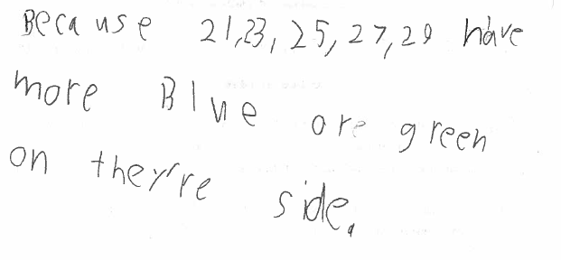

STUDENT D

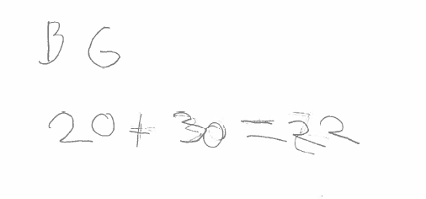

STUDENT E

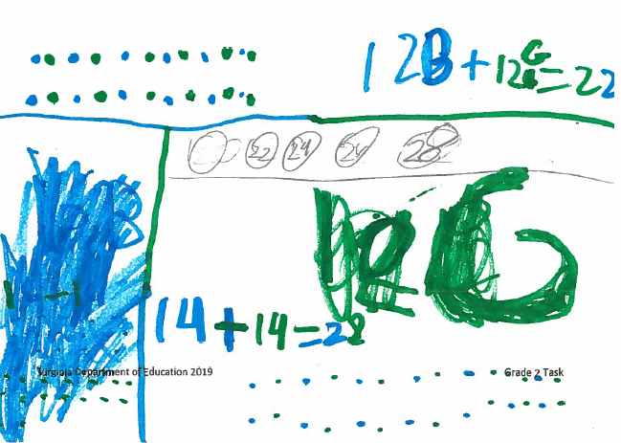

STUDENT F

