Name________________________________ Date________________________
Playing with Patterns
Ricardo created the following pattern using pictures and words:

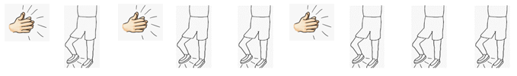
clap – stomp – clap – stomp – stomp – clap – stomp – stomp – stomp …

- Can you use pictures, symbols, or numbers to create a new representation of Ricardo’s pattern? Explain your thinking.

- Extend your representation of Ricardo’s pattern until there are 14 parts. Use pictures, symbols, or numbers to show what your pattern would look like. Explain your thinking.

