NAME ________________________________ DATE __________________

Doubles Game

Mrs. Munson’s class is making a doubles game. Students will spin a spinner, double the number it lands on, and cover that sum on the game board.
- What numbers could the class place on the spinner?
- If the numbers on the game board are the sums, what numbers should be placed on the game board?
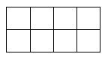
Show your work and explain your thinking.

Spinner

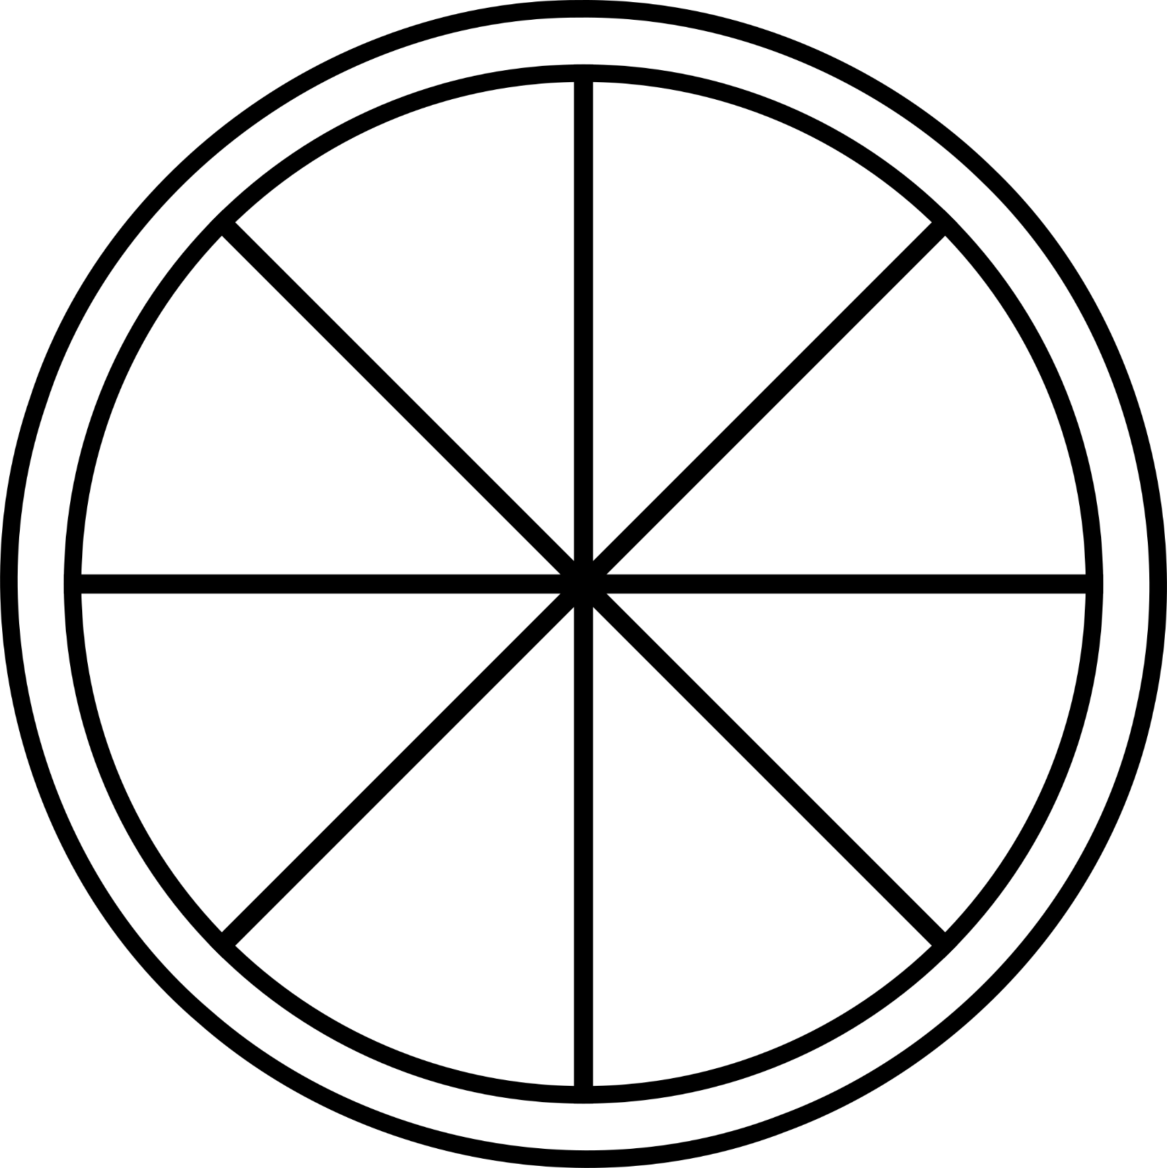

Doubles Game Board

0 | o | o | o
0 | o | o | o

