Task Overview/Description/Purpose:
- The purpose of this task is to deepen student understanding of number relationships as part of developing fact fluency.
- Thru this task, students will investigate the idea of hierarchical inclusion; smaller numbers are contained within larger numbers (i.e., 3 is contained in and a part of 5). Students will explore the concept of number relationships through a comparison problem in which one value must be two more than the other.

Standards Alignment: Strand - Computation and Estimation
Primary SOL: 1.6 The student will create and solve single-step story and picture problems using addition and subtraction within 20.
Related SOL: K.4, 1.7, 2.5
Learning Intentions:
- Content – I am learning to make sense of story problems and understand number relationships.
- Language – I am learning to understand and use comparison language such as greater than, less than and equal to.
- Social – I am learning to communicate my thinking, listen to classmates’ solutions and share feedback.
Success Criteria (Evidence of Student Learning):
- I can compare numbers and determine how much greater one number is than another.
- I can model the problem using objects, representations or equations.
- I can communicate my thinking clearly to my classmates and describe number relationships.
Mathematics Process Goals
Problem Solving | Students will use problem solving strategies and reasoning to compare quantities to find a relationship of “two more than”.
Communication and Reasoning | Students will explain why their chosen numbers make sense for the criteria presented in the problem.
Connections and Representations | Students will create a representation to demonstrate the relationship between quantities.

Task Pre-Planning
Approximate Length/Time Frame: 50 minutes
Launch (Whole Group) - 15 minutes; Student work time (Individually) - 20 minutes; Share and Discussion (Whole Group) – 15 minutes
Grouping of Students: Begin with a whole class launch of task. After introducing task, students work individually to solve task. If some students solve before group discussion time, encourage them to find other solutions and/or share their thinking with a classmate who has also completed task.
Materials and Technology:  - counters or connecting cubes  - number path  - copy of task for each student | Vocabulary:  more, fewer  greater than, less than, equal to  count on, count back  add, subtract

Anticipate Responses: See the Planning for Mathematical Discourse Chart (columns 1-3).

Task Implementation (Before)
Task Launch:
- To establish context and activate prior knowledge, begin the lesson by asking “who has shared toys with a friend?”
  - How do you go about sharing?
  - How can you figure out if one friend had more the other?
- If I were playing with blocks, and I had one more than my friend, how many blocks might I have? How many blocks might my friend have? Use blocks to build visual representation of comparison.
- Try out some student suggestions, if needed; ask if I have 3 blocks and my friend has one more, how many would he have? Lead student thinking to my friend could have 4 blocks because 4 is one more than 3. Establish a few examples of pairs of numbers, in which the second number is one greater than the first (e.g. (3, 4) (6, 7) (15, 16)). How can you tell that one friend has one more?
- We have a problem today is which friends are playing with toy cars. They do not have the same or equal amount of cars. Your task is to listen to the clues in the story to figure out the number of cars each friend might have. Display and read task to students. Ask student(s) to retell what’s happening in the story problem to check for understanding and clarify any questions.
- As students restate the problem, questions like the following may help students make sense of the task and help develop comprehension strategies:
  - Sam has some …how many could some be? More than….
  - Is the amount for Ellie getting bigger or smaller?
Task Implementation (During)
Directions for Supporting Implementation of the Task
- Monitor – Teacher will listen and observe students as they work on task and ask assessing or advancing questions (see potential ideas on the Planning for Mathematical Discourse Chart).
- Select – Teacher will decide which strategies or thinking that will be highlighted (after student task implementation) in order to advance mathematical ideas and support student learning.
- Sequence – Teacher will decide the order in which student ideas will be highlighted (following the student task implementation).
- Connect – Teacher will consider ways to facilitate connections between different student responses.
Suggestions For Additional Student Support
May include, among others:
- Direct comparison by lining up stacks of cubes. How much longer is Ellie’s stack than Sam’s? How many extra does Ellie have? How can you tell? How many more cubes would we have to give Sam to make the towers have the same amount?
- A number path or number track would help students with number order and can be used as a tool for counting on or adding a group.
- Vocabulary development could be assisted by re-reading the problem and interpreting; some, if Sam has some cars, how many could some be? If Ellie has more than Sam, will her number be bigger or smaller than Sam?
- Sentences frames to support student thinking:
Sam could have ____cars. Ellie could have ___ cars. This answer makes sense because________.
- An extension would be to pose a comparison of Ellie having “three more cars” than Sam.
- Another idea for extension would be to introduce the comparison language of fewer than – if Ellie has 7 cars and Sam has two fewer cars, how many cars would Sam have?
Task Implementation (After)
Connecting Student Responses (From Anticipating Student Response Chart) and Closure of the Task:
- Based on the actual student responses, sequence and select particular students to present their mathematical work during class discussion:
  - One option could be to sequence student work showing a random selection of numbers for Sam and Ellie to use of more efficient strategies such as counting on or adding a group of two.
  - Another option may be to start with an incorrect response and have students agree or disagree.
    - Do we think these numbers will work for our problem? Why or why not?
    - How could we change numbers so the solution would make sense?
- Connect different students’ responses and connect the responses to the key mathematical ideas to bring closure to the task. Key mathematical ideas to develop from student work:
- The concept of hierarchical inclusion: understanding that all numbers preceding a number can be or are systematically included in the value of another selected number. Meaning that whatever quantity Sam has, Ellie will have that same amount plus two extra. The quantity 3 for Sam is contained inside the quantity 5 for Ellie.
- An emerging pattern to discuss is that “two more” skips a number in the counting sequence. Internalizing patterns and number relationships through conceptual understanding builds fact fluency. Later in second grade (or as extension) this pattern can be extended further to starting with an odd number and counting by two’s or two more than will keep the string of numbers odd, starting with an even number and adding two more with keep the numbers even.
- Consider ways to ensure that each student will have an equitable opportunity to share his/her thinking during task discussion.
  - One possibility, upon completion of the task, would be to list student responses for Sam and Ellie. Then encourage students to look for patterns. Consider using the following questions to prompt further discussion:
    - What patterns are you noticing with the number of cars selected for Sam and Ellie?
    - What are you wondering?
    - How can there be so many different answers?
Teacher Reflection About Student Learning:
- Use the rich mathematical task rubric to evaluate students’ progress toward the process goals.
- How will the evidence provided through student work inform further instruction? Look at the students’ work. Who demonstrated what strategies?
- Who was unable to show Ellie having a larger number than Sam?
- Who found a larger number for Ellie but it was not within the parameters of two more?
- Who used manipulatives to figure out and explain the relationship between numbers?
- Who was beginning to identify patterns to support their work?
- Who is quickly and confidently adding two more?
- Who is using two digit numbers in their solution?
- Who found more than one solution for this problem?
- Which students noticed the pattern and were able to generalize to create problems with different patterns?

Planning for Mathematical Discourse
Mathematical Task: ____Toy Cars_________ Content Standard(s): ____SOL 1.6____
Teacher Completes Prior to Task Implementation |  |  | Teacher Completes During Task Implementation
Anticipated Student Response/Strategy  Provide examples of possible correct student responses along with examples of student errors/misconceptions | Assessing Questions – Teacher Stays to Hear Response  Teacher questioning that allows student to explain and clarify thinking | Advancing Questions – Teacher Poses Question and Walks Away  Teacher questioning that moves thinking forward | List of Students Providing Response Who? Which students used this strategy? | Discussion Order - sequencing student responses  - Based on the actual student responses, sequence and select particular students to present their mathematical work during class discussion  - Consider ways to ensure that each student will have an equitable opportunity to share his/her thinking during task discussion
Anticipated Student Response :  Student has difficulty getting started. | - Can you retell the problem to me?  - How many cars shall we give to Sam? Can you show me that amount with counters? | - If you gave Sam __ cars, how can this help you build the number of cars for Ellie? | Student A
Anticipated Student Response :  Student assigns Ellie 2 cars; doesn’t understand the relationship that Ellie’s number is “two more” than Sam’s. | - How did you choose the number of cars for Sam? For Ellie?  - How can you show Ellie has more than Sam? | - What numbers will show Ellie has two more than Sam? | Student B
Anticipated Student Response:  Student randomly selects numbers without regard to relationship parameters between values. | - Which friend did you start with in choosing a number of cars? Why?  - Will the other friend have a greater number of cars or smaller number? How do you know?  - How much greater should Ellie’s number of cars be than Sam’s? | - What number of cars would show Ellie having two more than Sam?  - Or what number of cars would show Sam having two less than Ellie? | Student C

Anticipated Student Response:  Student demonstrates a one more relationship for the number Ellie’s cars. | - Who has more cars? How many more does Ellie have?  - Does this match the information in the problem? | - How can you change Ellie’s number of cars to match the information given in the problem?  - How would you show two more for Ellie on the number path? | Student D
Anticipated Student Response:  Student demonstrates “counting on” strategy. | - What was your strategy to find the number of cars for Sam and Ellie? | - What’s a different number of cars for Sam and Ellie that would make sense for this problem?  - What patterns could you find that may help you discover other solutions? | Student E  Student G
Anticipated Student Response:  Student demonstrates “adding a group of two”. | - What was your strategy to find the number of cars for Sam and Ellie? | - Will this strategy work for any number of cars given to Sam?  - What patterns do you notice when you add 2 to any given number? | Student F  Student H
Anticipated Student Response:  Student finds and describes a pattern in numbers for solution; e.g., select number, skip one, next number. | - What kinds of patterns are you noticing in these numbers? | - Will this pattern work with larger numbers?  - How does this pattern help you find other solutions for this problem? | Students G

Name ___________________________ Date __________________
Toy Cars
Sam and Ellie were playing with toy cars.
- Sam has some toy cars.
- Ellie has two more cars than Sam.
How many cars could they each have?
How do you know your answer makes sense?
What other answers can you find?

Rich Mathematical Task Rubric
 | Advanced | Proficient | Developing | Emerging
Mathematical  Understanding | Proficient Plus:  - Uses relationships among mathematical concepts | - Demonstrates an understanding of concepts and skills associated with task  - Applies mathematical concepts and skills which lead to a valid and correct solution | - Demonstrates a partial understanding of concepts and skills associated with task  - Applies mathematical concepts and skills which lead to an incomplete or incorrect solution | - Demonstrates little or no understanding of concepts and skills associated with task  - Applies limited mathematical concepts and skills in an attempt to find a solution or provides no solution
Problem Solving | Proficient Plus:  - Problem solving strategy is efficient | - Problem solving strategy displays an understanding of the underlying mathematical concept  - Produces a solution relevant to the problem and confirms the reasonableness of the solution | - Chooses a problem solving strategy that does not display an understanding of the underlying mathematical concept  - Produces a solution relevant to the problem but does not confirm the reasonableness of the solution | - A problem solving strategy is not evident or is not complete  - Does not produce a solution that is relevant to the problem
Communication  and  Reasoning | Proficient Plus:  - Reasoning is organized and coherent  - Consistent use of precise mathematical language and accurate use of symbolic notation | - Communicates thinking process  - Demonstrates reasoning and/or justifies solution steps  - Supports arguments and claims with evidence  - Uses mathematical language to express ideas with precision | - Reasoning or justification of solution steps is limited or contains misconceptions  - Provides limited or inconsistent evidence to support arguments and claims  - Uses limited mathematical language to partially  communicate thinking with some imprecision | - Provides little to no correct reasoning or justification  - Does not provide evidence to support arguments and claims  - Uses little or no mathematical language to communicate thinking
Representations  and  Connections | Proficient Plus:  - Uses representations to analyze relationships and extend thinking  - Uses mathematical connections to extend the solution to other mathematics or to deepen understanding | - Uses a representation or multiple representations, with accurate labels, to explore and model the problem  - Makes a mathematical connection that is relevant to the context of the problem | - Uses an incomplete or limited representation to model the problem  - Makes a partial mathematical connection or the connection is not relevant to the context of the problem | - Uses no representation or uses a representation that does not model the problem  - Makes no mathematical connections

Task Supporting Documents
Picture of toy cars can be to support context of problem.

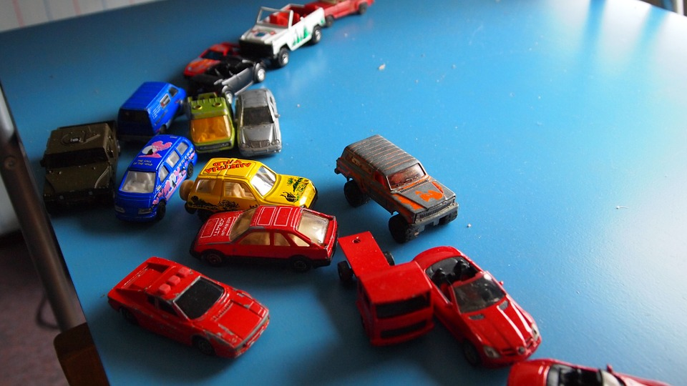

Possible Sentence frames for supporting learners.

Sam could have _____ toy cars.

Ellie could have _____ toy cars.

My answer makes sense for the problem because
____________________________________________________________________________________________________________________.

Number Paths
 | i | Attach 10 here | i |  | i | Attach 10 here
1 |  | 11 |  | 1 |  | 11
2 |  | 12 |  | 2 |  | 12
3 |  | 13 |  | 3 |  | 13
4 |  | 14 |  | 4 |  | 14
5 |  | 15 |  | 5 |  | 15
6 |  | 16 |  | 6 |  | 16
7 |  | 17 |  | 7 |  | 17
8 |  | 18 |  | 8 |  | 18
9 |  | 19 |  | 9 |  | 19
10 |  | 20 |  | 10 |  | 20

