Just In Time Quick Check
Standard of Learning (SOL) G.9
Strand: Reasoning, Lines, and Transformations

Standard of Learning (SOL) G.9
The student will verify and use properties of quadrilaterals to solve problems, including practical problems.

Grade Level Skills:
- Solve problems, including practical problems, using the properties specific to parallelograms, rectangles, rhombi, squares, isosceles trapezoids, and trapezoids.
- Prove that quadrilaterals have specific properties, using coordinate and algebraic methods, such as the distance formula, slope, and midpoint formulas.
- Prove the properties of quadrilaterals, using direct proofs.

Just in Time Quick Check

Just in Time Quick Check Teacher Notes

Supporting Resources:
- VDOE Mathematics Instructional Plans (MIPS)
  - G.9 – Properties of Quadrilaterals (Word) / PDF Version
- VDOE Word Wall Cards: Geometry (Word)|(PDF)
  - Properties of Parallelograms
  - Rectangle
  - Rhombus
  - Square
  - Trapezoid
  - Isosceles Trapezoid
- Other VDOE Resources
  - Geometry, Module 8, Topic 1 – Applying Properties of a Parallelogram[eMediaVA]
  - Geometry, Module 8, Topic 2 – Applying Properties of a Rectangle[eMediaVA]
  - Geometry, Module 8, Topic 3 – Applying Properties of a Rhombus[eMediaVA]
  - Geometry, Module 8, Topic 4 – Applying Properties of a Square[eMediaVA]
  - Geometry, Module 8, Topic 5 – Applying Properties of Trapezoids and Isosceles Trapezoids[eMediaVA]
  - Geometry, Module 8, Topic 6 – Proving Properties of Quadrilaterals[eMediaVA]
Supporting and Prerequisite SOL: G.1c, G.3a, G.3b, G.4b, G.4c, G.4d, G.4e, G.4f, G.4h, A.6a, 8.5, 7.5, 7.6a, 7.6b, 6.9

SOL G.9 - Just in Time Quick Check

- Given ordered pairs (-5, -3), (-3, 2), and (1, -1) plotted on the graph below, write at least 2 unique ordered pairs that could represent the fourth vertex of a parallelogram. Justify your thinking.

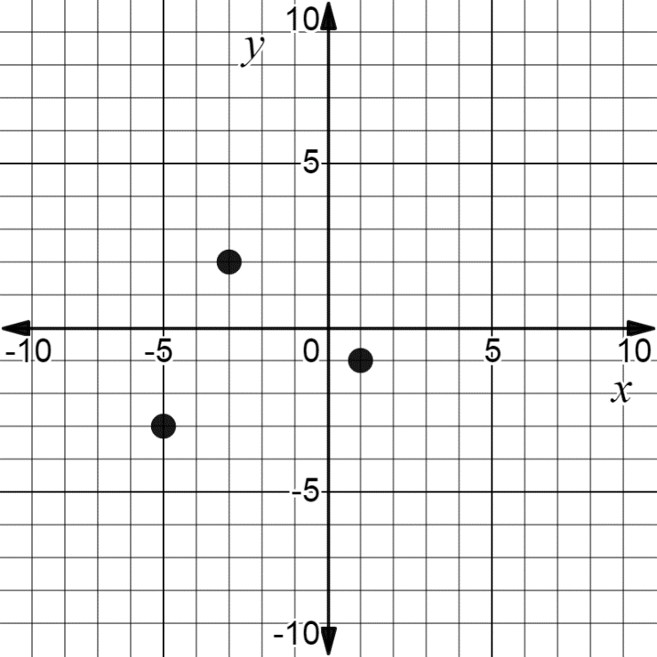

- Given: Trapezoid ABCD with base $\overline{AB}$ and $\overline{CD}$ and $m∠A=(3x+20)°, m∠B=(4x)°,$and $m∠D=(2x+10)°$. Find the value of x. Then find the measure of angle C. Explain your reasoning.
- Given Quadrilateral ABCD with points A (2, 1), B (4, 3.5), C (6, 1), and D (4, -1.5). What is the most specific name for Quadrilateral ABCD? Justify your answer.

- A hose for a sprinkler system lies along one diagonal of a square garden. The exact length of the hose is $25\sqrt{2}$ feet. What is the perimeter of the garden? Explain your reasoning.

- Rectangle MNOP is shown below with $m∠MON=62°$. Find $m∠OMN and m∠PRO$. Explain your reasoning.
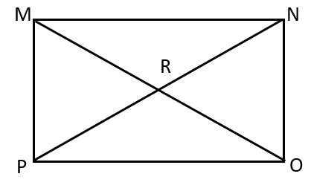
$m∠OMN=$ _________
$m∠PRO=$ _________

- Complete the proof below.
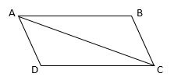
Given: $\overline{AD}≅\overline{CB}$, $\overline{AB}≅\overline{DC}$
Prove: ABCD is a parallelogram
Statements | Reasons
$1.\overline{AD}≅\overline{CB}$, $\overline{AB}≅\overline{DC}$ | 1.
$$2.$$ | 2. Reflexive Property of Congruence
3. $∆ABC≅∆CDA$ | 3.
4. $∠BAC≅∠DCA$, $∠BCA≅∠DAC$ | 4.
5. $\overline{AB}∥\overline{DC}$, $\overline{AD}∥\overline{BC}$ | 5.
6. | 6.

SOL G.9 - Just in Time Quick Check Teacher Notes
Common Errors/Misconceptions and their Possible Indications
1. Given ordered pairs (-5, -3), (-3, 2), and (1, -1) plotted on the graph below, write at least 2 unique ordered pairs that could represent the fourth vertex of this parallelogram. Justify your thinking.

A common error a student may make is to identify only one possible vertex. Many students read a graph from left to right and may only be able to recognize the point (3, 4). Some students may need to connect the vertices to determine different possible configurations of the parallelogram. Students should be able to justify their answers through coordinate methods to include slope and distance. Coordinate methods should be used to verify that opposite sides are parallel and congruent. Teachers should encourage students to use a dynamic graphing calculator or Desmos to plot the points and verify side lengths. For those students who can identify two vertices, consider challenging them to find a third possible vertex.
2. Given: Trapezoid ABCD with bases of $\overline{AB}$ and $\overline{CD}$ and $m∠A=(3x+20)°, m∠B=(4x)°,$and $m∠D=(2x+10)°$. Find the value of x. Then find the measure of angle C. Explain your reasoning.
A common error a student may make is to set $m∠A$ equal to m$∠B$ and solve for x. This may indicate that some students assume Trapezoid ABCD to be an isosceles trapezoid where base angles are congruent. Teachers should stress the importance of not relying solely on visual appearance to identify the properties of a specific quadrilateral. : Students should be able to explain why angles A and D (and angles B and C) are supplementary using concepts from G.2.

3. Given Quadrilateral ABCD with points A (2, 1), B (4, 3.5), C (6, 1), and D (4, -1.5). What is the most specific name for Quadrilateral ABCD? Justify your answer.
A common error students may make is to identify the figure as a square instead of a rhombus because they only found the lengths of the sides. Students who do not graph the points are more likely to make this error. Students who focus only on side lengths may need to review characteristics of quadrilaterals and discuss how slope can be used to determine whether consecutive sides are perpendicular to each other. Teachers should use VDOE Words Walls cards as a quick reference to the properties of specific parallelograms. Teachers should encourage students to use a dynamic graphing calculator or Desmos to justify properties.
4. A hose for a sprinkler system lies along one diagonal of a square garden. The exact length of the hose is $25\sqrt{2}$ feet. What is the perimeter of the garden? Explain your reasoning.
A common error a student may make is to use $25\sqrt{2}$ as the side length of the garden instead of the length of the diagonal. Teachers should encourage students to draw a picture for visual reference. While students can solve using the Pythagorean Theorem or Trigonometry, students should understand that diagonals of a square create 45-45-90 triangles where properties of Special Right Triangles could be used to solve. Students should be encouraged to explain different ways to solve this problem.

5. Rectangle MNOP is shown below with $m∠MON=62°$. Find $m∠OMN and m∠PRO$. Explain your reasoning.
$m∠OMN=$ _________
$m∠PRO=$ _________
A common error a student may make is to find $m∠OMN=62°$. This may indicate the student views $∠MON$ and $∠OMN$ as opposite angles and concludes that they are congruent. Another common error a student may make would be to find $m∠RPO$ instead of $m∠PRO$. A student may struggle with identifying the correct angle when the angle is named by three letters instead of named by one letter or indicated by a number. To address these errors, teachers could encourage students to trace their angles to better visualize which angles are being represented in the problem as well as using the eMediaVA videos as references for the students. Students may also benefit from a discussion of why the four smaller triangles inside the rectangle are isosceles triangles.

6. Complete the proof below.
Given: $\overline{AD}≅\overline{CB}$, $\overline{AB}≅\overline{DC}$
Prove: ABCD is a parallelogram
Statements | Reasons
$1.\overline{AD}≅\overline{CB}$, $\overline{AB}≅\overline{DC}$ | 1.
$$2.$$ | 2. Reflexive Property of Congruence
3. $∆ABC≅∆CDA$ | 3.
4. $∠BAC≅∠DCA$, $∠BCA≅∠DAC$ | 4.
5. $\overline{AB}∥\overline{DC}$, $\overline{AD}∥\overline{BC}$ | 5.
6. | 6.

A common error some students may make would be to justify $∠BAC≅∠DCA$ and $∠BCA≅∠DAC$ with the reason of Alternate Interior Angles are congruent. This may indicate that some students did not reference statement 3 where two triangles are proven congruent by the SSS Postulate. Students should know that parallel lines must be proven before using Alternate Interior Angles congruency. Teachers are encouraged to model how to diagram the given information before completing the proof so that students have a visual to reference in determining appropriate statements, reasons, and conclusion to the proof.
Another common error some students may make is to justify that ABCD is a parallelogram using the Prove statement in the proof. Some students commonly use the word “Prove” as a reason in their justification process. Teachers could use Proof Puzzles found in the VDOE Mathematics Instructional Plans to help students become more familiar with completing proofs.

