Just In Time Quick Check
Standard of Learning (SOL) G.13
Strand: Three-Dimensional Figures

Standard of Learning (SOL) G.13
The student will use surface area and volume of three-dimensional objects to solve practical problems.

Grade Level Skills:
- Determine the surface area of cylinders, prisms, pyramids, cones, hemispheres, and spheres, using the appropriate formulas.
- Determine the volume of cylinders, prisms, pyramids, cones, hemispheres, and spheres, using the appropriate formulas.
- Solve problems including practical problems, involving surface area and volume of cylinders, prisms, pyramids, cones, hemispheres, and spheres, as well as composite three-dimensional figures.
- Solve problems, including practice problems, involving the lateral area of circular cylinders, prisms, and regular pyramids.
- Given information about a three-dimensional figure such as length of a side, area of a face, or volume, determine missing information.

Just in Time Quick Check

Just in Time Quick Check Teacher Notes

Supporting Resources:
- VDOE Mathematics Instructional Plans (MIPS)
  - Surface Area and Volume (Word) / PDF Version
- VDOE Word Wall Cards: Geometry (Word)|(PDF)
  - Cone
  - Cylinder
  - Polyhedron
  - Sphere
  - Hemisphere
  - Pyramid
- Other VDOE Resources
  - Geometry, Module 13 – Area and Volume [eMediaVA]
Supporting and Prerequisite SOL: A.4a, A.4e, 8.6a, 8.6b, 8.10, 8.17, 7.4a, 7.4b

SOL G.13 - Just in Time Quick Check

- A fish tank, in the shape of a rectangular prism, measures 6 feet by 5 feet by 1.3 feet. About how many gallons of water will it take to fill the tank three-fourths full? (A cubic foot is about 7.5 gallons.)

- Find the surface area of the triangular prism.

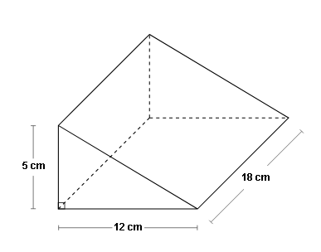

- A tent is being designed in the shape of a cone with a slant height of 18.5 feet and a diameter of 20 feet. Approximately how much material is needed to cover the lateral area of the tent without any overlap? Round your answer to the nearest tenth.

- Aimee purchased a bottle of perfume that is in the shape of a square pyramid. The bottle has a height of 3.5 inches and base edges 2 inches long. What is the volume of the perfume bottle?

- The figure below shows a cone placed on top of a cylinder. Find the surface area of the composite figure.
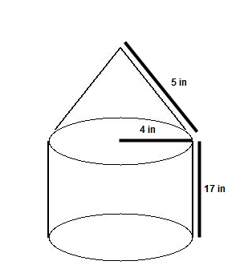

- An ice cream cone is 10 centimeters deep and has a diameter of 8 centimeters. A scoop of ice cream in the shape of a hemisphere is placed on top and also has a diameter of 8 centimeters. If the ice cream melts into the cone, will it overflow?
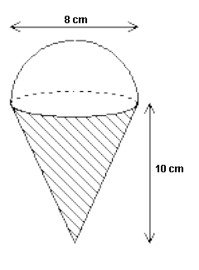

SOL G.13 - Just in Time Quick Check Teacher Notes
Common Errors/Misconceptions and their Possible Indications

- A fish tank, in the shape of a rectangular prism, measures 6 feet by 5 feet by 1.3 feet. About how many gallons of water will it take to fill the tank three-fourths full? (A cubic foot is about 7.5 gallons.)
A common misconception that some students may have is to calculate the volume of the rectangular fish tank, then multiply it by three-fourths and give the result as the solution. Students who calculate the volume correctly have demonstrated an understanding of how to find volume, but may not have considered the practical application of how many gallons are contained in a cubic foot. This may indicate that some students did not consider converting the number of cubic feet to an equivalent number of gallons of water. Some students may not realize how this information is relevant to the context of the problem. Teachers should provide students with some familiar applications where part of the figure is to be filled (volume) or part of the figure is covered (surface area). Examples include the amount of paint in gallons that is needed to paint a room with dimension 11 feet by 12 feet; or, the liters of water that is needed to fill up a cylindrical pool with a diameter of 8 feet and 3.5 feet in height. Additionally, teachers should emphasize the use of correct units so that students will have to consider what exactly it is being calculated in each problem.

- Find the surface area of the triangular prism.
A common error that some students may make is using the wrong number for the third side of the triangle because they do not know how to calculate it, or they fail to include all of the sides of the figure. Another common error that some students may make is thinking that the two sides are 12 x 18 or forgetting to include both triangles when calculating the surface area. Due to the orientation of the figure, some students may determine that the height of the triangular prism is 5 cm. This may indicate that some students do not realize that the bases of a prism are its two parallel congruent polygons and that the height is the distance between the two bases. Teachers are encouraged to explore the concept of cross sections with students. In each prism (right or oblique), the cross sections parallel to the bases will be congruent to the bases. Therefore, students can check with the parallel cross sections once they have identified the bases of a prism. Teachers are also encouraged to use relational solids to help students identify each component of the triangular prism to include its bases, faces, and edges.

- A tent is being designed in the shape of a cone with a slant height of 18.5 feet and a diameter of 20 feet. Approximately how much material is needed to cover the lateral area of the tent without any overlap? Round your answer to the nearest tenth.
A common error that students may make is to calculate the surface area of the cone instead of the lateral area. This may indicate that students do not differentiate surface area from lateral area, or vice versa. Teachers should highlight the differences between surface area and lateral area when introducing these formulas of various three-dimensional figures. Teachers may consider having students to come up with examples to illustrate the differences, such as painting the walls of a room is an example of lateral area, since the floor and the ceiling are not included.

- Aimee purchased a bottle of perfume that is in the shape of a square pyramid. The bottle has a height of 3.5 inches and base edges 2 inches long. What is the volume of the perfume bottle?
A common error that students may make is to use the length of the base edges (2 inches) and substitute it for B in the pyramid formula, $V=\frac{1}{3}Bh$. This may indicate that students, rather than using the area of the base (4 square inches), do not understand that B represents the area of the base. Teachers should emphasize the difference between b, the linear measurement of the side length of the polygon, and B, the area of the two-dimensional polygons that is the base of the prism or pyramid. Teachers should also encourage students to reference back to the EOC Geometry Formula Sheet for clarification as B is listed as the “Area of Base” under the Abbreviation section.

- The figure below shows a cone placed on top of a cylinder. Find the surface area of the composite figure.
A common error that students may make is to calculate the surface area of the composite figure by finding the sum of the surface areas of the cone and the cylinder. This may indicate that the student has overlooked that the top of the cylinder and the bottom of the cone is not included in finding the surface area of the composite figure. Teachers should consider using solid shapes so that students can create composite figures and model how to cover the outside surface. Teachers are encouraged to incorporate using solid shapes to investigate the difference in finding the surface area of each distinct shape and the surface area of the composite figure.

- An ice cream cone is 10 centimeters deep and has a diameter of 8 centimeters. A scoop of ice cream in the shape of a hemisphere is placed on top and also has a diameter of 8 centimeters. If the ice cream melts into the cone, will it overflow?
A common error that students may make is to use the volume formula of sphere to calculate the volume of the ice cream scoop, then compare directly to the volume of the cone. This may indicate that students did not observe the shape of the ice cream scoop. Teachers are encouraged to explore the relationships between the surface area and volume formulas of many three-dimensional shapes. For example, it is a good exercise for students to take the formula for the volume of cylinder and derive the formula for the volume of a sphere.

