Just In Time Quick Check
Standard of Learning (SOL) G.12
Strand: Polygons and Circles

Standard of Learning (SOL) G.12
The student will solve problems involving equations of circles.

Grade Level Skills:
- Given a graph or the equation of a circle in standard form, identify the coordinates of the center of the circle.
- Given the coordinates of the endpoints of a diameter of a circle, determine the coordinates of the center of the circle.
- Given a graph or the equation of a circle in standard form, identify the length of the radius or diameter of the circle.
- Given the coordinates of the endpoints of the diameter of a circle, determine the length of the radius or diameter of the circle.
- Given the coordinates of the center and the coordinates of a point on the circle, determine the length of the radius or diameter of the circle.
- Given the coordinates of the center and length of the radius of a circle, identify the coordinates of a point(s) on the circle.
- Determine the equation of a circle given:
  - a graph of a circle with a center with coordinates that are integers;
  - coordinates of the center and a point on the circle;
  - coordinates of the center and the length of the radius or diameter; or
  - coordinates of the endpoints of a diameter.

Just in Time Quick Check

Just in Time Quick Check Teacher Notes

Supporting Resources:
- VDOE Mathematics Instructional Plans (MIPS)
  - G.12 - Circles in the Coordinate Plane (Word) / PDF Version
- VDOE Word Wall Cards: Geometry (Word)|(PDF)
  - Circle
  - Circle Equation
- VDOE Rich Mathematical Tasks: Shake, Rattle, and Roll Task
  - G.12 Shake, Rattle, and Roll Task Template (Word) / PDF Version
- Other VDOE Resources
  - Geometry, Module 11, Topic 1 - The Standard Equation of a Circle [eMediaVA]
  - Geometry Module 11 Topic 2 - Determining the Equation of a Circle Given the Coordinates of the Center and a Point on the Circle [eMediaVA]
  - Geometry Module 11 Topic 3 - Determining the Equation of a Circle Given the Coordinates of the Endpoints of a Diameter [eMediaVA]
  - Geometry, Module 11, Topic 4 - Identifying Points that Lie on a Circle [eMediaVA]

- Desmos Activity
  - Circle Patterns
  - Intro: Equations of Circles
Supporting and Prerequisite SOL: G.3a, A.3a, 8.9a, 8.9b, 6.8a, 6.8b

SOL G.12 - Just in Time Quick Check

- An equation of a circle is $(x-3)^{2}+(y+5)^{2}=24.$ State the center and radius of the circle.

- The center of circle C is at (-3, 9). The point D (10, 5) lies on the circle.

  - Write the equation of the circle.

  - State the diameter of the circle.

- Write the equation of a circle with endpoints of the diameter located at (-6, 1) and (4,-9).

- Depending on its strength, an earthquake can be felt in locations miles away from the epicenter.
Suppose that the epicenter of the earthquake is located at the point (4, -2) and is felt up to 10 miles away. Using a graphing utility or Desmos, state the letters of the locations that are affected using the equation of a circle.

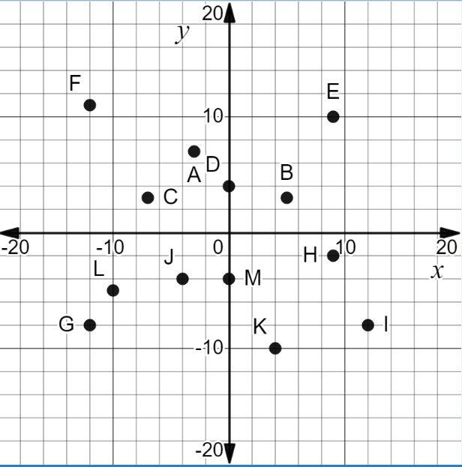

SOL G.12 - Just in Time Quick Check Teacher Notes
Common Errors/Misconceptions and their Possible Indications

            - An equation of a circle is $(x-3)^{2}+(y+5)^{2}=24.$ State the center and radius of the circle.

A common error a student may make is identifying the center as (-3, 5). This may indicate that the student does not understand that the coordinates of the center of the circle are actually the opposite sign of the values they see in the parenthesis since the standard form of the equation of a circle is $(x-h)^{2}+(y-k)^{2}= r^{2}.$ In addition, a student may also assume the radius of the circle is 24 instead of $2\sqrt{6}$ because he/she did not take the square root of 24. Teachers should encourage students to graph the equation of the circle in a graphing calculator or Desmos to help verify the center and radius of the circle. Teachers should consider using the Desmos Intro to Circles activity to get students more comfortable with identifying the center and radius of a circle given an equation or graph of circle.

            - The center of circle C is at (-3, 9). The point D (10, 5) lies on the circle.

- Write the equation of the circle.
A common error a student may make is assuming the equation of the circle is $(x-3)^{2}+(y-9)^{2}=185.$ This may indicate that the student assumes that the addends are always written as $\left(x- \right)$ and $(y-)$. Other students may get the addends correct but get the radius incorrect. Teachers are encouraged to use the Mathematics Instructional Plan- Circles in the Coordinate Plane to help students become comfortable with identifying the center of a circle and its radius. The circle equation word wall card may also be a useful reference for students.

- State the diameter of the circle.
A common misconception a student may make is to state the diameter is 370 or $\sqrt{370}$. If the student states the diameter is $370$, then this may indicate that the student has failed to find the radius prior to multiplying by 2. If the student states the diameter is $\sqrt{370}$, this may indicate the student struggles with doubling a radical. Teachers may have students make comparisons between what students have identified as the radius and the diameter to see if the relationship makes sense. For more visual learners, it may be useful to graph the coordinates of the center of the circle and the point of the circle. Then, the students can find the missing endpoint graphically to create the diameter and use Pythagorean Theorem to find the length of the diameter of the circle.

            - Write the equation of a circle with endpoints of the diameter located at (-6, 1) and (4,-9).

A common error a student may make is to state the radius squared equals $200$. This may indicate that the student used the length of the diameter as the radius. A review of the relationship between the radius and the diameter along with the formulas a student needs to use to find the center and radius may be helpful for students that struggle getting started on this problem. Teachers are also encouraged to have students graph the coordinates of the diameter to allow students the opportunity to solve for the radius and center graphically. EmediaVA’s Geometry Module 11, Topic 3 is a valuable resource for teachers to reference.

            - Depending on its strength, an earthquake can be felt in locations miles away from the epicenter.
Suppose that the epicenter of the earthquake is located at the point (4, -2) and is felt up to 10 miles away. Using a graphing utility or Desmos, state the letters of the locations that are affected using the equation of a circle.
A common error a student may make is not to include the letter I because it is on the circle with the center (4,-2) and radius 10. This may indicate that the student does not consider a point on the circle to be a part of the affected area. Teachers are encouraged to use the Shake, Rattle, and Roll task that exposes students to circles in a real-world situation. It may also be helpful to have a class discussion of what an affected area includes. Furthermore, graphing the scenario on paper or in Desmos may assist students in answering this type of question.

