Just In Time Quick Check
Standard of Learning (SOL) G.11d
Strand: Polygons and Circles

Standard of Learning (SOL) G.11d
The student will solve problems, including practical problems, by applying properties of circles. This will include determining area of a sector.

Grade Level Skills:
- Solve problems, including practical problems, by applying properties of circles.
- Calculate the area of a sector.

Just in Time Quick Check

Just in Time Quick Check Teacher Notes

Supporting Resources:
- VDOE Mathematics Instructional Plans (MIPS)
  - G.11cd - Arc Length and Area of a Sector (Word) / PDF Version
- VDOE Word Wall Cards: Geometry (Word)|(PDF)
  - Circle
  - Central Angle
  - Measuring Arcs
  - Area of a Sector
- Other VDOE Resources
  - Geometry, Module 10, Topic 9 - Calculating the Area of a Sector (eMediaVA)
Supporting and Prerequisite SOL: A.4a, A.4e, 7.3, 6.7b

SOL G.11d - Just in Time Quick Check

- Sarah and Jamir each ordered their favorite pizza. Sarah’s favorite pizza had a radius of 6 inches. She cut her pizza into 6 equal slices and ate 3 of the slices. Jamir’s favorite pizza had a diameter of 12 inches. He cut his pizza into 8 equal slices and ate 4 of the slices.
  - What is the area, to the nearest square inch, of pizza that Sarah ate?

  - What is the area, to the nearest square inch, of pizza that Jamir ate?

  - Who ate more pizza, Sarah or Jamir? Explain your thinking.

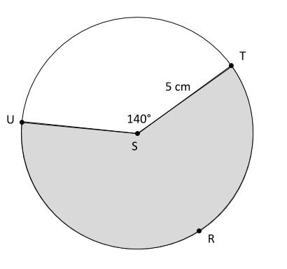
- Given Circle S, what is the area of the shaded sector, to the nearest square centimeter?

SOL G.11d - Just in Time Quick Check Teacher Notes
Common Errors/Misconceptions and their Possible Indications

- Sarah and Jamir each ordered their favorite pizza. Sarah’s favorite pizza had a radius of 6 inches. She cut her pizza into 6 equal slices and ate 3 of the slices. Jamir’s favorite pizza had a diameter of 12 inches. He cut his pizza into 8 equal slices and ate 4 of the slices.
  - What is the area, to the nearest square inch, of pizza that Sarah ate?
A common error that some students will make is using the circumference of the pizza rather than the area. Other students may find the total area, but not find the area of three slices. Some students may struggle because there is not a central angle provided in the question. Each common error indicates that the student does not understand the proportional relationship between the area of a circle and the area of a sector. These students may benefit from drawing a figure to represent the pizza and the amount eaten, or from using manipulatives such as pattern blocks to provide a visual representation of the information.
  - What is the area, to the nearest square inch, of pizza that Jamir ate?
In addition to the common errors listed in part (a), students may also misuse the diameter as the radius. This may indicate that students lack understanding of geometric vocabulary or how to label using the correct geometric markings when given information about a circle. Teachers may find it helpful to incorporate vocabulary and geometric markings in a variety of activities, including referencing the VDOE Word Wall Cards.
  - Who ate more pizza, Sarah or Jamir? Explain your thinking.
A common misconception that some students may have is that Jamir must have eaten more pizza since he ate more slices. This indicates that these students do not understand the proportional relationship between the area of a circle and the area of a sector. These students may not have made the connection that the circles are congruent and the fractions are equivalent. It may be helpful to create a diagram using a dynamic geometry tool in order to help illustrate these equivalent relationships. The Cake Problem in the G.11cd MIPS may also extend students’ thinking in this type of problem.
- Given Circle S, what is the area of the shaded sector, to the nearest square centimeter?
A common error that some students make is finding the area of the unshaded sector. This may indicate that students may not know that they need to find the central angle that corresponds to the shaded sector. The teacher may wish to arrange a class activity where the class is broken into thirds and each third solves 3 problems, each addressing a different sized circle – 1) circle area 2) sector area that corresponds to a major arc and 3) sector area that corresponds to the remaining minor arc. A class discussion could follow focusing on the relationships between those 3 solutions, finding for each circle that the sum of the areas of the 2 sectors is equal to the total circle area.

