Just In Time Quick Check
Standard of Learning (SOL) G.11c
Strand: Polygons and Circles

Standard of Learning (SOL) G.11c
The student will solve problems, including practical problems, by applying the properties of circles. This will include determining arc length.

Grade Level Skills:
- Solve problems, including practical problems, by applying properties of circles.
- Calculate the length of an arc of a circle.

Just in Time Quick Check

Just in Time Quick Check Teacher Notes

Supporting Resources:
- VDOE Mathematics Instructional Plans (MIPS)
  - G.11cd - Arc Length and Area of a Sector (Word) / PDF Version
- VDOE Word Wall Cards: Geometry (Word)|(PDF)
  - Circle
  - Central Angle
  - Measuring Arcs
  - Arc Length
- Other VDOE Resources
  - Geometry, Module 10, Topic 8 - Calculating the Length of an Arc (eMediaVA)
Supporting and Prerequisite SOL: A.4a, A.4e, 7.3, 6.7b

SOL G.11c - Just in Time Quick Check

- Carlos bought a pizza that is cut into 8 slices. The pizza has a radius of 10 cm. What is the arc length, to the nearest centimeter, for one slice?
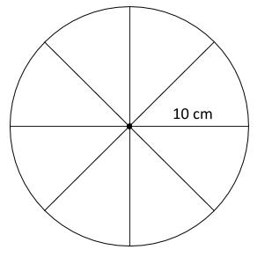

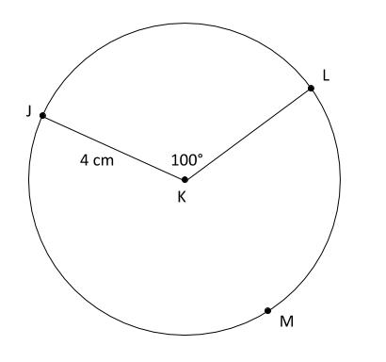

- Given Circle K, what is the arc length, to the nearest centimeter, of $\hat{JML}$?

- Steve has a circle with a diameter of 4 inches and a central angle of 90 degrees. Tiana has a circle with a radius of 2 inches that is divided into 4 congruent sectors.
  - Draw and label Steve and Tiana’s circles.

  - Compare the arc lengths between the sector created by the 90° central angle in Steve’s circle and one sector in Tiana’s circle. Explain your thinking.

SOL G.11c - Just in Time Quick Check Teacher Notes
Common Errors/Misconceptions and their Possible Indications

- Carlos bought a pizza that is cut into 8 slices. The pizza has a radius of 10 cm. What is the arc length, to the nearest centimeter, for one slice?

A common error that some students will make is using the area of the pizza rather than the circumference. Other students may find the total circumference, but fail to divide by 8. Some students may also try to use 8° since there is not a central angle provided in the question. Each common error indicates that the student does not understand the proportional relationship between the circumference of a circle and the arc length of a sector. One teaching strategy would be to go back to more common portions of circles, like halves or quarters in order to emphasize this proportional relationship.
- Given Circle K, what is the arc length, to the nearest centimeter, of $\hat{JML}$?

A common error is finding the arc length of the minor arc $\hat{JL}$ instead of the major arc $\hat{JML}$. This may indicate that students may not recognize the difference between the naming conventions of major and minor arcs. The teacher could arrange a class activity where the class is broken into thirds and each third solves 3 problems each addressing a different sized circle – 1) circumference 2) length of a major arc 3) length of the remaining minor arc. Discussion could follow focusing on the relationships between those 3 solutions, finding for each circle that the minor arc length + major arc length = circumference.

- Steve has a circle with a diameter of 4 inches and a central angle of 90°. Tiana has a circle with a radius of 2 inches that is divided into 4 congruent sectors.
  - Draw and label Steve and Tiana’s circles.
Common errors for some students are drawing Steve’s circle with a radius of 4 inches and not labeling the congruent sectors in Tiana’s circle. This may indicate that students lack understanding of geometric vocabulary or how to label using the correct geometric markings given information about a circle. Teachers may find it helpful to incorporate vocabulary and geometric markings in a variety of activities, including referencing the VDOE Word Wall Cards.

  - Compare the arc lengths between the sector created by the 90° central angle in Steve’s circle and one sector in Tiana’s circle. Explain your thinking.
A common misconception is that the arc lengths in Steve and Tiana’s circles are different lengths. The diagram drawn in part (a) may give greater insight into the reason behind this misconception. For some students, it may be a circle drawn and labeled incorrectly, while others may fail to recognize that $\frac{1}{4}$ and $\frac{90}{360}$ are equivalent portions of the circle. Students may benefit from physically constructing this problem, starting with a compass to create the circles and using the perpendicular bisector or angle bisector constructions to create the sectors according to the descriptions of Steve and Tiana’s circles and then physically cut the sectors apart to compare the arc lengths.

