Just In Time Quick Check
Standard of Learning (SOL) G.11b
Strand: Polygons and Circles

Standard of Learning (SOL) G.11b
The student will solve problems, including practical problems, by applying properties of circles. This will include determining lengths of segments formed by intersecting chords, secants, and/or tangents.

Grade Level Skills:
- Solve problems, including practical problems, by applying properties of circles.
- Determine segment lengths associated with:
  - two intersecting chords;
  - two intersecting secants;
  - an intersecting secant and tangent; and
  - two intersecting tangents.

Just in Time Quick Check

Just in Time Quick Check Teacher Notes

Supporting Resources:
- VDOE Mathematics Instructional Plans (MIPS)
  - G.11ab - Angles, Arcs, and Segments (Word) / PDF Version
- VDOE Word Wall Cards: Geometry (Word)|(PDF)
  - Circle
  - Lines and Circles
  - Tangent
  - Segments in a Circle
  - Segments of Secants Theorem
  - Segments of Secants and Tangents Theorem
- Other VDOE Resources
  - Geometry, Module 10, Topic 4 - Finding the Lengths of Intersecting Chords (eMediaVA)
  - Geometry, Module 10, Topic 5 - Finding the Lengths of Intersecting Secants (eMediaVA)
  - Geometry, Module 10, Topic 6 - Finding the Lengths of Intersecting Secants and Tangents (eMediaVA)
  - Geometry, Module 10, Topic 7 - Finding the Lengths of Intersecting Tangents (eMediaVA)
Supporting and Prerequisite SOL: G.4a, G.7, A.4a, A.4e, 7.3

SOL G.11b - Just in Time Quick Check
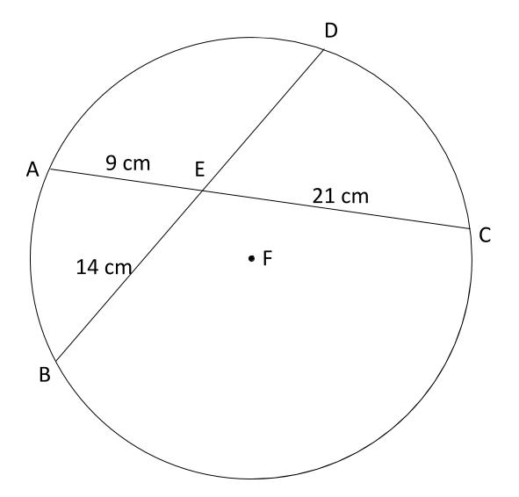
- Chords $\overline{AC}$ and $\overline{DB}$ intersect at point E. What is the length of $\overline{DB}$?

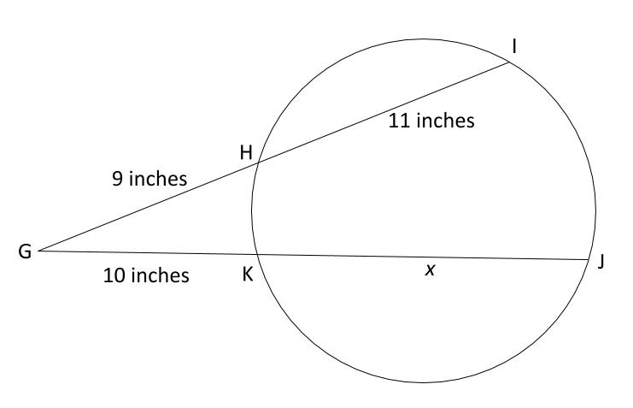
- Secant lines $\overline{GI}$ and $\overline{GJ}$ intersect at point G. What is the length of $\overline{KJ}$?

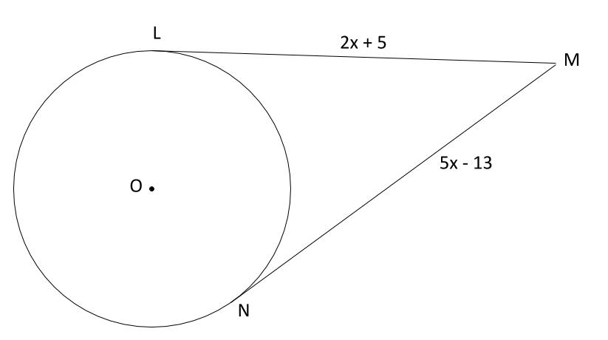
- Sarah is in her car at point M. She needs to reach the city represented by circle O by either the road represented by tangent segment $\overline{LM}$ or the road represented by the tangent segment $\overline{NM}$. How many miles until Sarah reaches the city?

SOL G.11b - Just in Time Quick Check Teacher Notes
Common Errors/Misconceptions and their Possible Indications
- Chords $\overline{AC}$ and $\overline{DB}$ intersect at point E. What is the length of $\overline{DB}$?

A common error that some students may make is believing that $\overline{AC}$ is the same length as $\overline{DB}.$ This error would lead these students to find the length of DE as 16 and the length of $\overline{DB}$as 30. Other students may correctly find the length of $\overline{DE}$ but not use it to find $\overline{DB}$. This may indicate that students either have not read the question carefully or they do not understand the distinction between finding the length of part of a line segment versus finding the length of a whole line segment. If students are struggling with the formula, the Mathematics Instructional Plan for G.11ab provides instructions for students to develop these formulas with the use of dynamic geometry tools.
- Secant line segments $\overline{GI}$ and $\overline{GJ}$ intersect at point G. What is the length of $\overline{KJ}$?

A common misconception that some students may have is that this type of problem should be solved using the same formula as the previous problem. This may indicate that the student does not understand that the formula originates from comparing the side lengths of a pair of overlapping similar triangles. For help in developing this understanding, teachers may want to use the Mathematics Instructional Plan for G.11ab. Teachers and students could also reference the VDOE Geometry Word Wall Card for the Segments of Secants Theorem.

- Sarah is in her car at point M. She needs to reach the city represented by circle O using either the road represented by tangent segment $\overline{LM}$ or the road represented by the tangent segment $\overline{NM}$. How many miles is it from Point M to the city?

A common error that some students may make is to solve for the value of x but not substitute back into either expression to determine the actual distance. This may indicate that students recognize two tangents as a special circumstance of congruence, but fail to use the context of the problem to find the desired solution. Teachers may wish to provide similar contextualized problems using this special property of two tangents as a chance to allow students to use their problem solving skills. This is an opportunity to also review congruent triangles and prove congruent triangles (in this case, $∆LOM≅∆NOM$) then use congruent parts to prove that the tangent segments must be congruent. The Mathematics Instructional Plan for G.11ab could also be used to develop this property with the use of a dynamic geometry tool.

