Just In Time Quick Check
Standard of Learning (SOL) G.11a
Strand: Polygons and Circles

Standard of Learning (SOL) G.11a
The student will solve problems, including practical problems, by applying properties of circles. This will include determining angle measures formed by intersecting chords, secants, and/or tangents.

Grade Level Skills:
- Solve problems, including practical problems, by applying properties of circles.
- Determine angle measures and arc measures associated with::
  - two intersecting chords;
  - two intersecting secants;
  - an intersecting secant and tangent;
  - two intersecting tangents; and
  - central and inscribed angles.

Just in Time Quick Check

Just in Time Quick Check Teacher Notes

Supporting Resources:
- VDOE Mathematics Instructional Plans (MIPS)
  - G.11ab - Angles, Arcs, and Segments (Word) / PDF Version
- VDOE Word Wall Cards: Geometry (Word)|(PDF)
  - Circle
  - Lines and Circles
  - Secant
  - Tangent
  - Central Angle
  - Measuring Arcs
  - Secants and Tangents
  - Inscribed Angle
  - Inscribed Angle Theorem 1
  - Inscribed Angle Theorem 2
  - Inscribed Angle Theorem 3
- Other VDOE Resources
  - Geometry, Module 10, Topic 1 - Angles Formed by Intersections in the Interior of a Circle (eMediaVA)
  - Geometry, Module 10, Topic 2 - Angles Formed by Intersections in the Exterior of a Circle (eMediaVA)
  - Geometry, Module 10, Topic 3 - Central and Inscribed Angles (eMediaVA)
Supporting and Prerequisite SOL: A.4a, A.4e, 8.5, 7.3

SOL G.11a - Just in Time Quick Check
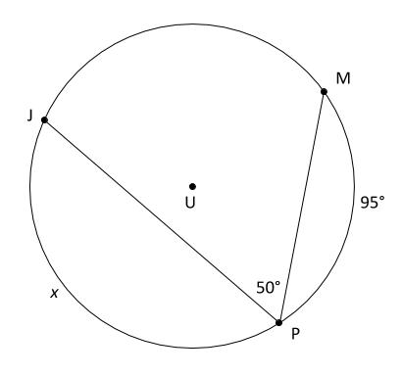
- Given: Circle U, what is the value of x?

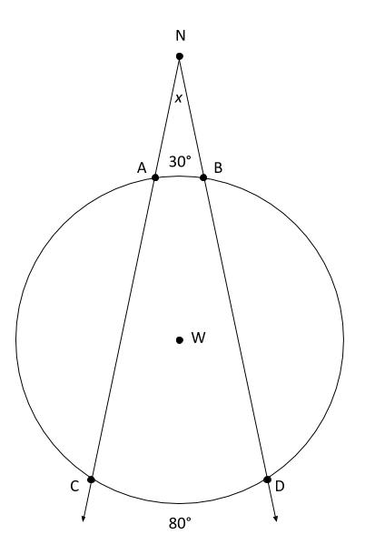

- A circular mirror is hung from a nail by two strings. The nail is represented by point N and the strings are represented by $\vec{NC}$ and $\vec{ND}$. What is the measure in degrees, x, of the angle formed by the two strings?

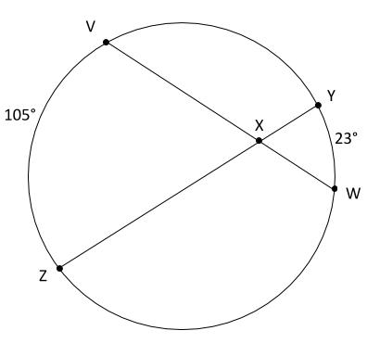
- Chords $\overline{VW}$ and $\overline{YZ}$ intersect at point X in the circle shown. What is the measure of ∠VXZ?

SOL G.11a - Just in Time Quick Check Teacher Notes
Common Errors/Misconceptions and their Possible Indications
- Given: Circle U, what is the value of x?

A common error students may make is using 50° as the measure of $\hat{JM}$. This may indicate that students have confused the method to calculate the measure of a central angle and an inscribed angle. Students may benefit from using a dynamic geometry tool in order to examine a wide array of examples of inscribed angles. The MIPS plan for G.11ab provides some directions to help lead this investigation. A simple manipulative can also be made out of a paper plate, a rubber band and brads to help students visualize the difference between an inscribed angle and central angle that intercept the same arc. The VDOE Vocabulary Word Wall Cards may also help to provide a visual reminder to students of the difference between these two types of angles.

- A circular mirror is hung from a nail by two strings. The nail is represented by point N and the strings are represented by $\vec{NC}$ and $\vec{ND}$. What is the measure in degrees, x, of the angle formed by the two strings?

A common misconception that some students may have is that the measure of the angle is the average of the two arcs. This may indicate that they cannot recognize the difference between lines that intersect to create an angle inside the circle versus lines that intersect to create an angle outside of the circle. The Mathematics Instructional Plan for G.11ab provides instructions for students to develop these formulas with the use of dynamic geometry tools.

- Chords $\overline{VW}$ and $\overline{YZ}$ intersect at point X in the circle shown. What is the measure of ∠VXZ?

A common misconception that some students may have is thinking that ∠VXZ is a central angle. This misconception demonstrates that students do not understand the definition of a central angle. Teachers may wish to use the VDOE Word Wall Cards to reinforce this definition. The Mathematics Instructional Plan for G.11ab can also be used to help further help develop vocabulary in context.

