Just In Time Quick Check
Standard of Learning (SOL) G.10b
Strand: Polygons and Circles

Standard of Learning (SOL) G.10b
The student will solve problems, including practical problems, involving angles of convex polygons. This will include determining the measure of an interior and/or exterior angle.

Grade Level Skills:
- Solve problems, including practical problems, involving angles of convex polygons.
- Determine the measure of each interior and exterior angle of a regular polygon.
- Determine angle measures of a regular polygon in a tessellation.

Just in Time Quick Check

Just in Time Quick Check Teacher Notes

Supporting Resources:
- VDOE Mathematics Instructional Plans (MIPS)
  - G.10a-c - Angles in Polygons (Word) / PDF Version
- VDOE Word Wall Cards: Geometry (Word)|(PDF)
  - Polygon Exterior Angle Sum Theorem
  - Polygon Interior Angle Sum Theorem
  - Regular Polygon
- Other VDOE Resources
  - Geometry, Module 9, Topic 1 - Interior Angles of a Polygon (eMediaVA)
  - Geometry, Module 9, Topic 2 - Exterior Angles of a Polygon (eMediaVA)
Supporting and Prerequisite SOL: G.10a, 8.5

SOL G.10b - Just in Time Quick Check

- Juanita has a regular polygon with 15 sides. Juanita knows how to find the sum of the interior angles, but is not sure how to find the measure of just one interior angle. Describe how Juanita could use the sum of the measures of the interior angles to find the measure of one of the interior angles.

- Given a regular quadrilateral and a regular pentagon with a shared side, determine the value of y. Explain your thinking.
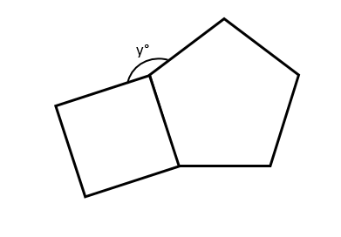

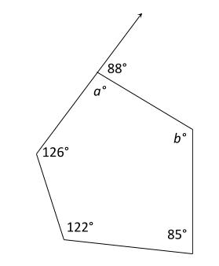
- Determine the values of a and b in the figure. Explain your thinking.

SOL G.10b - Just in Time Quick Check Teacher Notes
Common Errors/Misconceptions and their Possible Indications

- Juanita has a regular polygon with 15 sides. Juanita knows how to find the sum of the interior angles, but is not sure how to find the measure of just one interior angle. Describe how Juanita could use the sum of the measures of the interior angles to find the measure of one of the interior angles.

A common error that some students may make is to divide the sum of the measures of all of the interior angles by 13 (using n – 2) to find the measure of one angle. This may indicate that students may not recognize how many angles are in a given polygon. Students with this misconception may find it helpful to go back to a more familiar case, such as a triangle or a quadrilateral, to emphasize the equivalent relationship between the number of sides and number of angles in a polygon. A secondary strategy would be to discuss using the exterior angle sum theorem in order to find an interior angle.

- Given a regular quadrilateral and a regular pentagon with a shared side, determine the value of y. Explain your thinking.
The most common error may occur when students do not remember how to find the measure of an interior angle of a regular polygon correctly. Most students will be able to find the interior angle of the quadrilateral as 90 degrees, but these same students may have difficulty finding the interior angle of a pentagon. Some students may attempt to divide 360 by 5 to find this angle. Another common error that some students may make is not recognizing that the sum of the angle measures of y°, 90°, and 108° is 360°. Teachers could use dynamic software to emphasize that angles at a vertex must have a sum of 360°.

- Determine the values of a and b in the figure. Explain your thinking.
A common error that students may make is not to recognize that determining the value of a requires them to use the given exterior angle measure. This error may indicate that students need additional practice identifying linear pair relationships. Students may benefit from seeing a wide variety of examples of linear pairs, especially in combination with other types of geometric figures. Consult the word wall cards as a reference to help build student understanding. Students who find the value of a correctly may still have difficulty finding the value of b if they aren’t able to find the sum of the angles of a pentagon correctly. These students would also benefit from using the word wall cards as a reference. Teachers may also wish to give students the opportunity to manipulate different types of polygons with the interior and exterior angles labeled on dynamic software like Desmos or Geogebra.

