Just In Time Quick Check
Standard of Learning (SOL) G.8a
Strand: Triangles

Standard of Learning (SOL) G.8a
The student will solve problems, including practical problems, involving right triangles. This will include applying the Pythagorean Theorem and its converse.

Grade Level Skills:
- Solve problems, including practical problems, using right triangle trigonometry and properties of special right triangles.
- Determine whether a triangle formed with three given lengths is a right triangle.

Just in Time Quick Check

Just in Time Quick Check Teacher Notes

Supporting Resources:
- VDOE Mathematics Instructional Plans (MIPS)
  - G.8a – The Pythagorean Relationship (Word) / PDF Version
- VDOE Word Wall Cards: Geometry (Word)|(PDF)
  - Pythagorean Theorem
- VDOE Rich Mathematical Tasks: Take Me Out to the Ball Game Task
  - G.8 Take Me Out to the Ball Game (Word) / PDF Version
- Other VDOE Resources
  - Geometry, Module 7, Topic 1 – The Pythagorean Theorem [eMediaVA]
  - Geometry, Module 7, Topic 2 – Converse of the Pythagorean Theorem [eMediaVA]
Supporting and Prerequisite SOL: G.1a, G.1c, A.3a, 8.3b, 8.9a, 8.9b

SOL G.8a - Just in Time Quick Check

- A player throws a baseball from second base to home plate. What is closest to the distance between second base and home plate? Round your answer to the nearest foot.

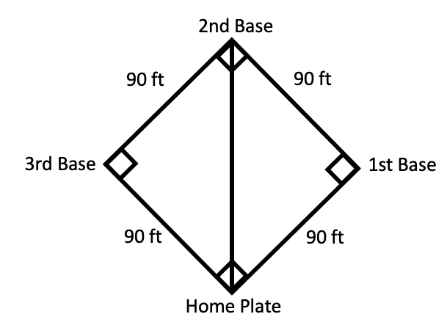

- Find the value of x to the nearest centimeter.

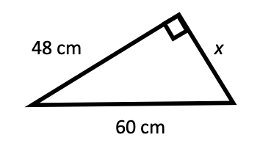

- Determine whether a triangle with side lengths $\sqrt{3}$ cm, $\sqrt{4}$ cm, $\sqrt{5}$ cm is a right triangle. Explain your reasoning.

- A door frame that appears to be rectangular has a height of 213 cm, width of 92 cm, and one diagonal that measures 231 cm. Determine if the door frame is rectangular. Explain your thinking.
A

SOL G.8a - Just in Time Quick Check Teacher Notes
Common Errors/Misconceptions and their Possible Indications

- A player throws a baseball from second base to home plate. What is closest to the distance between second base and home plate? Round your answer to the nearest foot.

A common error students may make is not squaring the values once they are substituted in the Pythagorean Theorem formula. This may indicate that some students think the formula is a + b = c. In this particular case, some students may add 90 + 90 and then try to take the square root of 180. Teachers are encouraged to use Quick Check 8.9b with students that might exhibit this type of error. A strategy that could be beneficial to use with students is to model the relationship between the legs and hypotenuse of a right triangle using concrete manipulatives or dynamic software to illustrate the Pythagorean Theorem. Additionally, it may be beneficial to use Quick Check 8.9a to verify the Pythagorean Theorem.

- Find the value of x to the nearest centimeter.

A common error some students may make is confusing the hypotenuse for the leg of the triangle. Students who are confused will place the unknown variable in the position of the hypotenuse regardless of which side it represents. This would lead a student to set up an equation to solve for the missing side as ${48}^{2}+{60}^{2}=a^{2}$. Further, some students may not recognize the appropriate values in which to substitute into the Pythagorean Theorem formula (e.g., leg lengths as “a” and “b” and hypotenuse as “c”). This may indicate that some students are not aware that the hypotenuse is always opposite the right angle of a right triangle. Students may benefit from performing activities with concrete manipulatives and dynamic software to learn about the relationship between the sum of the squares of the two legs and the square of the hypotenuse in a right triangle.

- Determine whether a triangle with side lengths $\sqrt{3}$ cm, $\sqrt{4}$ cm, $\sqrt{5}$ cm is a right triangle. Explain your reasoning.

A common misconception that some students may have is not applying the Converse of the Pythagorean Theorem. This may indicate that students do not understand that since the square of the length of the longest side is the sum of the squares of the other two sides, by the Converse of Pythagorean Theorem, the triangle is a right triangle. Further, a common error that students may make is recognizing that a 3, 4, 5 triangle is a common right triangle (Pythagorean Triple), yet make the assumption that the square roots of these three numbers will also form a right triangle. Teachers are encouraged to have students investigate the Pythagorean Triples and make generalizations about those lengths.

- A door frame that appears to be rectangular has a height of 213 cm, width of 92 cm, and one diagonal that measures 231 cm. Determine if the door frame is rectangular. Explain your thinking.

A common misconception that some students may have is not recognizing that the diagonal of a rectangle forms two congruent right triangles within this rectangle. This may indicate that some students do not recognize that the diagonal represents the hypotenuse of the two right triangles. Teachers should encourage students to draw a diagram and label all of the given information provided before attempting to set up an equation to solve the problem. Being able to visualize the scenario will help students to see how the Pythagorean Theorem can be applied.

