Just In Time Quick Check
Standard of Learning (SOL) G.7
Strand: Triangles

Standard of Learning (SOL) G.7
The student, given information in the form of a figure or statement, will prove two triangles are similar.

Grade Level Skills:
- Prove two triangles similar given relationships among angles and sides of triangles expressed numerically or algebraically.
- Prove two triangles similar given representations in the coordinate plane and using coordinate methods (distance formula and slope formula).
- Use direct proofs to prove triangles similar.

Just in Time Quick Check

Just in Time Quick Check Teacher Notes

Supporting Resources:
- VDOE Mathematics Instructional Plans (MIPS)
  - G.7 – Similar Triangles (Word) / PDF Version
- VDOE Word Wall Cards: Geometry (Word)|(PDF)
  - Similar Polygons
  - Similar Polygons and Proportions
  - AA Triangle Similarity Postulate
  - SAS Triangle Similarity Theorem
  - SSS Triangle Similarity Theorem
- Other VDOE Resources
  - Geometry, Module 6 – Similar Triangles [eMediaVA]
Supporting and Prerequisite SOL: G.1c, G.3a, G.6, 8.5, 7.5, 7.3

SOL G.7 - Just in Time Quick Check

- What value of x will prove $∆BAC \sim ∆DAE$? Explain your answer.
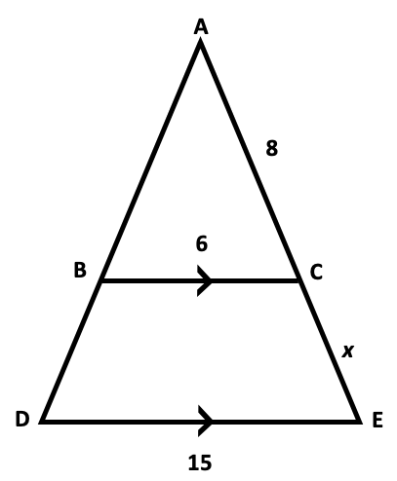

- Triangle PQR is shown.

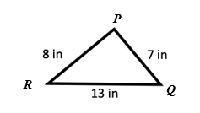

Triangle ABC is similar to triangle PQR. Determine the side lengths of triangle ABC.

- What additional information is needed to prove the two triangles are similar by SAS?
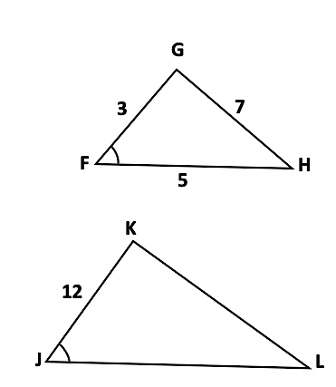
- Complete the following proof.

Given: $∠A ≅ ∠B$.
Prove: $∆ACE\sim ∆BCD$

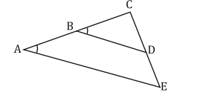

Statements | Reasons
1. $∠A≅∠B$ | 1. Given
2. | 2.
3. $∆ACE\sim ∆BCD$ | 3. AA Triangle Similarity Triangle Postulate

5. Determine if $∆ABC\sim ∆ONM$. If so, give the reason and explain your thinking.

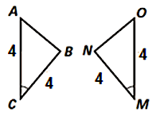

6. Determine if $∆ABC\sim ∆DBA$. Explain your thinking.
A

SOL G.7 - Just in Time Quick Check Teacher Notes
Common Errors/Misconceptions and their Possible Indications

- What value of x will prove $∆BAC \sim ∆DAE$? Explain your answer.

A common error that some students may make is to set up the proportion as $\frac{6}{15}=\frac{8}{x}$. While students are able to associate the corresponding sides correctly, setting up a proportion in this manner may indicate that students do not recognize the part-whole relationship between $∆ABC$ and $∆ADE$. To help students see the difference between part-whole and whole-whole comparisons, teachers should encourage students to separate and sketch the two triangles prior to setting up the proportion. In this manner, students will be able to visualize the three pairs of corresponding sides. Use of dynamic Geometry software, may also be beneficial to students when modeling corresponding sides of similar triangles.

- Triangle PQR is shown.

Triangle ABC is similar to triangle PQR. Determine the side lengths of triangle ABC.

A common error that some students may make is using an additive relationship to form the lengths of triangle ABC (i.e., a student adds 3 to each side of the triangle shown). This may indicate that some students do not understand that to create triangle ABC similar to the given triangle, the measures of the corresponding sides must be proportional. Teachers should consider incorporating instructional activities, such as copying similar triangles onto tracing paper and rotating them so each has the same orientation. Doing this may help students understand that similar triangles are created using dilations and similarity does not depend on the position of the triangles.

- What additional information is needed to prove the two triangles are similar by SAS?
A common error some students may make is to state that $\overline{KL}=28$ as the additional information required because it will give them a scale factor 1:4 – same as $\overline{FG}$ : $\overline{JK}$. This may indicate that some students understand corresponding sides of similar triangles are proportional. However, students do not understand that two triangles can only be proven similar using one of the following criteria: Side-Angle-Side (SAS), Side-Side-Side (SSS), and Angle-Angle (AA).

Alternatively, students may state that $\overline{KL}=28$ as the additional information because they are not able to differentiate an included angle from a non-included angle. Thus, they are not able to apply the criterion SAS correctly. Since the pictures do not align perfectly, it may be a good idea for students to re-draw the two triangles so that the corresponding parts are in the same position.

- Complete the following proof.

Given: $∠A ≅ ∠B$.
Prove: $∆ACE\sim ∆BCD$

Statements | Reasons
1. $∠A≅∠B$ | 1. Given
2. | 2.
3. $∆ACE\sim ∆BCD$ | 3. AA Triangle Similarity Triangle Postulate

A common error that students may make is incorrectly identifying $∠E≅∠D$ by corresponding angles as their statement and reason for step #2. This may indicate that some students recognize corresponding angles, but overlook that they have not stated line BD is parallel to line AE because corresponding angles are congruent. Students would then have to state that $∠E$ and $∠D$ are congruent because of the parallel lines.
Additionally, students may not recognize that $∠ACE≅∠BCD$ by reflexive property. To address these concerns, teachers should review with students all angle pair relationships created by parallel lines and a transversal. Teachers should focus on the definition of the reflexive property. While the reflexive property is used for sides in Geometry proofs, it is not productive to have students to associate reflexive property with “shared side” only. Furthermore, teachers should encourage students to sketch and separate the two triangles, then color-code the corresponding parts so that students will be able to visualize the reflexive angles.

- Determine if $∆ABC\sim ∆ONM$. If so, give the reason and explain your thinking.

A common misconception that some students may have is to conclude that the two given triangles are not similar simply because the two triangles are congruent. This indicates that students are not considering a scale factor of 1 for corresponding sides as proportional. It is crucial for teachers to create opportunities for students to have meaningful class discussions as to why congruent figures are similar, but similar figures are not necessarily congruent to strengthen students’ understanding of congruence and similarity.

- Determine if $∆ABC\sim ∆DBA$. Explain your thinking.

Some students may conclude that $∆ABC$ and $∆DBA$ are similar because the two triangles appear to have the same shape but different sizes. This may indicate that students have not considered using coordinate methods to determine if the two triangles are similar. Teachers may wish to ask, “What information do we need in order to prove two triangles similar?” Students will likely answer angles and/or sides. Teachers are encouraged to follow up with questioning techniques on how the side lengths can be determined from the information provided.

