Just In Time Quick Check
Standard of Learning (SOL) G.6
Strand: Triangles

Standard of Learning (SOL) G.6
The student, given information in the form of a figure or statement, will prove two triangles are congruent.

Grade Level Skills:
- Prove two triangles congruent given relationships among angles and sides of triangles expressed numerically or algebraically.
- Prove two triangles congruent given representations in the coordinate plane and using coordinate methods (distance formula and slope formula).
- Use direct proofs to prove two triangles congruent.

Just in Time Quick Check

Just in Time Quick Check Teacher Notes

Supporting Resources:
- VDOE Mathematics Instructional Plans (MIPS)
  - G.6 – Congruent Triangles? (Word) / PDF Version
- VDOE Word Wall Cards: Geometry (Word)|(PDF)
  - Congruent Triangles
  - SSS Triangle Congruence Postulate
  - SAS Triangle Congruence Postulate
  - HL Right Triangle Congruence
  - ASA Triangle Congruence Postulate
  - AAS Triangle Congruence Theorem
- Other VDOE Resources
  - Geometry, Module 5 – Congruent Triangles [eMediaVA]
- Desmos Activity
  - Congruent Triangles
Supporting and Prerequisite SOL: G.1c, G.3a, G.4c, G.4d, G.4e, G.4f, 8.5, 7.7, 6.9

SOL G.6 - Just in Time Quick Check

- Given: $∠W$ and $∠Y$ are right angles; $\overline{VW}$ $≅$ $\overline{ZY}$; X is the midpoint of $\overline{WY}$.
Prove: $∆VWX ≅ ∆ZYX$

Statements | Reasons
1. $∠W$ and $∠Y$ are right angles | 1.
2. $∠W$ $≅∠Y$ | 2. Definition of right angles
3. $\overline{VW}$ $≅$ $\overline{ZY}$; X is the midpoint of $\overline{WY}$ | 3.
4. | 4. Definition of midpoint
5.$∆VWX ≅ ∆ZYX$ | 5.

- Two triangles are given.
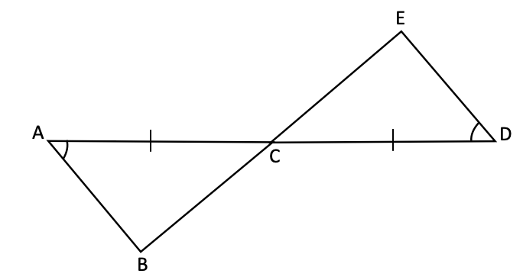
  - Is there sufficient information to prove these two triangles congruent? Explain.

  - If possible, create a congruency statement to indicate the two triangles are congruent.

- Quadrilateral PQSR is given. $\overline{PQ}∥\overline{RS}$ and $\overline{PR}∥\overline{QS}$. Determine which two triangles are congruent. Write a congruency statement. Provide your reasoning.

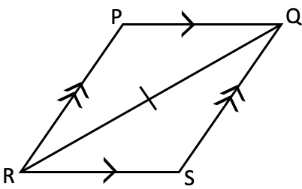

- Given: $∠MNP$ $≅$ $∠OPN$; $\overline{NM}$ $≅$ $\overline{PO}$.
Prove: $∠NMP ≅ ∠PON$

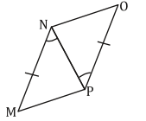
Statements | Reasons
1. $∠MNP$ $≅$ $∠OPN$ | 1. Given
2. $\overline{NM}$ $≅$ $\overline{PO}$ | 2. Given
3. | 3. Reflexive Property
4. $∆NMP≅ ∆PON$ | 4.
5. | 5.

- $∆TRP ≅ ∆QSP$. If $m∠T=41°$, $m∠R=33°$, and $m∠P=10x+6°$, find $m∠S$.

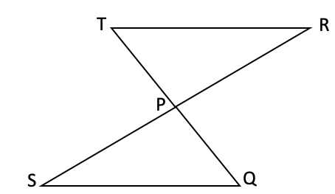
- Two triangles are shown on the coordinate grid. All vertices have coordinates that are integers. Determine if the triangles are congruent. Explain how you came to your conclusion. If the triangles are congruent, write a congruency statement.
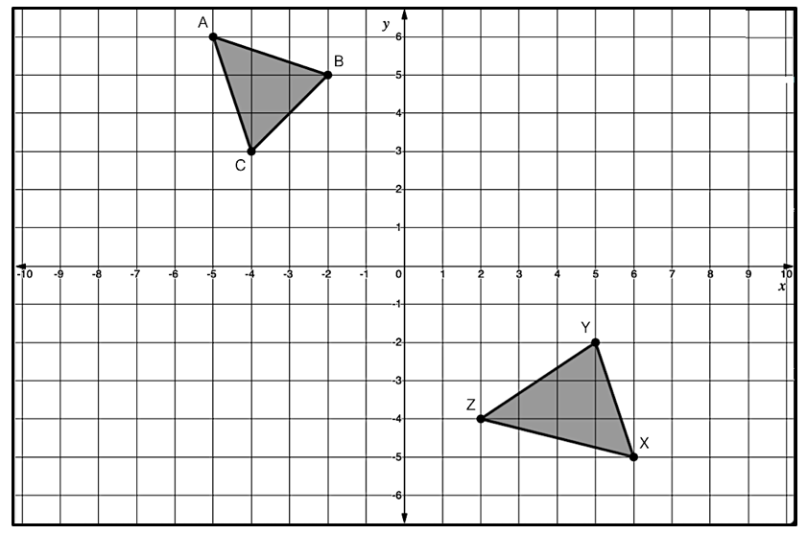

SOL G.6 - Just in Time Quick Check Teacher Notes
Common Errors/Misconceptions and their Possible Indications

- Given: $∠W$ and $∠Y$ are right angles; $\overline{VW}$ $≅$ $\overline{ZY}$; X is the midpoint of $\overline{WY}$.
Prove: $∆VWX ≅ ∆ZYX$

Statements | Reasons
1. $∠W$ and $∠Y$ are right angles | 1.
2. $∠W$ $≅∠Y$ | 2. Definition of right angles
3. $\overline{VW}$ $≅$ $\overline{ZY}$; X is the midpoint of $\overline{WY}$ | 3.
4. | 4. Definition of midpoint
5.$∆VWX ≅ ∆ZYX$ | 5.

A common error some students may make is to use the Hypotenuse-Leg (HL) Congruence method to prove the two given triangles congruent. This may indicate that some students do not understand the criteria of HL Right Triangle Congruence and may have associated HL Right Triangle Congruence with proving that any two triangles are congruent. Teachers should demonstrate the two criteria needed (i.e., the hypotenuse and leg of one right triangle must be congruent to the hypotenuse and leg of another right triangle) when introducing the HL Congruence to prove two right triangles are congruent. Teachers may consider using color coding for the two triangles and markings for corresponding pairs that are congruent in the diagram while completing the proof. Teachers may also consider modeling how to diagram the given information before working on the proof so that students may be able to visualize the given information and determine the appropriate statements, reasons, and conclusion to the proof.

- Two triangles are given.
  - Is there sufficient information to prove these two triangles congruent? Explain.

  - If possible, create a congruency statement to indicate the two triangles are congruent.

A common misconception some students may have is to think there is not enough information provided to prove the two triangles congruent. This may indicate that some students do not recognize that intersecting segments form a pair of vertical angles.
Other students may confuse the Angle-Side-Angle (ASA) Triangle Congruence Postulate with the Angle-Angle-Side (AAS) Triangle Congruence Theorem. This may indicate that some students are not able to differentiate the location of the congruent sides in the two triangles. Teachers should discuss with students the difference between an included side and a non-included side when introducing and teaching the ASA Triangle Congruence Postulate and AAS Triangle Congruence Theorem. Additionally, teachers may want to address why the AAS Triangle Congruence is sometimes referred as the SAA Triangle Congruence. The AAS Triangle Congruence Theorem begins with two consecutive angles and then moves on to the next side (in either direction). The SAA Triangle Congruence begins with the non-included side and then moves on the next two consecutive angles (in either direction).

- Quadrilateral PQSR is given. $\overline{PQ}∥\overline{RS}$ and $\overline{PR}∥\overline{QS}$. Determine which two triangles are congruent. Write a congruency statement. Provide your reasoning.

A common misconception some students may have is to use the Side-Angle-Side (SAS) Triangle Congruence Postulate to prove the two triangles congruent instead of the Angle-Side-Angle (ASA) Triangle Congruence Postulate. This may indicate that some students do not realize the markings of $\overline{PQ}$ and $\overline{RS}$ indicate parallelism and not congruence. Teachers should explicitly explain the different markings (the symbolic representations) that are used for congruence and parallelism. Further, since $\overline{PQ}∥\overline{RS}$, $\overline{QR}$ serves as the transversal creating alternate interior angles. Teachers should review with students the relationships of angle pairs formed by parallel lines and the transversal. In addition, teachers are encouraged to demonstrate that if two angles of one triangle and the included side are congruent to two angles and the included side of another triangle, then the two triangles must be congruent.

4. Given: $∠MNP$ $≅$ $∠OPN$; $\overline{NM}$ $≅$ $\overline{PO}$.
Prove: $∠NMP ≅ ∠PON$

Statements | Reasons
1. $∠MNP$ $≅$ $∠OPN$ | 1. Given
2. $\overline{NM}$ $≅$ $\overline{PO}$ | 2. Given
3. | 3. Reflexive Property
4. $∆NMP≅ ∆PON$ | 4.
5. | 5.

A common error some students may make is to use Corresponding Parts of Congruent Triangles are Congruent (CPCTC) as a reason in step #4 and not provide a statement or reason for #5. This may indicate that some students do not have an understanding of the definition of CPCTC. Rather, students believe that CPCTC is used to justify two triangles are congruent because they associate CPCTC as one of the methods to prove triangles congruent. Teachers should emphasize that CPCTC can only be used to show two angles or two sides (i.e., the corresponding parts) are congruent after two triangles are proven congruent. Teacher should consider writing out Corresponding Parts of Congruent Triangles are Congruent in various proofs to help students develop the concept before introducing its acronym. While CPCTC is commonly used at or near the end of a proof, teachers should not guide students to use it as a rule of thumb.

5. $∆TRP≅ ∆QSP$. If $m∠T=41°$, $m∠R=33°$, and $m∠P=10x+6°$, find $m∠S$.

A common error some students may make is to conclude $∠S≅∠T$ and $m∠S=41°$ because of the relative placement of the two triangles in the diagram. This may indicate that some students have not yet developed the concept of congruence as the result of rigid isometric transformations. It would be beneficial for teachers to have classroom discussions with students and incorporate instructional activities to highlight the meaning of congruence (does not depend on position) as well as the significance of the congruence statements. Students should be able to justify why the order of the letters is very important for congruence statements, as corresponding parts of congruent polygons must be written in the same order. An instructional strategy that may be beneficial is to color code the corresponding parts, ask students to match by color, and then explain the match using the correct correspondence. The measurement of $∠P$ is given but it is not necessarily needed to solve this problem. If students use it to solve for the measurement of $∠S,$ then it indicates that students do not have a solid understanding on the concept of vertical angles and/or they are confused with the mathematics expression given in the measurement of $∠P$.

6. Two triangles are shown on the coordinate grid. All vertices have coordinates that are integers. Determine if the
triangles are congruent. Explain how you came to your conclusion. If the triangles are congruent, write a congruency statement.

A common error some students may make is to conclude the two triangles are congruent by the Side-Side-Side (SSS) Triangle Congruence Postulate without providing any mathematical justifications. This may indicate that some students base such a conclusion on the appearance of the two triangles or by counting the units between the vertices. A strategy that could benefit students is to ask them to brainstorm ideas about what information is needed in order to prove the two triangles are congruent. From that discourse, teachers should listen for students to mention side lengths, angle measures, or slopes of the segments representing the sides of the triangle. Further, students may not be able to apply either the distance formula or slope formula appropriately to determine whether the sides are congruent for the two given triangles. In addition to stating the distance formula and the slope formula, teachers should review the purpose and the reason of using each formula with students. Teachers should review all angle pair relationships created by parallel lines and a transversal so that students may realize how to use those relationships in Coordinate Geometry proofs to show two triangles are congruent in cases where congruent angles are needed.

