Just In Time Quick Check
Standard of Learning (SOL) G.5c
Strand: Triangles

Standard of Learning (SOL) G.5c
The student, given information concerning the length of sides and/or measures of angles in triangles, will solve problems, including practical problems. This will include determining whether a triangle exists.

Grade Level Skills:
- Given information about the lengths of sides and/or measures of angles in triangles, solve problems, including practical problems.
- Given the lengths of three segments, determine whether a triangle could be formed.

Just in Time Quick Check

Just in Time Quick Check Teacher Notes

Supporting Resources:
- VDOE Mathematics Instructional Plans (MIPS)
  - G.5a-d – How Many Triangles? (Word) / PDF Version
- VDOE Word Wall Cards: Geometry (Word)|(PDF)
  - Triangle Inequality Theorem
- Other VDOE Resources
  - Geometry, Module 4, Topic 2 – Triangle Existence [eMediaVA]
Supporting and Prerequisite SOL: N/A

SOL G.5c - Just in Time Quick Check

- Ms. Jones asked her students to determine which of the following sets of segments could form the three sides of a triangle.

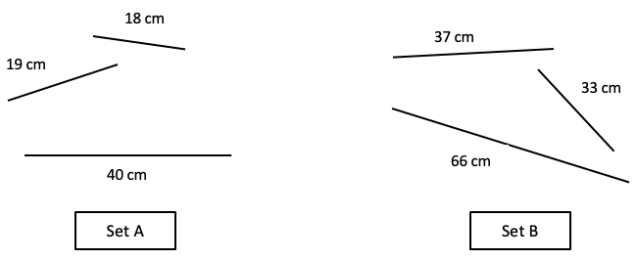

Jessica states the sum of the lengths of the two shorter sides of Set A is less than the length of the longest side. Therefore, the line segments in Set A would form the sides of a triangle.

Ashley states the sum of the lengths of the two shorter sides of Set B is greater than the length of the longest side. Therefore, the line segments in Set B would form the sides of a triangle.

Who is correct, Jessica or Ashley? Explain your thinking.

- Could a triangle have side lengths of 16 ft, 44 ft, and 28 ft? Explain your thinking.

- A triangle has side lengths of 2 units and 8 units. Identify all possible integral lengths of the third side. Explain your thinking.

- Anthony stated that a triangle with side lengths of 3 cm and 4 cm could have a third side with a side length of 7 cm. Is Anthony correct? Explain. Create a statement about the length of the third side.

SOL G.5c - Just in Time Quick Check Teacher Notes
Common Errors/Misconceptions and their Possible Indications

            - Ms. Jones asked her students to determine which of the following sets of segments could form a triangle.

Jessica states the sum of the lengths of the two shorter sides of Set A is less than the length of the longest side. Therefore, the line segments in Set A would form the sides of a triangle.

Ashley states the sum of the lengths of the two shorter sides of Set B is greater than the length of the longest side. Therefore, the line segments in Set B would form the sides of a triangle.

Who is correct, Jessica or Ashley? Explain your thinking.

A common error students may make is agreeing with Jessica’s reasoning. This may indicate that students have not applied the Triangle Inequality Theorem appropriately where they are to determine that the sum of the two shorter side lengths must be greater than the longest side length to form a triangle. This may also indicate that students have ignored criteria such as the “longest side length.” Students with this misconception would benefit from first verifying whether the sum of any two sides of a triangle is greater than the measure of the third side. As soon as the students discover that the sum of two sides is less than (or equal to) the measure of a third side, then the sides cannot form a triangle. Teachers should demonstrate that the sum of the lengths of the two shorter sides of a triangle must always be greater than the length of the third and longest side. Teachers are encouraged to provide examples of side lengths using visual representations or concrete manipulatives to determine whether a triangle can be formed. Teachers may adjust the units for the use of manipulatives.

            - Could a triangle have side lengths of 16 ft, 44 ft, and 28 ft? Explain your thinking.

A common error that students may make is stating that the triangle could be formed as the sum of the two shorter sides is greater than or equal to the longest side. This may indicate that students did not verify each aspect of the Triangle Inequality Theorem (AB + BC > AC; BC + AC > AB; and, AC + AB > BC). Students may benefit from assigning each side length measure to a variable (i.e., AB, BC, or AC). Then, using the substitution property, evaluate each inequality statement. It would be helpful if teachers encouraged students to examine the pair of side lengths that would determine whether a triangle is formed – the sum of the two shorter side lengths (16 ft and 28 ft) must be greater than the longest side length (44 ft). Teachers may give students multiple side lengths to examine using visual representations, concrete manipulatives, or dynamic software to determine whether a triangle can be formed (units may be adjusted as appropriate).

            - A triangle has side lengths of 2 units and 8 units. Identify all possible integral lengths of the third side. Explain your thinking.

A common error students may make is selecting 3, 4, 5, or 6; however, these values do not satisfy the Triangle Inequality Theorem. This may indicate that students have not applied the Triangle Inequality Theorem appropriately. Reference question 1 for strategies to support students who demonstrate this misconception.

            - Anthony stated that a triangle with side lengths of 3 cm and 4 cm could have a third side with a side length of 7 cm. Is Anthony correct? Explain. Create a statement about the length of the third side.

Some students will indicate that Anthony is correct. This may indicate a common misconception that AB + BC $≥$ AC. Further, a common error that students may make is not recognizing that a triangle cannot be formed if the length of the third side is equal to the sum of the lengths of the other two sides. The third side length must be greater than the sum of the other two sides for a triangle to exist. Therefore, in this example, the third side length must be greater than 1 and less than 7 as no other length would form a triangle. Teachers are encouraged to emphasize the Triangle Inequality Theorem and how to verify whether a triangle exists by demonstrating that the sum of the shorter side lengths is equal to the longest side length per this example; hence, the triangle cannot exist based on the given side lengths. Reference question 1 for additional strategies to support students who demonstrate this misconception.

