Just In Time Quick Check
Standard of Learning (SOL) G.5a
Strand: Triangles

Standard of Learning (SOL) G.5a
The student, given information concerning the length of sides and/or measures of angles in triangles, will solve problems, including practical problems. This will include ordering the sides by length, given angle measures.

Grade Level Skills:
- Given information about the length of sides and/or measures of angles in triangles, solve problems, including practical problems.
- Order the sides of a triangle by their lengths when given information about the measures of the angles.

Just in Time Quick Check

Just in Time Quick Check Teacher Notes

Supporting Resources:
- VDOE Mathematics Instructional Plans (MIPS)
  - G.5a-d – How Many Triangles? (Word) / PDF Version
- VDOE Word Wall Cards: Geometry (Word)|(PDF)
  - Triangle Sum Theorem
  - Exterior Angle Theorem
  - Classifying Triangles by Sides
  - Classifying Triangles by Angles
  - Angle and Side Relationships
  - Triangle Inequality Theorem
- Other VDOE Resources
  - Geometry, Module 4, Topic 1 – Ordering the Sides and Angles of a Triangle [eMediaVA]

Supporting and Prerequisite SOL: N/A

SOL G.5a - Just in Time Quick Check

- Given the angle measures of $∆ABC$, order the sides from greatest to least. Place your response in the blanks provided below. The figure is not drawn to scale.
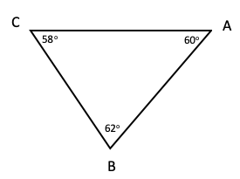

________ , ________ , ________

- Shenandoah National Park has many hiking trails. In the south district location of the Shenandoah National Park, there are three hiking trails that are in close proximity of each other – Big Run Loop, Browns Gap Loop, and Jones River Falls Loop. These hiking trails create a triangle as shown. Given the angle measures of the triangle formed, determine the longest trail and the shortest trail. Place your response in the blanks provided below. The figure is not drawn to scale.
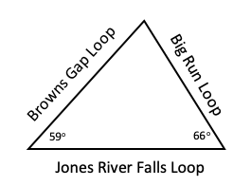

Longest trail: ________
Shortest trail: ________
- Determine the longest side of the $∆LMN$. The figure is not drawn to scale. Explain your thinking.
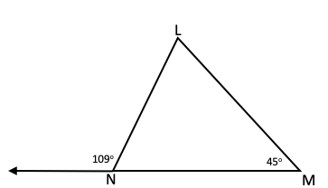

- In any triangle with an angle measure of 110º, is the longest side always opposite this angle? Explain your thinking.

SOL G.5a - Just in Time Quick Check Teacher Notes
Common Errors/Misconceptions and their Possible Indications

            - Given the angle measures of $∆ABC$, order the sides from greatest to least. Place your response in the blanks provided below. The figure is not drawn to scale.
________ , ________ , ________

A common misconception that students may have is not understanding the relationship between the lengths of the sides and measures of the angles of a triangle. This may indicate that students do not understand that the longest side of a triangle is opposite the largest angle of the triangle and the shortest side is opposite the smallest angle. Further, this may indicate that students may not be able to name the line segment opposite an angle in a triangle (e.g., the segment opposite $∠$C is $\overline{AB}$ ). Some students may find it easier to identify the longest side in a triangle, by first ordering the angles from smallest to largest and then using that list to order the sides. Teachers are encouraged to help students use the ordered list of angles to order the sides. Teachers should ask scaffolding questions such as, “Which side is opposite $∠C$? Opposite $∠A$? Opposite $∠B$?” to help students order the sides.

A common error that students may make is not using the correct symbolic notation to denote a line segment (e.g., $\overline{AB}$ versus $\overset{⃡}{AB}$ versus AB). Teachers are encouraged to reference the VDOE Geometry Word Wall Cards with students to ensure that the appropriate symbolic notation is consistently used – specifically the Word Wall Cards titled Basics of Geometry 1, Basics of Geometry 2, and Geometry Notation.

            - Shenandoah National Park has many hiking trails. In the south district location of the Shenandoah National Park, there are three hiking trails that are in close proximity of each other – Big Run Loop, Browns Gap Loop, and Jones River Falls Loop. These hiking trails create a triangle as shown. Given the angle measures of the triangle formed, determine the longest trail and the shortest trail. Place your response in the blanks provided below. The figure is not drawn to scale.

Longest trail: ________
Shortest trail: ________
A common misconception that students may have is thinking that not enough information is given to determine the longest and shortest trail. This may indicate that students do not recognize that the Triangle Sum Theorem must be applied to find the missing angle measure first before determining the longest and shortest sides of the triangle. Teachers are encouraged to emphasize with students to calculate the sum of the given angles; and, then subtract the sum from 180º as the sum of the angles of any triangle is equivalent to 180º. Once the missing angle measure is known, teachers should model for students how to order the side opposite each angle from least to greatest.
            - Determine the longest side of the $∆LMN$. The figure is not drawn to scale. Explain your thinking.

A common error that students may make is not applying knowledge of supplementary angles and the Triangle Sum Theorem to order the sides of the triangle. Because the exterior angle forms a linear pair with the missing interior angle of $∆LMN$, teachers should demonstrate that the difference of the measure of the exterior angle and 180º will result in the value of the missing interior angle of $∆LMN$. Once all the angles of the triangle are known, teachers should model ordering the angles from least to greatest with students and demonstrate that the side opposite the greatest angle in the triangle is the longest side. Teachers may want to use color-coding to mark the missing angle measures and the side opposite to provide differentation for students.

            - In any triangle with an angle measure of 110º, is the longest side always opposite this angle? Explain your thinking.

A common misconception that students may have is to reason that this is a false statement. This may indicate that students fail to recognize that if one angle in a triangle measures 110º, then the sum of the measures of the other two angles is 70º. Therefore, the side opposite the 110º angle must be the longest side as this angle serves as the greatest angle measure. Teachers may want to use concrete manipulatives or dynamic Geometry software to create triangles with various angle measures and then determine the order of the side lengths in both ascending or descending order.

