Just In Time Quick Check
Standard of Learning (SOL) G.4.h
Strand: Reasoning, Lines and Transformations

Standard of Learning (SOL) G.4.h
The student will construct and justify the constructions of an equilateral triangle, a square, and a regular hexagon inscribed in a circle.

Grade Level Skills:
- Construct and justify the constructions of an equilateral triangle, a square, and a regular hexagon inscribed in a circle.

Just in Time Quick Check

Just in Time Quick Check Teacher Notes

Supporting Resources:
- VDOE Mathematics Instructional Plans (MIPS)
  - G.4a-h - Constructions (Word) / PDF Version
- VDOE Word Wall Cards: Geometry (Word)|(PDF)
  - An equilateral triangle inscribed in a circle
  - A square inscribed in a circle
  - A regular hexagon inscribed in a circle
- Other VDOE Resources
  - Geometry, Module 12, Topic 9 - Constructing an Equilateral Triangle Inscribed in a Circle[eMediaVA]
  - Geometry, Module 12, Topic 10 - Constructing a Square Inscribed in a Circle [eMediaVA]
  - Geometry, Module 12, Topic 11 - Constructing a Regular Hexagon Inscribed in a Circle [eMediaVA]
  - VDOE Mathematics Tools Practice TestNav8 Site
Supporting and Prerequisite SOL: G.9, G.11a, G,11b

SOL G.4.h - Just in Time Quick Check

- What is the relationship between the side length of a regular hexagon and the length of the radius of the circle in which it is inscribed? Explain your reasoning.

- Points D and F are two vertices of an equilateral triangle inscribed in circle A. What point is the third vertex of the equilateral triangle?
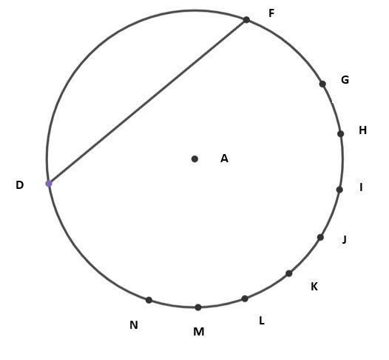
- The drawing shows Christina’s construction of a hexagon inscribed in a circle. Sean wants to use Christina’s construction to construct an equilateral triangle inscribed in this same circle. Describe how Sean’s construction will differ from Christina’s construction. How can Sean prove that the triangle he constructs is equilateral?
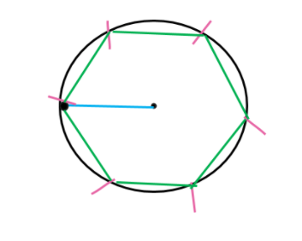
- A square will be inscribed in circle A.
- Points X and A lie on a diameter of circle A.
- X is one vertex of the square.
Complete a construction to determine which other point is a vertex of the square. Justify your work
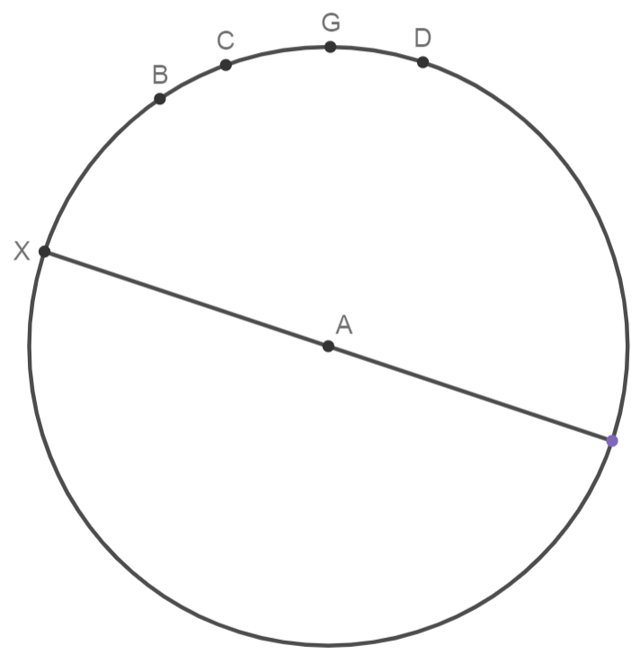

SOL G.4.h - Just in Time Quick Check Teacher Notes
Common Errors/Misconceptions and their Possible Indications
- What is the relationship between the side length of a regular hexagon and the length of the radius of the circle in which it is inscribed? Explain your reasoning.
A common error some students may make is to omit the fact that all the radii of a circle are congruent and that the six sides of the hexagon are chords of the circle created from the length of the circle’s radius. These students also may not realize that each central angle is 60 degrees, which will make each triangle formed by the radii an equilateral triangle. For this reason, they are able to prove that the length of each side of the hexagon is equal to the length of the radius. This may indicate students did not understand the relationship of the compass width, the radius, and the sides of the hexagon. The eMedia VA video on this construction provides detailed steps and visuals that may benefit some students. Another strategy would be to model the construction of the inscribed regular hexagon with a dynamic geometry software or at www.desmos.com/geometry . Teachers may also use the VDOE Mathematics Tools Practice with students.

- Points D and F are two vertices of an equilateral triangle inscribed in circle A. What point is the third vertex of the equilateral triangle?
Students who do not recall the characteristics of an equilateral triangle may not realize they need to use the length of the given chord to find the missing vertex. These students may attempt to use the diameter to find the missing side lengths but should quickly see that they are unable to create an equilateral triangle. Ask questions such as— “What do you know about the segment/chord given in the diagram? What is the problem asking you to do? What do you know about equilateral triangles?” Some students may benefit from a review of the properties of an equilateral triangle. Once students are familiar with those properties, teachers may wish to explore how to construct an equilateral triangle that is not inscribed in a circle, and then lead up to the different methods of constructing the equilateral triangle inscribed in a circle.
Students who are proficient with the construction of a hexagon in a circle will have more success constructing an equilateral triangle in a circle because they will be able to justify/explain why connecting every other point of the hexagon results in the equilateral triangle. Engaging students in using a digital platform such as Desmos, Geometer’s Sketchpad, GeoGebra, as well as the VDOE Mathematics Tools practice will help students become familiar with the online straightedge and compass. Teachers may also wish to review the eMediaVA video for additional strategies for constructing an inscribed equilateral triangle.

- The drawing shows Christina’s construction of a hexagon inscribed in a circle. Sean wants to use Christina’s construction to construct an equilateral triangle inscribed in this same circle. Describe how Sean’s construction will differ from Christina’s construction. How can Sean prove that the triangle he constructs is equilateral?
Most students will be able to explain that they connect alternate vertices of the hexagon to create the triangle, but some students will be unable to explain why the triangle is an equilateral triangle. Introducing (or reintroducing) this construction while teaching standards related to inscribed angles can help students make connections between the 60 degree angle of the triangle and the 120 degree arc that it intercepts. Students who are unable to identify the arc as 120 degrees may need to be reminded that the circle is 360 degrees and that the markings used to create the hexagon have divided it into 6 congruent arcs of 60 degrees each. Other students may use properties of a hexagon to prove that the triangle is equilateral.

- A square will be inscribed in circle A.
- Points X and A lie on a diameter of circle A.
- X is one vertex of the square.
Complete a construction to determine which other point is a vertex of the square. Justify your work

Some students may attempt to begin the construction of the square in the same way they begin the construction of an inscribed equilateral triangle or hexagon. The students who have misconceptions about this construction generally do not realize that they have to construct a perpendicular bisector of the diameter. This connection is easier to make if they think about the central angle that is formed by the radii of two consecutive vertices. Once they realize the angle is 90 degrees, they will make the connection to perpendicular lines and the perpendicular bisector. Teachers may wish to refer to the construction of a perpendicular bisector as a review of background information students need. Teachers are encouraged to have students compare the construction of a perpendicular bisector of a line segment to the construction of an inscribed square. Additionally, teachers could list the properties of a square and have students investigate how the construction verifies those properties.

