Just In Time Quick Check
Standard of Learning (SOL) G.4g
Strand: Reasoning, Lines, and Transformations

Standard of Learning (SOL) G.4g
The student will construct and justify the constructions of a line parallel to a given line through a point not on the line.

Grade Level Skills:
- Construct and justify the constructions of a line parallel to a given line through a point not on the line.

Just in Time Quick Check

Just in Time Quick Check Teacher Notes

Supporting Resources:
- VDOE Mathematics Instructional Plans (MIPS)
  - G.4a-h - Constructions (Word) / PDF Version
- VDOE Word Wall Cards: Geometry (Word)|(PDF)
  - Constructions
  - Construct a line parallel to a given line through a point not on the line
- Other VDOE Resources
  - Geometry, Module 12, Topic 1 - Introduction to Constructions [eMediaVA]
  - Geometry, Module 12, Topic 8 - Constructing a Line Parallel to a Given Line through a Point Not on the Line[eMediaVA]
Supporting and Prerequisite SOL: G.2a, G.3b, 8.5

SOL G.4g - Just in Time Quick Check
- Construct a line parallel to $\overset{⃡}{AB}$ through point C. Use the construction to determine which points would lie on the parallel line created. Explain your reasoning.
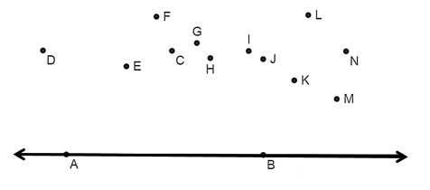

- The figure illustrates the nearly completed construction of a line parallel to $\overset{⃡}{OZ }$through point P not on $\overset{⃡}{OZ}$ with BY = AP. Select the statement that must be true if this construction represents a line parallel to a given line through a point not on the line. Explain your reasoning.

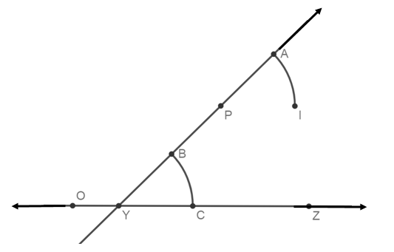

$\overline{PI}≅$ $\overline{YC}$ and  $\overline{PC}≅$ $\overline{IZ}$ | $\overline{AI}≅$ $\overline{BC}$ and  $\overline{IY}≅$ $\overline{BZ}$ | $\overline{PI}≅$ $\overline{YC}$ and  $\overline{AI}≅$ $\overline{BC}$ | $\overline{PY}≅$ $\overline{IC}$ and  $\overline{AB}≅$ $\overline{CZ}$

- This figure illustrates the construction of $\overset{⃡}{PD}$parallel to $\overset{⃡}{QA}$through point P. Explain why the two lines are parallel.
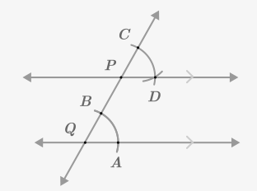

SOL G.4g - Just in Time Quick Check Teacher Notes
Common Errors/Misconceptions and their Possible Indications

- Construct a line parallel to $\overset{⃡}{AB}$ through point C. Use the construction to determine which points would lie on the parallel line created. Explain your reasoning.
A common error a student may make while constructing the line parallel to a given line through a point not on the line would be to use a straightedge to connect point C to any collinear points rather than drawing a transversal through point C. A student could guess the correct answer but inappropriately use the tools of construction without attention to precision or the slope of $\overset{⃡}{AB}$. Some students may wish to construct a parallelogram out of congruent segments using line segments AC and AB as side lengths but the student may fail to ensure the opposite sides are parallel. Students could use the VDOE Word Wall Cards to guide their constructions and justifications. Teachers are also encouraged to review constructions with students using a dynamic software and using paper and pencil (compass and straightedge).Teachers should encourage a variety of approaches to this construction.
- The figure illustrates the nearly completed construction of a line parallel to $\overset{⃡}{OZ}$ through point P not on $\overset{⃡}{OZ}$ with BY = AP. Select the statement that must be true if this construction represents a line parallel to a given line through a point not on the line. Explain your reasoning.
$\overline{PI}≅$ $\overline{YC}$ and  $\overline{PC}≅$ $\overline{IZ}$ | $\overline{AI}≅$ $\overline{BC}$ and  $\overline{IY}≅$ $\overline{BZ}$ | $\overline{PI}≅$ $\overline{YC}$ and  $\overline{AI}≅$ $\overline{BC}$ | $\overline{PY}≅$ $\overline{IC}$ and  $\overline{AB}≅$ $\overline{CZ}$

A common misconception for some students is to assume that BC and AI are the same length as BY and AP. This may indicate that the student is not familiar with the subsequent relationships formed by constructing a line parallel to a given line through a point not on the line. Teachers are encouraged to review the vocabulary associated with this construction. Teachers could ask students what angles are formed by creating this construction. This is a great opportunity to review the vocabulary associated with angles formed by intersecting lines as well as congruent triangles to reinforce the justification of the construction. The linked eMediaVA video offers justifications of the construction of a line parallel to a given line through a point not on the line.

- This figure illustrates the construction of $\overset{⃡}{PD}$parallel to $\overset{⃡}{QA}$through point P. Explain why the two lines are parallel.
Some students may be able to perform this construction, but may not understand or be able to explain why the lines are parallel because of the construction. Teachers may wish to have students think about what is necessary in order to prove two lines parallel and then make the connection to the copied angle (creating a congruent angle) in the construction. The linked eMediaVA video explains this relationship and is a good resource for students.

