Just In Time Quick Check
Standard of Learning (SOL) G.4f
Strand: Reasoning, Lines, and Transformations

Standard of Learning (SOL) G.4f
The student will construct and justify the constructions of an angle congruent to a given angle.

Grade Level Skills:
- Construct and justify the constructions of an angle congruent to a given angle.

Just in Time Quick Check

Just in Time Quick Check Teacher Notes

Supporting Resources:
- VDOE Mathematics Instructional Plans (MIPS)
  - G.4a-h - Constructions (Word) / PDF Version
- VDOE Word Wall Cards: Geometry (Word)|(PDF)
  - Constructions
  - Construct an angle congruent to a given angle
- Other VDOE Resources
  - Geometry, Module 12, Topic 1 - Introduction to Constructions [eMediaVA]
  - Geometry, Module 12, Topic 7 - Constructing an angle congruent to a given angle [eMediaVA]
Supporting and Prerequisite SOL: G.6, G.9

SOL G.4f - Just in Time Quick Check

- Given $∠BAC,$ construct an angle congruent to $∠BAC,$ with vertex $D$ and $\vec{DE}$ as one side of the angle. Use the construction to determine which points would lie on the ray created$.$ Explain your reasoning.
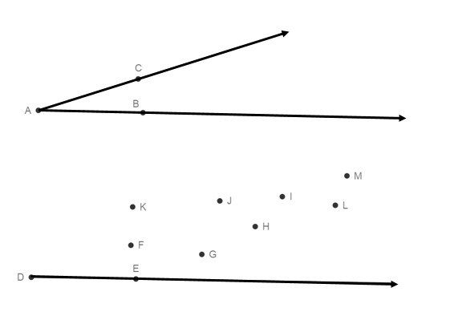
- Given: $∠AMB$ and $∠RTP$ . Use constructions to determine whether $∠AMB≅∠RTP.$
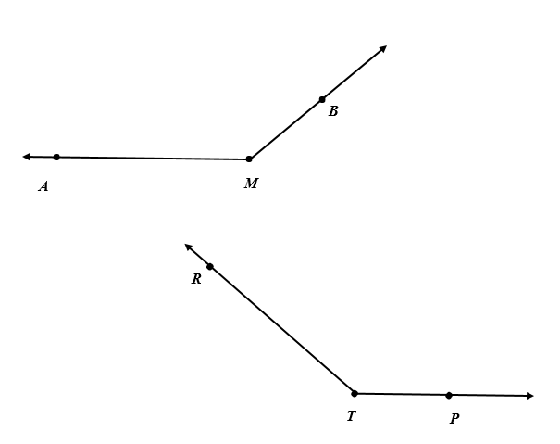

SOL G.4f - Just in Time Quick Check Teacher Notes
Common Errors/Misconceptions and their Possible Indications

            - Given $∠BAC,$ construct an angle congruent to $∠BAC,$ with vertex $D$ and $\vec{DE}$ as one side of the angle. Use the construction to determine which points would lie on the ray created$.$ Explain your reasoning.

A common error a student may make while constructing the congruent angle is to change or not secure the size of the compass width when drawing the initial arcs on$∠BAC$ and on $\vec{DE}$. Other students may get this first step correct, but may be confused about how to use the compass radius to measure $∠BAC$ and then copy that measurement to create the congruent angle. To address these misconceptions, students can use the VDOE Word Wall Cards as an example of one way to create the construction. Teachers are also encouraged to review constructions with students using dynamic software and using paper and pencil (compass and straightedge).

            - Given: $∠AMB$ and $∠RTP$ . Use constructions to determine whether $∠AMB≅∠RTP.$

Some students may not be confident in how to approach this construction because a) the angles have different orientations or b) because the angles are obtuse. A common misconception a student may have is to assume that since AM is equal to RT and MB is equal to TP, the angles are congruent. This may indicate that the student is not familiar with the subsequent relationships formed by constructing congruent angles. This is a great opportunity to review the vocabulary associated with congruent triangles, the associated construction, as well as transformations i.e. translations to reinforce the justification of the construction. The eMediaVA video “Constructing an angle congruent to a given angle” offers justifications of the construction of a congruent angle from a given angle. This video would be a good resource to reinforce this skill for students.

