Just In Time Quick Check
Standard of Learning (SOL) G.4e
Strand: Reasoning, Lines, and Transformations

Standard of Learning (SOL) G.4e
The student will construct and justify the constructions of the bisector of a given angle.

Grade Level Skills:
- Construct and justify the constructions of the bisector of a given angle.

Just in Time Quick Check

Just in Time Quick Check Teacher Notes

Supporting Resources:
- VDOE Mathematics Instructional Plans (MIPS)
  - G.4a-h - Constructions (Word) / PDF Version
- VDOE Word Wall Cards: Geometry (Word)|(PDF)
  - Constructions – A bisector of an angle
- Other VDOE Resources
  - Geometry, Module 12, Topic 6 – Constructing an Angle Bisector[eMediaVA]
  - VDOE Mathematics Tools Practice TestNav8 Site
Supporting and Prerequisite SOL: G.6, G.9

SOL G.4e - Just in Time Quick Check

- Construct the bisector of $∠MNL$. Justify your construction.
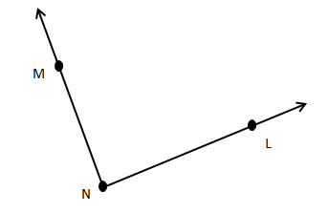

- Angle $ABC$ has been bisected below. All arcs were created using the same compass width. What specific quadrilateral would be formed by ABCD? Explain your reasoning and justify how the properties of that specific quadrilateral could be used to justify that $∠ABC$ would be bisected by $\vec{BD}$.
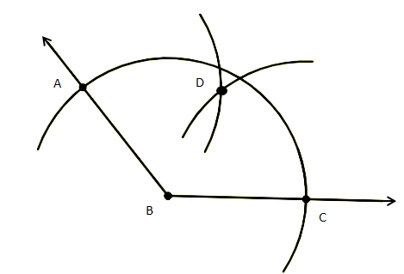

- Points A (2, 4), B (2, -4), and C (10, -4) have been used to create $∠ABC$ with $\overline{AB}≅\overline{CB}$. Sarah and Abby were asked plot a point, D, that would lie on the angle bisector of $∠ABC.$ Sarah plotted D as the ordered pair (8, 3) and Abby plotted point D as the ordered pair (7, 1). Using coordinate methods and properties of congruent triangles justify who correctly plotted a point that would lie on the angle bisector.
Sarah | Abby
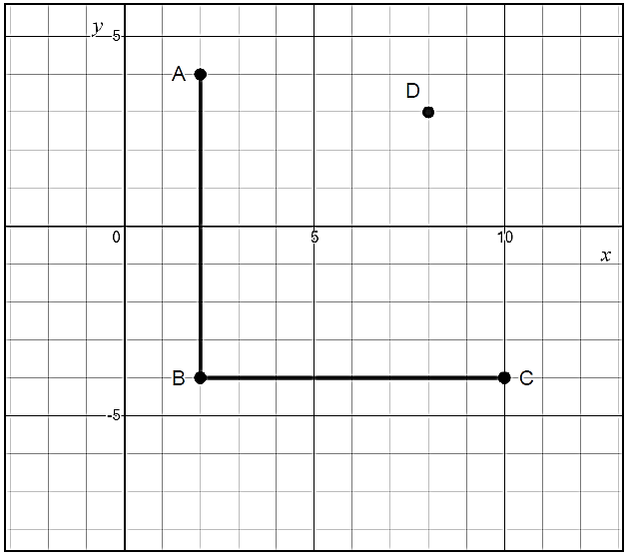 | 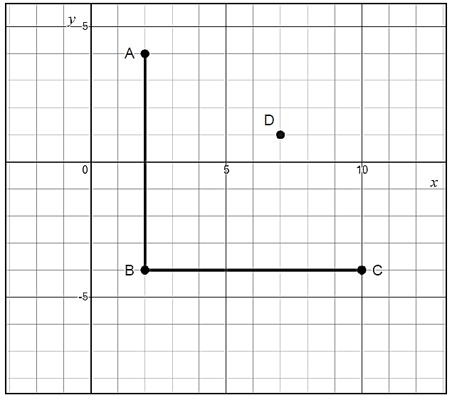

SOL G.4e - Just in Time Quick Check Teacher Notes
Common Errors/Misconceptions and their Possible Indications

            - Construct the bisector of $∠MNL$. Justify your construction.
A common error some students may make is to use points M and L to draw their intersecting arcs. This may indicate that students assume that points M and L are equidistant from point N or that they don’t realize the significance of using points that are equidistant from point N. It is important for students to realize that they are creating congruent triangles when they create the arcs that determine the bisector. The eMediaVA video on this construction and the VDOE Mathematics Instructional Plans (MIPs) provide step by step details and visuals for students to follow. Constructions should be taught using multiple methods to include using a straightedge and compass, paper folding, and dynamic geometry software.

            - Angle $ABC$ has been bisected below. All arcs were created using the same compass width. What specific quadrilateral would be formed by ABCD? Explain your reasoning and justify how the properties of that specific quadrilateral could be used to justify that $∠ABC$ would be bisected by $\vec{BD}$.
A common error a student may make would be to conclude that the quadrilateral formed is merely a parallelogram. While that is true, that would not justify the bisector of $∠ABC$. This may indicate that a student is visually making an assumption rather than using the information given that all arcs were created using the same compass width. This should indicate to a student that all sides of quadrilateral ABCD are congruent; therefore, the specific quadrilateral represented is a rhombus. Thus the student can justify that the diagonals of a rhombus bisect opposite angles, verifying $∠ABC$ would be bisected by $\vec{BD}$. The eMediaVA videos referenced in the teacher notes provides a detailed explaination surrounding justification of the bisector of an angle through the construction of a rhombus.

            - Points A (2, 4), B (2, -4), and C (10, -4) have been used to create $∠ABC$ with $\overline{AB}≅\overline{CB}$. Sarah and Abby were asked plot a point, D, that would lie on the angle bisector of $∠ABC.$ Sarah plotted D as the ordered pair (8, 3) and Abby plotted point D as the ordered pair (7, 1). Using coordinate methods and properties of congruent triangles justify who correctly plotted a point that would lie on the angle bisector.
Sarah | Abby

A common error a student may make would be to assume visually that Sarah’s point is correct. Other students are able to select the correct point from the two options given, but they do not associate angle bisectors with congruent triangles. These students may need to be shown how congruent triangles can be formed using any point on the angle bisector and the congruent sides of the original angle. Students should be able to verify through coordinate methods that $\overline{AD}≅\overline{CD}$. The Desmos distance function can be used to verify the lengths of the sides of the triangles.
Once students are able to see how congruent triangles are formed, they should be encouraged to identify the coordinates of other points on the angle bisector and verify that they also result in congruent triangles.
As an extension to this question, students could be asked to determine the slope of the angle bisector.

