Just In Time Quick Check
Standard of Learning (SOL) G.4d
Strand: Reasoning, Lines, and Transformations

Standard of Learning (SOL) G.4d
The student will construct and justify the constructions of a perpendicular to a given line at a given point on the line.

Grade Level Skills:
- Construct and justify the constructions of a perpendicular to a given line at a given point on the line.

Just in Time Quick Check

Just in Time Quick Check Teacher Notes

Supporting Resources:
- VDOE Mathematics Instructional Plans (MIPS)
  - G.4a-h - Constructions (Word) / PDF Version
- VDOE Word Wall Cards: Geometry (Word)|(PDF)
  - Perpendicular Lines
  - Constructions
  - Construct a perpendicular to a line from point P on the line
- Other VDOE Resources
  - Geometry, Module 12, Topic 1 - Introduction to Constructions [eMediaVA]
  - Geometry, Module 12, Topic 5 - Constructing a Perpendicular to a given line from a point on the line [eMediaVA]
Supporting and Prerequisite SOL: G.9

SOL G.4d - Just in Time Quick Check
- Construct a perpendicular line to $\overline{DE}$ that passes through point J. Then determine which points would lie on that line. Explain your reasoning.
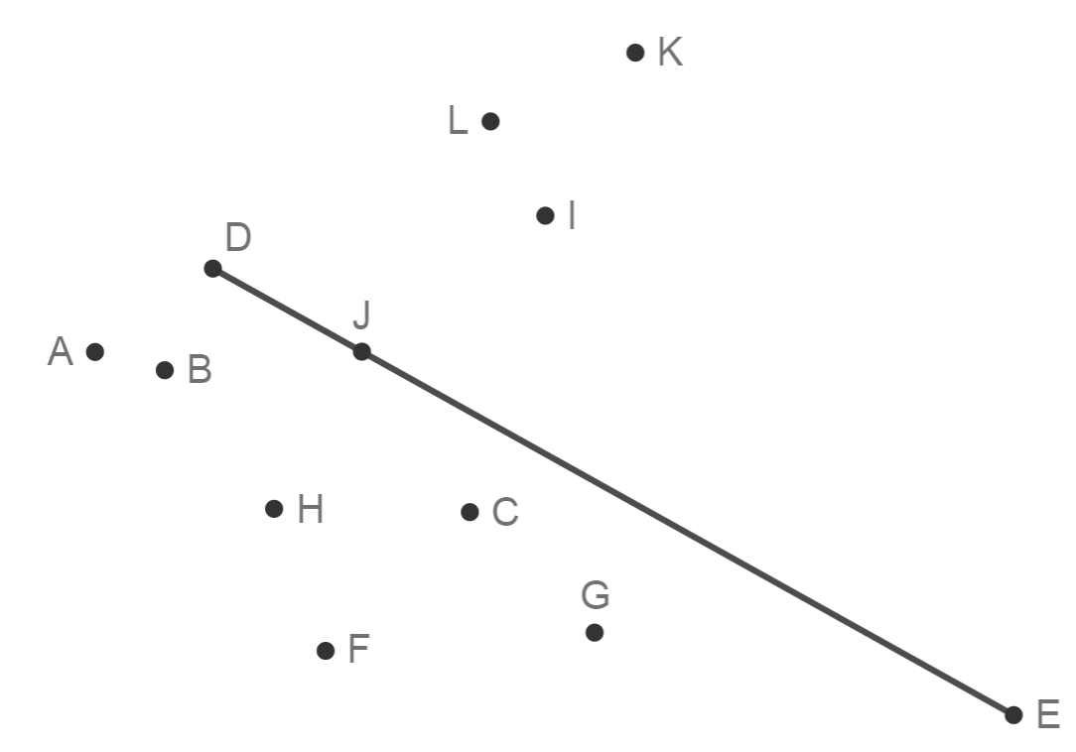

- The figure illustrates the construction of perpendicular line $\overset{⃡}{DW}$ through point $L$ that lies on$\overline{EH}$. Select each statement that must be true.
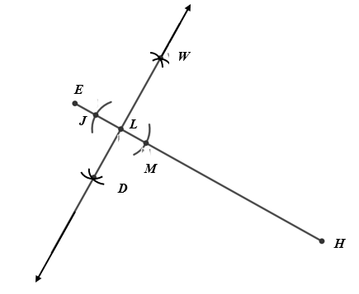

$∠HLW$ is a right angle $WJ=WM$ Points $W, E, and M$ define an equilateral triangle

$WE=WM$ $WM=MD$ Points $J, M, and D$ define an isosceles triangle

SOL G.4d - Just in Time Quick Check Teacher Notes
Common Errors/Misconceptions and their Possible Indications

            - Construct a perpendicular line to $\overline{DE}$ that passes through point J. Then determine which points would lie on that line. Explain your reasoning.
A common error for some students is to confuse the construction of a perpendicular bisector to a line segment with the construction of a perpendicular through a point on the line segment. They may try to use points D and E as the starting points to draw their first arcs. Other students may not be aware that they may need to extend the line segment beyond point D before drawing their first set of arcs. It is suggested that students practice using multiple representations of lines and line segments, (horizontal, vertical and diagonal) or polygons in constructing a perpendicular line through a point on the line. Students may refer to the VDOE word wall cards for one representation of how to create the perpendicular line from a point on the line.
- The figure illustrates the construction of perpendicular line $\overset{⃡}{DW}$ through point $L$ that lies on$\overline{EH}$. Select each statement that must be true.

$∠HLW$ is a right angle $WJ=WM$ Points $W, E, and M$ define an equilateral triangle

$WE=WM$ $WM=MD$ Points $J, M, and D$ define an isosceles triangle

A common error some students make when first beginning this construction is failing to locate points equidistant from point L that lie on line segment EJ (in this case point J and point M.) A common misconception some students may have is to think that the compass radius used to make the arcs that locate point W must equal the compass radius used to locate point D, or even points J and M. This misconception likely occurs because the students are not familiar with the connections this construction has to congruent triangles. The eMediaVA video referenced in Supporting Resources offers justifications of the construction of the perpendicular line from a point on the line. Teachers are encouraged to remind students that they cannot assume properties in an illustration unless the picture is marked or the information is given. This is a great opportunity to review the vocabulary associated with congruent triangles to reinforce the justification of the construction.

