Just In Time Quick Check
Standard of Learning (SOL) G.4.c
Strand: Reasoning, Lines, and Transformations

Standard of Learning (SOL) G.4.c
The student will construct and justify the constructions of a perpendicular to a given line from a point not on the line.

Grade Level Skills:
- Construct and justify the constructions of a perpendicular to a given line from a point not on the line.

Just in Time Quick Check

Just in Time Quick Check Teacher Notes

Supporting Resources:
- VDOE Mathematics Instructional Plans (MIPS)
  - G.4a-h - Constructions (Word) / PDF Version
- VDOE Word Wall Cards: Geometry (Word)|(PDF)
  - Construct a perpendicular to a line from point P not on the line
- Other VDOE Resources
  - Geometry, Module 12, Topic 4 - Constructing a Perpendicular to a Given Line from a Point Not on the Line [eMediaVA]
Supporting and Prerequisite SOL: G.3b, G.6, G.9

SOL G.4.c - Just in Time Quick Check

- What does this construction represent? Explain your reasoning.

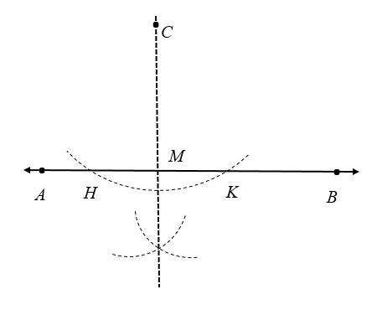

- Construct a line through point A that is perpendicular to$\overline{ BC}$. Justify your construction with mathematical notation on the diagram.

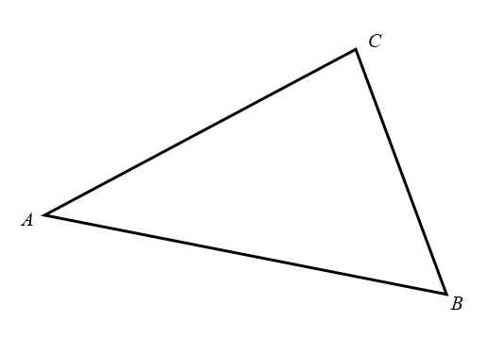

- The figure shows the construction of a perpendicular line to $\overset{⃡}{XY}$ through given point R.

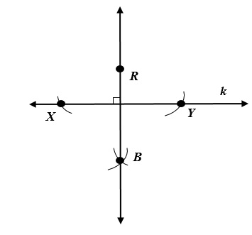
a. Given RX = 6.2 cm, find RY. Explain your reasoning.
b. Which line segment(s) must be congruent to$\overline{ BY}$? Explain your reasoning.

SOL G.4.c - Just in Time Quick Check Teacher Notes
Common Errors/Misconceptions and their Possible Indications
            - What does this construction represent? Explain your reasoning.

A common misconception for some students is to believe that this is the perpendicular bisector of line AB since the constructed line is perpendicular to line AB. Other students may attempt to use point A and/or point B in the construction because those points are shown on the line. Students may benefit from using eMediaVA resource Geometry, Module 12, Topic 4 to review this construction.
            - Construct a line through point A that is perpendicular to$\overline{BC}$. Justify your construction with mathematical notation on the diagram.

Some students have difficulty with this construction because of the orientation of the triangle. These students may benefit from turning their paper so that point A is at the top of their triangle. Other students will not be able to construct two arcs that intersect line segment BC because they do not realize they need to extend line segment BC beyond the triangle. These students may benefit from covering up the two sides of the triangle that are not necessary for this construction to better visualize the direction of the perpendicular that they are constructing. Another strategy that may benefit some students is to trace line segment BC and point A on another piece of paper. Students may then orient their paper so they are able to construct the perpendicular line. Once students have mastered this, continue to introduce constructions of different orientation.

            - The figure shows the construction of a perpendicular line to $\overset{⃡}{XY}$ through given point R.

a. Given RX = 6.2 cm, find RY. Explain your reasoning.
Some students may state that RY is 6.2 cm, but not be able to explain why this must be true. These students may need additional support in recognizing that they are creating congruent triangles while completing this construction. For this reason, it is beneficial to introduce and/or review this construction while teaching congruent triangle concepts.
b. Which line segment(s) must be congruent to$\overline{BY}$? Must$\overline{RY}$ be congruent to$\overline{BY}$ in this construction? Explain your reasoning.
Some students will have the misconception that $\overline{RY}$, $\overline{BX}$, and $\overline{RX}$ must all be congruent to $\overline{BY}.$ While the construction can be completed so that this is true, it is not necessary for all of these line segments to be the same length. Students may benefit from trying to construct a perpendicular line using different compass radii. The most important concept to reinforce with students is that every point located on the perpendicular line must be the same distance from point X as it is from point Y.

