Just In Time Quick Check
Standard of Learning (SOL) G.4b
Strand: Reasoning, Lines, and Transformations

Standard of Learning (SOL) G.4b
The student will construct and justify the constructions of the perpendicular bisector of a line segment.

Grade Level Skills:
- Construct and justify the constructions of the perpendicular bisector of a line segment.

Just in Time Quick Check

Just in Time Quick Check Teacher Notes

Supporting Resources:
- VDOE Mathematics Instructional Plans (MIPS)
  - G.4a-h - Constructions (Word) / PDF Version
- VDOE Word Wall Cards: Geometry (Word)|(PDF)
  - Perpendicular Lines
  - Perpendicular Bisector
  - Constructions
  - Perpendicular Bisector of a Line Segment
- Other VDOE Resources
  - Geometry, Module 12, Topic 1 - Introduction to Constructions [eMediaVA]
  - Geometry, Module 12, Topic 3 - Constructing a Perpendicular Bisector of a Line Segment [eMediaVA]
Supporting and Prerequisite SOL: G.9

SOL G.4b - Just in Time Quick Check

- Construct the perpendicular bisector of line segment$\overline{AB}$. Then determine which points would lie on this perpendicular bisector.

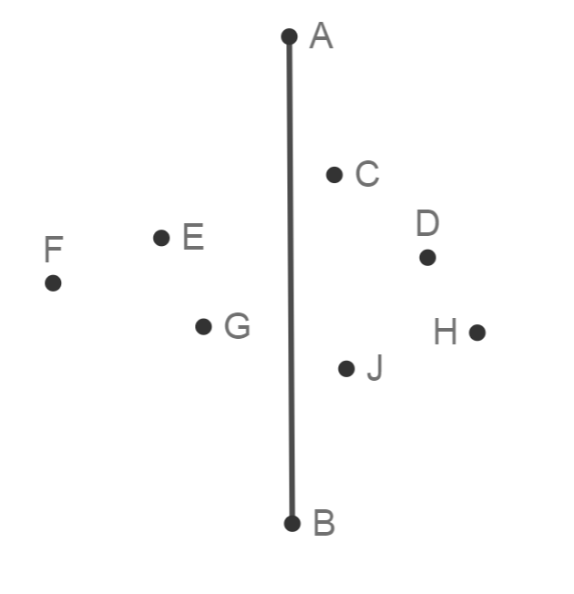

- Use constructions to determine if$\overset{⃡}{EG}$ is a perpendicular bisector to $\overline{DF}$. Justify your answer.

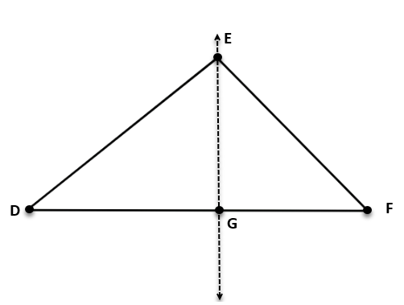

- The figure illustrates the construction of a perpendicular bisector. Select each statement that must be true to prove this construction represents a perpendicular bisector of a line segment.

  - The triangle formed by points A, C, and E is a right triangle
  - $\overline{AE}≅\overline{EB}$
  - $\overline{CD}≅\overline{AB}$
  - $\overline{DA}≅\overline{DB}$

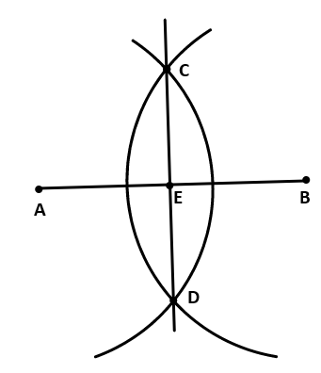

SOL G.4b - Just in Time Quick Check Teacher Notes
Common Errors/Misconceptions and their Possible Indications

            - Construct the perpendicular bisector of line segment$\overline{AB}$. Then determine which points would lie on this perpendicular bisector.

A common error for some students is to assume point C, D, E, G, or J appear to lie on a line perpendicular to $\overline{AB}$. This may indicate that the student has used visual cues to assume a point falls on a line that is perpendicular to $\overline{AB}$. Students often assume perpendicular lines are vertical and additionally may not be accustomed to using the compass at the top and bottom of a vertical line segment. Students should practice using multiple representations of lines, (horizontal, vertical and diagonal) or polygons in constructing a perpendicular bisector. Students may refer to the VDOE word wall cards for one representation of how to create the perpendicular bisector.

            - Use constructions to determine if$\overset{⃡}{EG}$ is a perpendicular bisector to $\overline{DF}$. Justify your answer.

A common error for some students is to assume that since line EG appears to be perpendicular to DF, then it is the perpendicular bisector. This may indicate that the student has used visual cues to assume that $\overset{⃡}{EG}$ is perpendicular to $\overline{DF}$ and that DG = GF. Teachers are encouraged to remind students that you cannot assume properties in an illustration unless the picture is marked or the information is given. This is a great opportunity to review the vocabulary associated with perpendicular line versus perpendicular bisector, as well. The VDOE word wall cards may also be helpful in reinforcing the steps for constructing a perpendicular bisector.

3. The figure illustrates the construction of a perpendicular bisector. Select each statement that must be true to prove this construction represents a perpendicular bisector of a line segment.
- The triangle formed by points A, C, and E is a right triangle.
- $\overline{AE}≅\overline{EB}$
- $\overline{CD}≅\overline{AB}$
- $\overline{DA}≅\overline{DB}$

A common misconception for some students is to assume all line segment relationships are true. This may indicate that the student is not familiar with the subsequent relationships formed by constructing a perpendicular bisector. Teachers can provide different experiences for students by having them complete the construction several times using a different compass radius each time. Teachers are encouraged to review the vocabulary associated with this construction. The eMediaVA video referenced offers justifications of the construction of the perpendicular bisector.

