Just In Time Quick Check
Standard of Learning (SOL) G.4a
Strand: Reasoning, Lines, and Transformations

Standard of Learning (SOL) G.4a
The student will construct and justify the constructions of a line segment congruent to a given line segment.

Grade Level Skills:
- Construct and justify the constructions of a line segment congruent to a given line segment.

Just in Time Quick Check

Just in Time Quick Check Teacher Notes

Supporting Resources:
- VDOE Mathematics Instructional Plans (MIPS)
  - G.4a-h - Constructions (Word) / PDF Version
- VDOE Word Wall Cards: Geometry (Word)|(PDF)
  - Constructions
  - A Line Segment Congruent to a Given Line Segment
- Other VDOE Resources
  - Geometry, Module 12, Topic 1 - Introduction to Constructions [eMediaVA]
  - Geometry, Module 12, Topic 2 - Constructing a Line Segment Congruent to a Given Line Segment [eMediaVA]
Supporting and Prerequisite SOL: G.11b

SOL G.4a - Just in Time Quick Check

- When constructing a line segment congruent to $\overline{AB}$, does it matter whether you place the endpoint of the compass on point A or point B when measuring the width of $\overline{AB}$?
A
B

- Determine which line segment is congruent to $\overline{AC}$. Justify your answer with constructions.
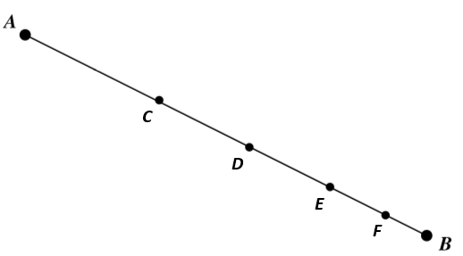

- $\overline{CE}$ B. $\overline{DF}$ C. $\overline{DB}$ D. $\overline{CD}$

- Given $\overline{CD}$, construct 2$\overline{CD}$ using your compass and straightedge.

SOL G.4a - Just in Time Quick Check Teacher Notes
Common Errors/Misconceptions and their Possible Indications

            - When constructing a line segment congruent to $\overline{AB}$, does it matter whether you place the endpoint of the compass on point A or point B when measuring the width of $\overline{AB}$?
A
B

A common misconception a student may have is thinking that the length of $\overline{AB }$is not the same as the length of $\overline{BA}$. This may indicate that the student is focused on following the directions of constructing a congruent line segment versus understanding the purpose of the steps of constructing congruent line segments. Teachers are encouraged to use letters other than A and B for constructions as well as have students try using both endpoints of $\overline{AB }$ to illustrate that this will result in the same measurement. In addition, it may benefit some students to rewrite the construction directions in their own words. The VDOE Word Wall Card for constructing a line segment congruent to another line segment may also be helpful for students.
            - Determine which line segment is congruent to $\overline{AC}$. Justify your answer with constructions.

- $\overline{CE}$ B. $\overline{DF}$ C. $\overline{DB}$ D. $\overline{CD}$

A common error a student may make is to choose $\overline{CE}$or $\overline{DB}$. This may indicate that the student has determined the congruent line segment based on sight. Teachers are encouraged to have students justify their answers by creating the constructions. When introducing this construction, teachers should emphasize that the size of the opening of the compass is used to measure the length of the line segment. This will help reinforce the notion that congruent line segments may not be identified easily by sight.
            - Given $\overline{CD}$, construct 2$\overline{CD}$ using your compass and straightedge.
A common error a student may make is to change the width of the compass when creating the second line segment$.$This may indicate student confusion about how to create a line segment that is twice the length of the original since construction directions typically focus on creating congruent segments. Teachers are encouraged to ask students questions to help them think through the process of creating 2$\overline{CD}$. For example, “What does 2$\overline{CD}$ mean? What is the relationship between $\overline{CD}$ and 2$\overline{CD}$? Would you have to change the width of the compass when creating this construction? Why or why not?” A strategy that may also be helpful for students is to show the student the completed construction and ask them how they think it was created.

