Just In Time Quick Check
Standard of Learning (SOL) G.3d
Strand: Reasoning, Lines, and Transformations

Standard of Learning (SOL) G.3d
The student will solve problems involving symmetry and transformation. This will include determining whether a figure has been translated, reflected, rotated, or dilated, using coordinate methods.

Grade Level Skills:
- Given an image and preimage, identify the transformation or combination of transformations that has/have occurred. Transformations include:
- a translation;
- a reflection over any horizontal or vertical line or the lines y = x or y = −x;
- a clockwise or counter clockwise rotation of 90°, 180°, 270°, or 360° on a coordinate grid where the center of rotation is limited to the origin; and
- a dilation from a fixed point on a coordinate grid.

Just in Time Quick Check

Just in Time Quick Check Teacher Notes

Supporting Resources:
- VDOE Mathematics Instructional Plans (MIPS)
  - G.3d - Transformations (Word) / PDF Version
- VDOE Word Wall Cards: Geometry (Word)|(PDF)
  - Rotation (Origin)
  - Reflection
  - Translation
  - Dilation
- Other VDOE Resources
  - Geometry, Module 3, Topic 4 – Translations [eMediaVA]
  - Geometry, Module 3, Topic 5 – Reflections [eMediaVA]
  - Geometry, Module 3, Topic 6 – Rotations [eMediaVA]
  - Geometry, Module 3, Topic 8 – Dilations [eMediaVA]
- Desmos Activity
  - Des-Patterns
  - Transformation Golf: Rigid Motion
Supporting and Prerequisite SOL: G.3b, A.6a, A.6c, 8.7a, 8.7b, 7.7, 6.8a, 6.8b

SOL G.3d - Just in Time Quick Check

- Given Triangle ABC on the coordinate plane, state the transformation that best describes each graph.

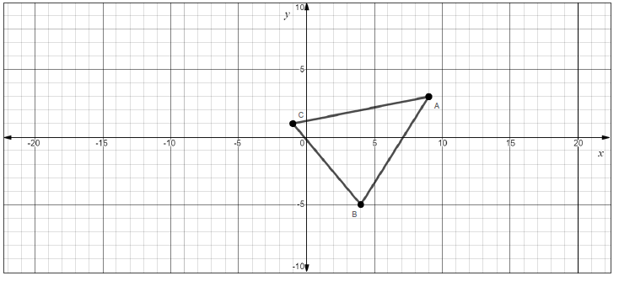

Possible Transformations
A reflection across x=2 | A rotation clockwise$90°$
A reflection across y=x | A translation left 10 and down 3
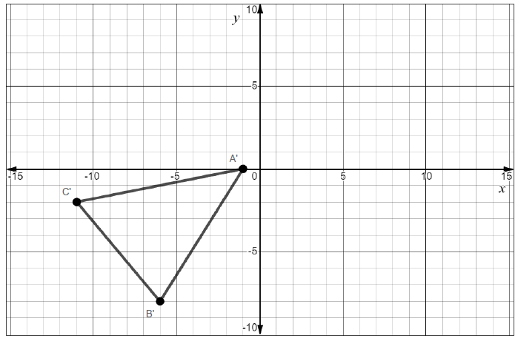 | 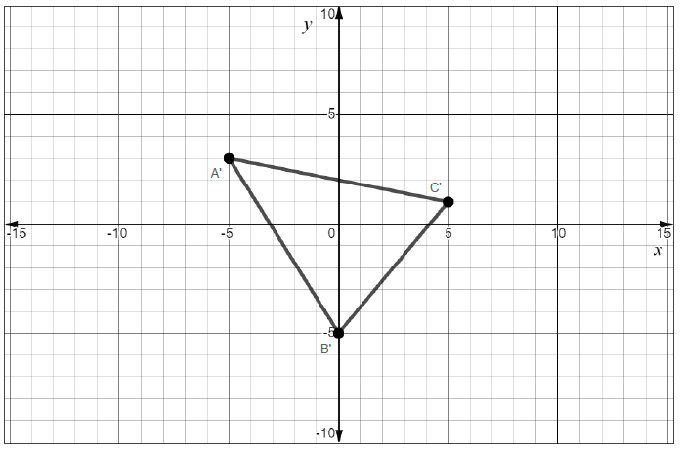
a. __________________ | b. ___________________
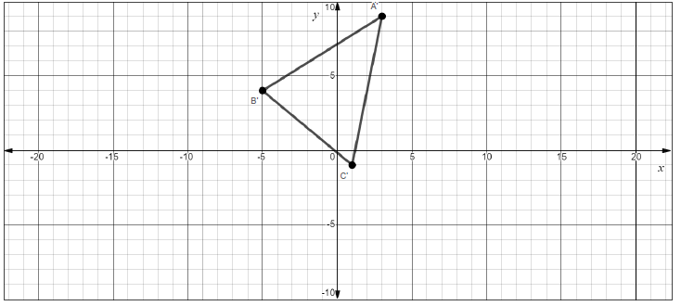 | 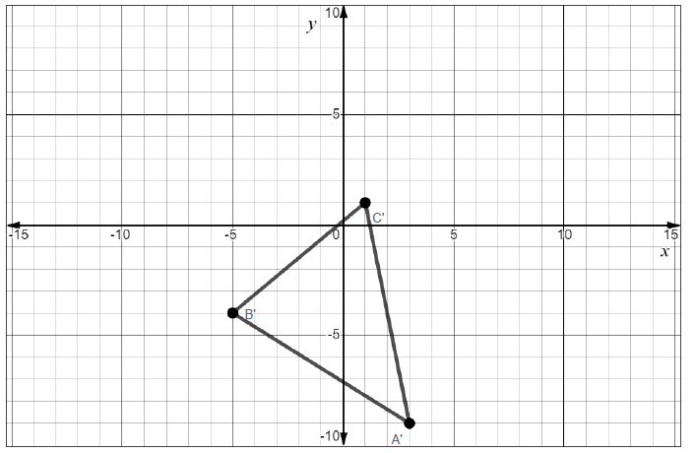
c. __________________ | d. ___________________

- Given $∆JKL$ where J is (-9,-5), K is (-8,1), and L is (-3,-4), complete the following transformations.

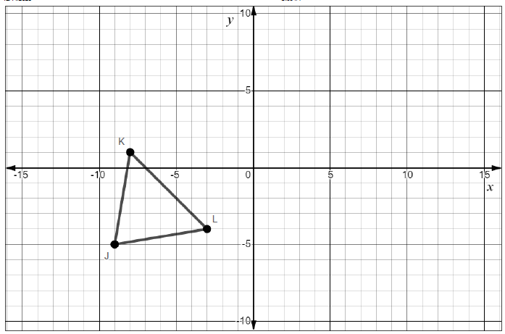

  - $∆J^{'}K^{'}L^{'}$ is created by reflecting $∆JKL$ across $y=-x$. Graph $∆J^{'}K^{'}L^{'}$.

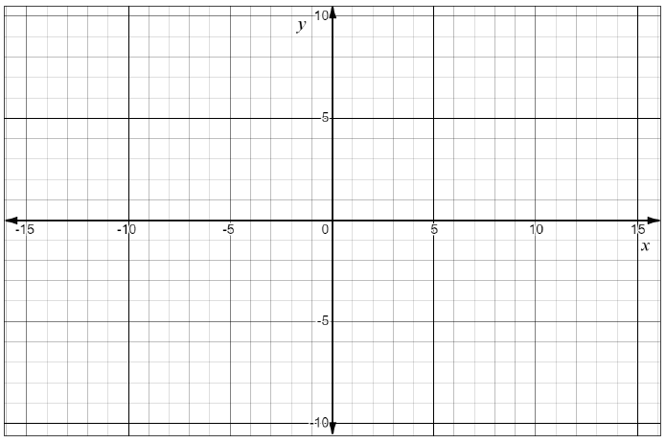

  - $∆J^{'}'K^{''}L^{''}$ is created by rotating $∆JKL$ counterclockwise $90°$. Graph $∆J^{'}'K^{''}L^{''}$.

- The diagram shows two quadrilaterals graphed on a coordinate plane. Describe the transformation that maps Quadrilateral ABCD to Quadrilateral RSTU.
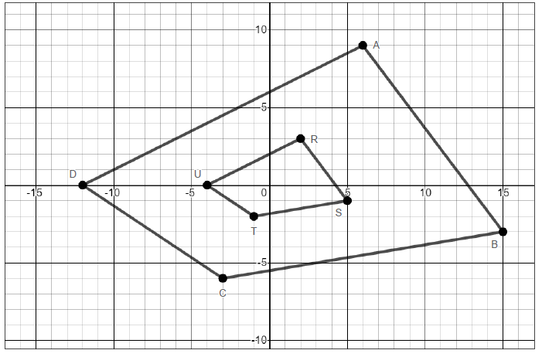

- Please use the graph below. Miguel thinks the transformation that describes how Quadrilateral PQRS is mapped to Quadrilateral TUWX is a clockwise rotation of $180°$ about the origin. Keisha thinks the transformation that describes how Quadrilateral PQRS is mapped to Quadrilateral TUWX is a reflection across the y-axis followed by a reflection across the x-axis. Who is correct? How do you know?
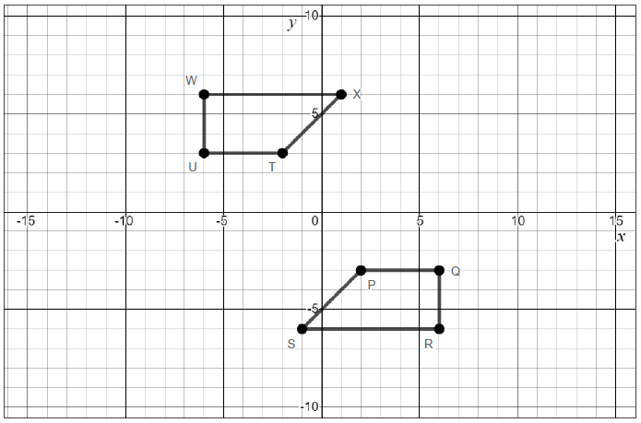

SOL G.3d - Just in Time Quick Check Teacher Notes
Common Errors/Misconceptions and their Possible Indications
            - Given Triangle ABC on the coordinate plane, state the transformation that best describes each graph.

Possible Transformations
A reflection across x=2 | A rotation clockwise$90°$
A reflection across y=x | A translation left 10 and down 3
a. __________________ | b. ___________________
c. __________________ | d. ___________________

Parts a and c: A common error a student may make is to confuse the reflection across y=x with the translation left 10 and down 3 or the reflection across x=2. This may indicate that the student is not graphing the line y=x correctly or struggles with reflecting across non-vertical or non-horizontal lines. Teachers are encouraged to have students identify patterns in the relationship with the rule and the actual transformation. The Desmos “Des-Patterns” activity provides an opportunity for students to help make connections to the pattern and the rule.

Parts b and d: Another common error a student may make is to confuse the rotation clockwise $90°$ with the reflection across x=2. This may indicate the student is mistaking a counterclockwise rotation for a clockwise rotation. Teachers are encouraged to use patty paper with students to have them physically rotate the figure or simply practice turning a figure on a piece of graph paper a full 90 degrees to illustrate 90 degree rotations. In addition, the Desmos activity “Transformation Golf: Rigid Motion” allows students to practice with various types of transformations.

            - Given $∆JKL$ where J is (-9,-5), K is (-8,1), and L is (-3,-4), complete the following transformations.

  - $∆J^{'}K^{'}L^{'}$ is created by reflecting $∆JKL$ across $y=-x$. Graph $∆J^{'}K^{'}L^{'}$.
A common error a student may make is to forget to take the opposite sign of the ordered pairs when using the rule to reflect $∆JKL$ across $y=-x$. For instance, a student may plot the points (-5,-9), (1,-8) and (-4,-3) which is a reflection across $y= x.$ This may indicate that a student has incorrectly memorized the rule for reflecting across $y=-x$. If a student has chosen to find the transformation graphically and drawn the line correctly but does not have the correct triangle drawn, this may indicate a student is trying to reflect the triangle across $y= -x$in the same manner as he/she would a vertical or horizontal line. In other words, the student may attempt to move the triangle horizontally or vertically rather than using the line for reflection. Teachers are encouraged to use Desmos or another dynamic graphing software to help illustrate transformations. In addition, some students may benefit from using patty paper to create transformations.

  - $∆J^{'}'K^{''}L^{''}$ is created by rotating $∆JKL$ counterclockwise $90°$. Graph $∆J^{'}'K^{''}L^{''}$.
A common error a student may make is to rotate the figure clockwise instead of counterclockwise. This may indicate that the student is confused about the vocabulary associated with clockwise and counterclockwise. Teachers may wish to use the visual of an analog clock to help students determine the correct direction or do a comparison between clockwise/counterclockwise to see how they are alike and different.

- The diagram shows two quadrilaterals graphed on a coordinate plane. Describe the transformation that maps Quadrilateral ABCD to Quadrilateral RSTU.

A common error a student may make is to state the transformation is a dilation by a scale factor of 3 centered at the origin. This may indicate that the student has started with the wrong quadrilateral or has incorrectly concluded that dilations only enlarge a figure. Teachers may consider using the VDOE MIPS G.3d Transformations lesson to familiarize students with transformations. In addition, teachers are encouraged to use real life examples of dilations, such as one’s eyes when dilated, and architecture to illustrate that dilations can be enlargements or reductions of a figure.
- Please use the graph below. Miguel thinks the transformation that describes how Quadrilateral PQRS is mapped to Quadrilateral TUWX is a clockwise rotation of $180°$ about the origin. Keisha thinks the transformation that describes how Quadrilateral PQRS is mapped to Quadrilateral TUWX is a reflection across the y-axis followed by a reflection across the x-axis. Who is correct? How do you know?

A common misconception a student may have is that only Miguel or Keisha are correct instead of both individuals. This may indicate the student thinks only one transformation or sequence of transformations can map one figure onto another. Teachers are encouraged to use examples where students have the opportunity to see that there is more than one combination of transformations that can map one figure onto another. The Desmos activity “Transformation Golf: Rigid Motion” is also an opportunity for students to experience more than one sequence of transformations mapping a pre-image to an image.

