Just In Time Quick Check
Standard of Learning (SOL) G.3b
Strand: Reasoning, Lines, and Transformations

Standard of Learning (SOL) G.3b
The student will solve problems involving symmetry and transformation. This will include applying slope to verify and determine whether lines are parallel or perpendicular.

Grade Level Skills:
- Compare the slopes to determine whether two lines are parallel, perpendicular, or neither.

Just in Time Quick Check

Just in Time Quick Check Teacher Notes

Supporting Resources:
- VDOE Mathematics Instructional Plans (MIPS)
  - G.3ab - Slope with Desmos (Word) / PDF Version
- VDOE Word Wall Cards: Geometry (Word)|(PDF)
  - Parallel Lines
  - Perpendicular Lines
  - Slope Formula
  - Slopes of Lines in Coordinate Plane
- Other VDOE Resources
  - Geometry, Module 3, Topic 3 - Slopes of Parallel and Perpendicular Lines [eMediaVA]
Supporting and Prerequisite SOL: G.4c, G.4d, G.4g, A.6a, A.6b, A.6c, 8.16d, 7.10a, 6.8a, 6.8b

SOL G.3b - Just in Time Quick Check

- Determine if the following lines are parallel, perpendicular, or neither. Explain your answer.

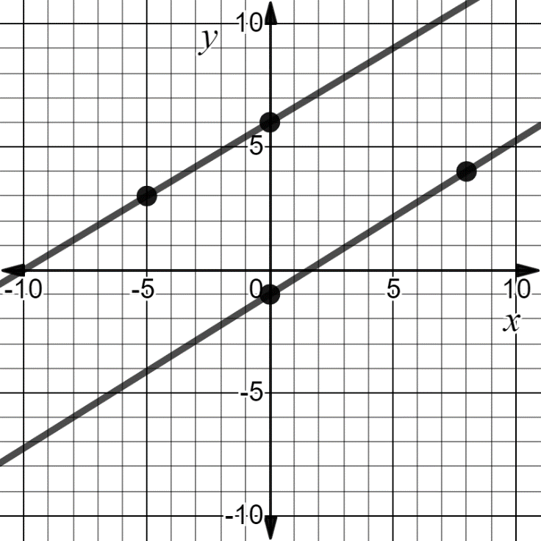

Parallel Perpendicular Neither

Explanation:

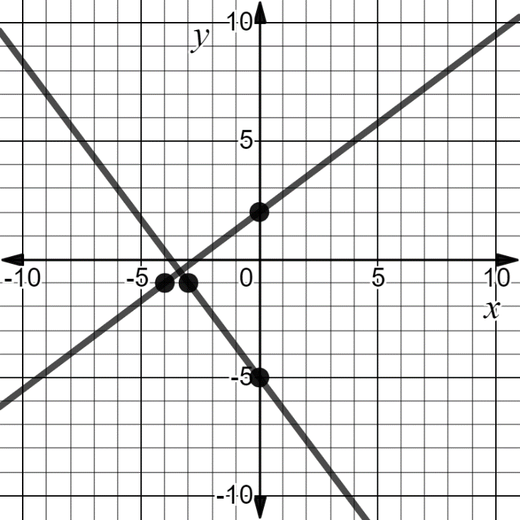

Parallel Perpendicular Neither

Explanation:

- Ashley and Alexandro have to determine if the two lines, $y=-2x+7$ and $6x+3y=21$, are parallel, perpendicular, or neither. Ashley thinks the lines are parallel. Alexandro thinks the lines are neither.

Who is correct? Explain your answer.

- The following graph contains line$l$ and point $M$. Line $l$ contains points $(-5, 5)$ and $(5, 1)$. Point $M$ is located at $M (-4, -3)$.
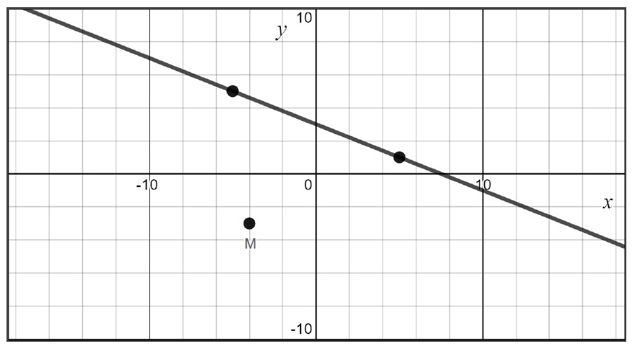

  - State the perpendicular slope of line $l$. Slope: _________
  - Plot another point with integral coordinates that lies on a line parallel to line $l$and passes through point $M$.

- Which set of equations are parallel, perpendicular, or neither? Place the set of equations in the appropriate box.

a. $2x+y=5$ b. $y=\frac{7}{9}x-4$ c. $3x+5y=9$
$y=\frac{1}{2}x+3$ $y=\frac{9}{7}x+3$ $12x+20y=18$

Parallel | Perpendicular | Neither

SOL G.3b - Just in Time Quick Check Teacher Notes
Common Errors/Misconceptions and their Possible Indications

- Determine if the following lines are parallel, perpendicular, or neither. Explain your answer.

Parallel Perpendicular Neither

Explanation:

A common error that students may make is assume that the two lines are parallel. This may indicate that the student has determined parallelism by looking at the graph and assuming the lines do not intersect rather than verifying the slopes algebraically or graphically. Teachers are encouraged to have students practice verifying the slope of the given lines to prove whether lines are parallel, perpendicular, or neither. Since a graph of the lines in already provided, teachers may encourage students to use $\frac{Rise}{Run}$ to avoid students having to identify the coordinates of points on each line. The VDOE Vocabulary Word Wall cards may also be helpful in reinforcing the definition of parallel and perpendicular lines.

Parallel Perpendicular Neither

Explanation:

A common error that students may make is to assume that these two lines are perpendicular based solely on sight. This may indicate that the student understands that perpendicular lines intersect at a right angle but does not have a solid understanding that the two slopes are negative reciprocals of each other. Teachers are encouraged to have students practice verifying the slope of the given lines to prove whether lines are parallel, perpendicular, or neither. Since a graph of the lines is already provided, teachers may encourage students to use $\frac{Rise}{Run}$ . The VDOE Vocabulary Word Wall cards may also be helpful in reinforcing the definition of parallel and perpendicular lines.

- Ashley and Alexandro have to determine if the two lines, $y=-2x+7$ and $6x+3y=21$, are parallel, perpendicular, or neither. Ashley thinks the lines are parallel. Alexandro thinks the lines are neither.

Who is correct? Explain your answer.

A common misconception is a student may assume the lines are parallel because they have the same slope. This may indicate that the student has not recognized that the two equations are the same when simplified. Teachers are encouraged to have students graph the equations of their lines as well as another way to support their answer. In this instance, if a student is using a graphing calculator or Desmos, it can be easily seen that the two equations are the same line.

- The following graph contains line$l$ and point $M$. Line $l$ contains points $(-5, 5)$ and $(5, 1)$. Point $M$ is located at $M (-4, -3)$.

  - State the perpendicular slope of line $l$. Slope: _________
A common error a student may make is state the slope is $-\frac{5}{2}$ . This may indicate that the student thinks the perpendicular slope is only the reciprocal of the slope rather than the negative reciprocal. Teachers are encouraged to use the VDOE Vocabulary Word Wall cards to help reiterate the definition of perpendicular slopes. It may also help some students to interchange the use of negative reciprocal with opposite reciprocal. Therefore, students can understand that “negative” means the “opposite sign” and “reciprocal” is the inverse of the fraction.

  - Plot another point with integral coordinates that lies on a line parallel to line $l$and passes through point $M$.

Some students may confuse the words “parallel” and “perpendicular” with one another and plot a point on the line perpendicular to line l. Other students may confuse slope and use run/rise. Using the VDOE Vocabulary Word Wall cards will provide a reminder of these definitions. These students may also benefit from practicing plotting points on parallel and perpendicular lines on a “life-size” coordinate plane placed on a classroom floor or outside. Another strategy is to have students think about slope as if they are seated; they must first rise from their seat before they can walk to a location.

- Which set of equations are parallel, perpendicular, or neither? Place the set of equations in the appropriate box.

a. $2x+y=5$ b. $y=\frac{7}{9}x-4$ c. $3x+5y=9$
$y=\frac{1}{2}x+3$ $y=\frac{9}{7}x+3$ $12x+20y=18$

Parallel | Perpendicular | Neither

A common error some students may make is to incorrectly solve one of the equations for y which may produce an incorrect slope. This may indicate that a student struggles with algebraically isolating a variable on one side of the equation or does not realize they need to isolate the variable prior to comparing the slopes. Teachers are encouraged to have students graph the lines on a graphing calculator or Desmos so students can count the slope directly from the graph. This will help students combat making an error when solving for y.

