Just In Time Quick Check
Standard of Learning (SOL) G.3a
Strand: Reasoning, Lines, and Transformations

Standard of Learning (SOL) G.3a
The student will solve problems involving symmetry and transformation. This will include investigating and using formulas for determining distance, midpoint, and slope.

Grade Level Skills:
- Determine the coordinates of the midpoint or endpoint of a segment, using the midpoint formula.
- Use a formula to determine the slope of a line.
- Apply the distance formula to determine the length of a line segment when given the coordinates of the endpoints.

Just in Time Quick Check

Just in Time Quick Check Teacher Notes

Supporting Resources:
- VDOE Mathematics Instructional Plans (MIPS)
  - G.3ab - Slope with Desmos (Word) / PDF Version
  - G.3a - Distance, Midpoint, and Slope (Word) / PDF Version
- VDOE Word Wall Cards: Geometry (Word)|(PDF)
  - Midpoint (Definition)
  - Midpoint Formula
  - Finding a Missing Endpoint
  - Slope Formula
  - Slopes of Lines in Coordinate Plane
  - Distance Formula
- Desmos Activity
  - Exploring Length with Geoboards
  - Triangle Fundamentals
Supporting and Prerequisite SOL: A.3a, A.6a, 8.3a, 8.3b, 8.9b, 8.16a, 8.16b. 7.10a, 6.8a, 6.8b

SOL G.3a - Just in Time Quick Check

- Given G (3, -1) and H (-9, 7), what is the slope of line $\overset{⃡}{GH}$ ? Please show your work and explain your thinking.

- Given A (3, -4), B (-10, -4), C (-2, 5) and D (3, -7). Determine if $\overline{AB}$ and $\overline{CD}$ are congruent segments. Please show your work and explain your thinking.

- Given: Parallelogram ABCD where A (-8, 9), B (4, 7), C (8, -4), and D (-4, -2). State the coordinates of the midpoint of diagonal $\overline{BD}$. Please show your work and explain your thinking.

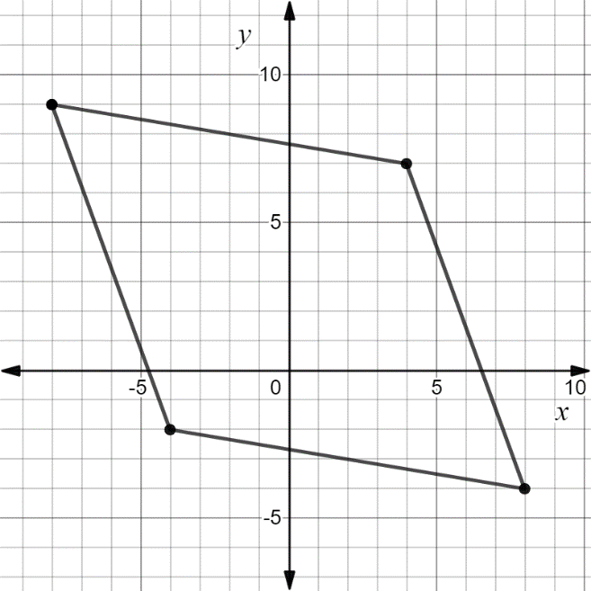
A
B
D
C

- A line segment $\overline{AB}$ has a midpoint M. If the endpoint B is (5, -11) and the midpoint M is (-2, -6), what are the coordinates of A? Explain your reasoning.

SOL G.3a - Just in Time Quick Check Teacher Notes
Common Errors/Misconceptions and their Possible Indications

- Given G (3, -1) and H (-9, 7), what is the slope of line $\overset{⃡}{GH}$ ? Please show your work and explain your thinking.
A common error a student may make is writing the slope as $\frac{-3}{2}$ . This may indicate that the student believes the slope formula to be $\frac{x_{2}-x_{1} }{y_{2}-y_{1}}$ instead of $\frac{y_{2}-y_{1}}{x_{2}-x_{1}}$ . This student may benefit from making connections to prior learning experiences where slope is considered to be a rate of change and using slope triangles. Teachers may also encourage students to think about slope as $\frac{Rise}{Run}$ since when you rise you move up which represents the change in the y-values and when you run you can go left/right which represents the change in the x-values.
Another common error a student may make is writing the slope as $\frac{3}{2}$ Teachers may also note that some students will make the error of using a positive value for the slope. This student may benefit from stacking the ordered pairs or writing the ordered pairs in a table to avoid transposing the order of subtracting the x and y-values. Teachers may want to encourage students that make this common error to graph $\overset{⃡}{GH}$ and look at the slant of the line. If the slope is positive, then the line rises from left to right. If the slope is negative, the line will fall from left to right. The VDOE Slope Formula Word Wall Card may also be helpful in reinforcing the slope formula.

- Given A (3, -4), B (-10, -4), C (-2, 5) and D (3, -7). Determine if $\overline{AB}$ and $\overline{CD}$ are congruent segments. Please show your work and explain your thinking.

A common error some students might make is incorrectly identifying and substituting the values of $\left(x_{1},y_{1}\right)$ and $\left(x_{2},y_{2}\right)$ into the distance formula. This might indicate a student struggles to correctly identify x and y values in an ordered pair. A strategy that teachers may use is to have students to stack the ordered pairs of the endpoints, so that the x and y values are respectively above each other. Teachers may use highlighting to identify x and y values in the coordinate pairs and in the distance formula.

Another error some students may make while finding the length of $\overline{AB}$ and $\overline{CD}$ by graphing is counting the length of each line segment directly from the graph. Since $\overline{AB}$ is a horizontal line, the length of the line segment can be determined from the coordinate plane. However, a misconception some students may make is estimating the length of $\overline{CD}$ to be a number other than 13 but in the range of 12 and 14. Teachers are encouraged to demonstrate using the Pythagorean Theorem to find the length of $\overline{CD}.$ Teachers may also share that students can verify their answers by graphing using dynamic geometry software. For example, in Desmos, teachers may have students graph the points C and D and use the Desmos distance function. To use the distance function in Desmos, type in:
distance ((coordinate pair 1), (coordinate pair 2)).

- Given: Parallelogram ABCD where A (-8, 9), B (4, 7), C (8, -4), and D (-4, -2). State the coordinates of the midpoint of diagonal $\overline{BD}$. Please show your work and explain your thinking.

A
B
D
C

A common error a student might make is assume the coordinates of the midpoint are both integers. This might indicate that the student visually estimated the midpoint and did not use the midpoint formula. Teachers may want to encourage students to use the midpoint formula if it is difficult to determine the midpoint graphically. The Desmos midpoint function may also be used to verify the midpoint once students have completed the initial work. To use the midpoint function, type in: midpoint((coordinate pair 1), (coordinate pair 2)).

- A line segment $\overline{AB}$ has a midpoint M. If the endpoint B is (5, -11) and the midpoint M is (-2, -6), what are the coordinates of A? Please show your work and explain your thinking.

A common error a student might make is to substitute the coordinates of M and B into the midpoint formula to solve for the midpoint instead of the missing endpoint. This may indicate that the student did not draw a diagram and label the given information. Teachers may want to encourage students to highlight or label given information provided in the problem and sketch or graph if a diagram is not provided. Some students can properly substitute the values into the midpoint formula but may be confused as how to simplify the resulting expression. This may indicate a student’s algebraic misunderstanding in solving proportional equations. Teachers may want to help students recognize that finding the missing endpoint is essentially solving for the midpoint in reverse. Therefore, students can double the midpoint and subtract the other endpoint. In addition, teachers may want to post or make the VDOE Word Wall cards accessible to students. To encourage the use of multiple representations, it may be helpful to show students how to solve this type of problem on the coordinate plane by making the connection that the missing endpoint can be found by creating two congruent segments. Using two congruent right triangles may be helpful when demonstrating how to create the two congruent segments. Students who are using a coordinate plane can also use the slope by counting the rise and run from the endpoint to the midpoint and repeating that rise and run from the midpoint to the second endpoint

