Just In Time Quick Check
Standard of Learning (SOL) G.2b
Strand: Reasoning, Lines, and Transformations

Standard of Learning (SOL) G.2b
The student will use the relationships between angles formed by two lines intersected by a transversal to solve problems, including practical problems, involving angles formed when parallel lines are intersected by a transversal.

Grade Level Skills:
- Solve problems by using the relationships between pairs of angles formed by the intersection of two parallel lines and a transversal including corresponding angles, alternate interior angles, alternate exterior angles, same-side (consecutive) interior angles, and same-side (consecutive) exterior angles.
- Solve problems, including practical problems, involving intersecting and parallel lines.

Just in Time Quick Check

Just in Time Quick Check Teacher Notes

Supporting Resources:
- VDOE Mathematics Instructional Plans (MIPS)
  - G.2ab - Parallel Lines and Angle Relationships (Word) / PDF Version
- VDOE Word Wall Cards: Geometry (Word)|(PDF)
  - Parallel Lines
  - Transversal
  - Corresponding Angles
  - Alternate Interior Angles
  - Alternate Exterior Angles
  - Consecutive Interior Angles
- VDOE Rich Mathematical Tasks: Lines and Tigers and Bears, Oh My! Task
  - G.2 Lines and Tigers and Bears, Oh My! Task Template (Word) / PDF Version
  - G.2 Lines and Tigers and Bears, Oh My! Student Version of Task (Word) / PDF Version
- Other VDOE Resources
  - Geometry, Module 2, Topic 1 - Angles Formed by a Transversal Intersecting Parallel Lines [eMediaVA]
  - Geometry, Module 2, Topic 2 - Practical Problems [eMediaVA]
- Desmos Activity
  - Lines, Transversals, and Angles
Supporting and Prerequisite SOL: A.4a, A.4e, 8.5, 8.14b, 8.17, 7.12

SOL G.2b - Just in Time Quick Check

- Given $c∥d$, solve for x.

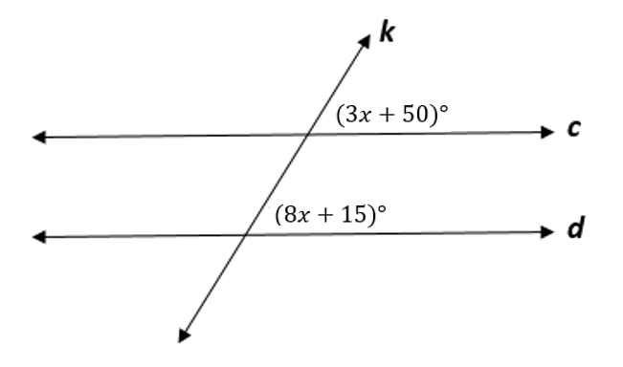

- Line$j$ is parallel to line $k$. Find the $m∠GFH$.

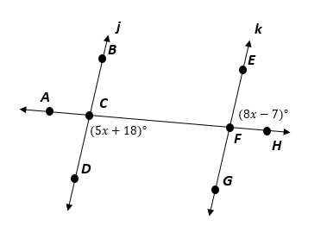

- A new crosswalk is being built between the parallel sidewalks of Circle Avenue. The edges of the crosswalk are parallel. One angle that the crosswalk makes with the sidewalk measures 78 degrees, as shown. Fill in the boxes to determine the measures of the missing angles.
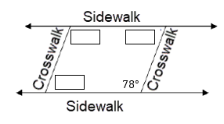
- Given $b∥c$ , fill in the boxes with the measures of the missing angles.

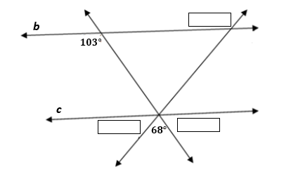
- Given $c∥e$ and $f∥g,$ describe how you would find the value of x.

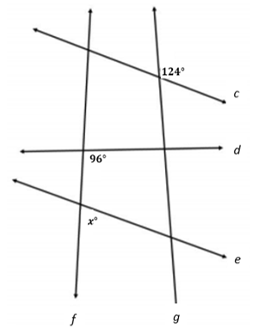

SOL G.2b - Just in Time Quick Check Teacher Notes
Common Errors/Misconceptions and their Possible Indications

- Given $c∥d$, solve for x.
A common error a student may make is set 3x+50+8x+15=180. This may indicate that the student has assumed that all angles that are on the same side are supplementary. A strategy that may help students determine if the angles are congruent or supplementary is to encourage students to identify the acute and obtuse angles. All acute angles formed by parallel lines cut by a transversal are congruent, as are all obtuse angles formed by these lines. Using the VDOE Word Wall Cards may help remind students of the various angle relationships associated with parallel lines.

- Line$j$ is parallel to line $k$. Find the $m∠GFH$.
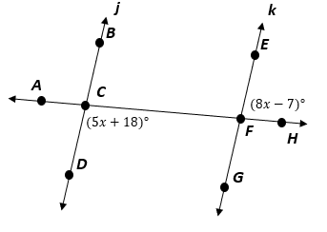
A common error a student may make is to solve for x but not find the angle measure. Another error some students may make is to find the value of x and substitute it into the wrong expression. This may indicate that the student does not recognize the congruent relationship between $∠DCF$ and $∠GFH$ or the linear pair relationship between $∠EFH$and $∠GFH$. Teachers can use the acute and obtuse angle strategy mentioned in question #1 or use patty paper to help students determine other angles that may be congruent to m$∠GFH$. The Parallel Line and Angle Relationships MIPS lesson may also be helpful in allowing students to discover angle relationships in parallel lines.

- A new crosswalk is being built between the parallel sidewalks of Circle Avenue. The edges of the crosswalk are parallel. One angle that the crosswalk makes with the sidewalk measures 78 degrees, as shown. Fill in the boxes to determine the measures of the missing angles.
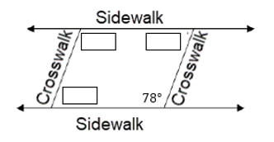
A common misconception a student may have is to think that there is not enough information available to solve the problem. This may indicate that the student does not recognize the angle relationships in parallel lines since the crosswalk lines are not extended. A teacher may encourage students to extend lines in pictures to visualize more easily the parallel lines and the angle relationships.

- Given $b∥c$ , fill in the boxes with the measures of the missing angles.

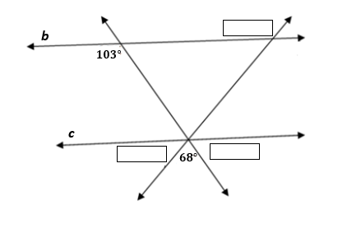

A common error a student may make is assume the other obtuse angle is $103°$ as well. This may indicate that the student assumes that both transversals create the same angle measurements. Teachers may encourage students to cover the transversal that is not being used so the problem appears simpler. Teachers may have students complete the Lines and Tigers and Bears, Oh My! Task to help them become more familiar with having parallel lines with non-parallel transversals in the same picture.

- Given $c∥e$ and $f∥g,$ describe how you would find the value of x.

A common error a student may make is to assume x is equal to $96°$ since x and $96°$ are corresponding angles. This may indicate that a student thinks that congruent and supplementary angle relationships in parallel lines hold true for non-parallel lines. Teachers may encourage students to cover the non-parallel transversal. The Lines and Tigers and Bears, Oh My! Task may help students become more familiar with having parallel lines with non-parallel transversals in the same picture.

