Just In Time Quick Check
Standard of Learning (SOL) G.2a
Strand: Reasoning, Lines and Transformations

Standard of Learning (SOL) G.2.a
The student will use the relationships between angles formed by two lines intersected by a transversal to prove two or more lines are parallel.

Grade Level Skills:
- Prove two or more lines are parallel given angle measurements expressed numerically or algebraically
- Prove two lines are parallel using deductive proofs given relationships between and among angles

Just in Time Quick Check

Just in Time Quick Check Teacher Notes

Supporting Resources:
- VDOE Mathematics Instructional Plans (MIPS)
  - G.2ab - Parallel Lines and Angle Relationships (Word) / PDF Version
- VDOE Word Wall Cards: Geometry (Word)|(PDF)
  - Parallel Lines
  - Transversal
  - Consecutive Interior Angles
  - Corresponding Angles
  - Alternate Interior Angles
  - Alternate Exterior Angles
  - Corresponding Angles
- VDOE Instructional Videos for Teachers:
- Other VDOE Resources
  - Geometry, Module 2, Topic 1 - Angles Formed by a Transversal Intersecting Parallel Lines [eMediaVA]
- Desmos Activity
  - Lines, Transversals, and Angles
Supporting and Prerequisite SOL: G.4g, A.4a, A.4e, 8.5, 8.14b, 8.17, 7.12, 6.9

SOL G.2a - Just in Time Quick Check

- Using the given diagram, determine two different angle relationships that would prove line m $∥$ n. State the postulate or theorem that justifies each answer.
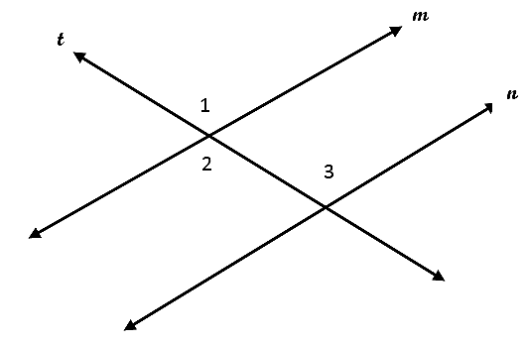

- Given:
$m∠1=(7x+13)°$
$m∠2=(3x-25)°$
$m∠3=(2x+5)°$

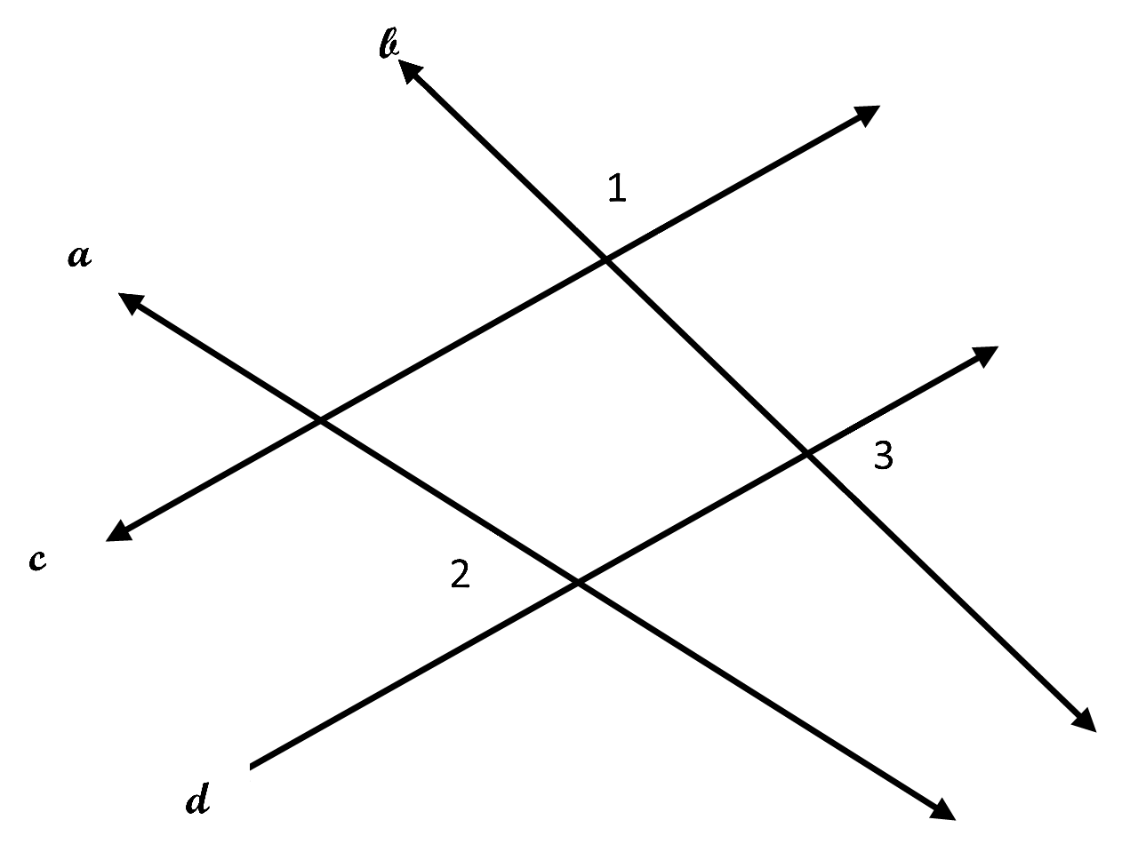

What value of x could be used to prove $c∥d$?

- Circle each statement that can be used to prove $m∥n and p∥q$. There may be more than one answer. Explain your reasoning.

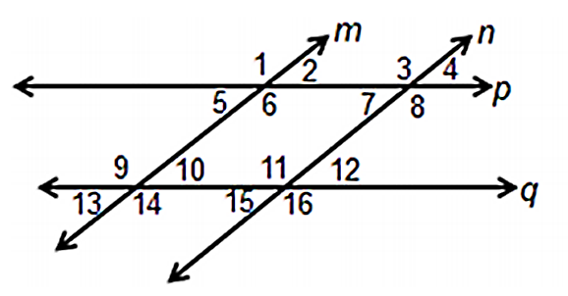

$$∠2≅∠5 and ∠13≅∠15$$ | $$m∠9+m∠12=180° and ∠1≅∠3$$
$$m∠1+m∠4=180° and ∠8≅∠16$$ | $$∠9≅∠16 and m∠11+m∠7=180°$$
$$m∠6+m∠7=180° and ∠3≅∠11$$ | $$m∠14+m∠15=180° and ∠1≅∠16$$

- Complete the two-column proof using the diagram below. Explain your reasoning using valid statements, reasons, and mathematical notation.
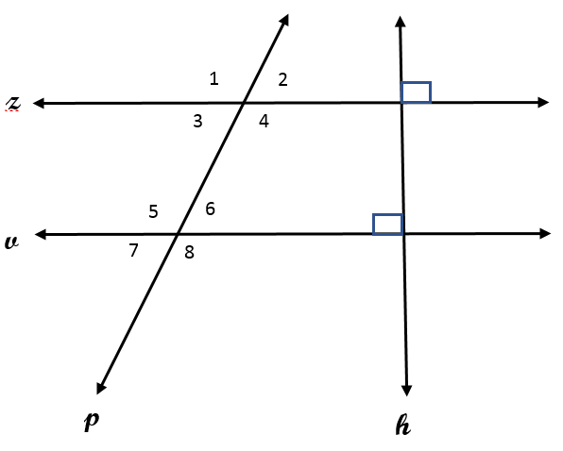

 | Statement | Reason
Given: $z⊥h, h⊥v,$ | - $z⊥h, h⊥v, m∠2=72°$ | - Given
$$m∠2=72°$$ | - $z∥v$
Prove: $m∠6=72°$
 | - $m∠6=72°$

SOL G.2.a - Just in Time Quick Check Teacher Notes
Common Errors/Misconceptions and their Possible Indications

- Using the given diagram, determine two different angle relationships that would prove line m $∥$ n. State the postulate or theorem that justifies each answer.

A common error that some students may make is not stating both angle relationships. Some students can identify that angle 2 and angle 3 are alternate interior angles and other students can identify that angle 1 and angle 3 are corresponding angles. Still other students recognize that angle 1 is congruent to angle 2, but they do not realize that this relationship does not prove lines are parallel. Teachers are encouraged to provide additional opportunities for identifying angle relationships and determining which relationships can be used to prove lines are parallel. Teachers should use the VDOE Vocabulary Word Wall Cards to help student make angle connections.

- Given:
$m∠1=(7x+13)°$
$m∠2=(3x-25)°$
$m∠3=(2x+5)°$

What value of x could be used to prove $c∥d$?

A common error that some students may make is using angle 2 and angle 3 to find the value of x. Students are asked to prove that lines c and d are parallel. This misconception may indicate students are using the wrong transversal to identify parallel lines. Students making this error may benefit from highlighting or coloring lines c and d and the related angles. Teachers may wish to ask questions such as—What are the angles associated with transversal a? Transversal b? What type of angles are they? What is their relationship? Another strategy that may benefit some students is using dynamic software to discover properties of angles along a transversal. This allows students to observe congruent and supplementary angles connected to parallel lines. As students move the transversal, and the diagram shifts, the angle measures will update.

- Circle each statement that can be used to prove $m∥n and p∥q$. There may be more than one answer. Explain your reasoning.

$$∠2≅∠5 and ∠13≅∠15$$ | $$m∠9+m∠12=180° and ∠1≅∠3$$
$$m∠1+m∠4=180° and ∠8≅∠16$$ | $$∠9≅∠16 and m∠11+m∠7=180°$$
$$m∠6+m∠7=180° and ∠3≅∠11$$ | $$m∠14+m∠15=180° and ∠1≅∠16$$

A common error some students may make is to incorrectly identify the supplementary pairs of angles as congruent and the congruent pairs of angles as supplementary. Other students make the error of trying to use the relationship between vertical angles to prove lines parallel. Still others may attempt to make relationships between angles that are not on the same transversal. These students may benefit from color-coding to show the relationships between angles on the same transversal. Another strategy that may benefit some students is to use graph paper and a straight edge to model lines that are NOT parallel and to model lines that are parallel. Students would then use a protractor to measure angles created by a transversal to determine those angles that are congruent and angles that are supplementary. During this activity, students would also benefit from a discussion of the angles that can be used to verify parallelism.

- Complete the two-column proof using the diagram below. Explain your reasoning using valid statements, reasons, and mathematical notation.
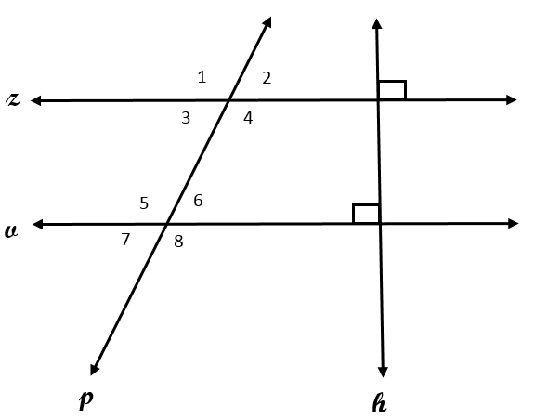

 | Statement | Reason
Given: $z⊥h, h⊥v,$ | - $z⊥h, h⊥v, m∠2=72°$ | - Given
$$m∠2=72°$$ | - $z∥v$
Prove: $m∠6=72°$
 | - $m∠6=72°$

Some students may be able to explain verbally why line z is parallel to line v, but they may not know the theorem well enough to state it as the reason for statement 2. Other students may have difficulty figuring out how to use statement 2 to help them make the connection to what they are trying to prove. All students will benefit from marking the figure with the given information and then identifying what they want to prove. Color-coding may also help some students determine angle relationships in the figure.

