Just In Time Quick Check
Standard of Learning (SOL) AII.9
Strand: Statistics

Standard of Learning (SOL) AII.9
The student will collect and analyze data, determine the equation of the curve of best fit in order to make predictions, and solve practical problems, using mathematical models of quadratic and exponential functions.

Grade Level Skills:
- Determine an equation of the curve of best fit, using a graphing utility, given a set of no more than 20 data points in a table, graph, or practical situation.
- Make predictions, using data, scatterplots, or the equation of the curve of best fit.
- Solve practical problems involving an equation of the curve of best fit.
- Evaluate the reasonableness of a mathematical model of a practical situation.

Just in Time Quick Check

Just in Time Quick Check Teacher Notes

Supporting Resources:
- VDOE Mathematics Instructional Plans (MIPS)
  - AII.9 Curve of Best Fit (Word) / PDF Version
- VDOE Word Wall Cards: Algebra II (Word) | (PDF)
  - Scatterplot,
  - Positive Linear Relationship (Correlation)
  - Negative Linear Relationship (Correlation)
  - No Correlation
  - Curve of Best Fit (linear)
  - Curve of Best Fit (quadratic)
  - Curve of Best Fit (exponential)
  - Outlier Data (graphic)
- Desmos Activity
  - Regression Activity
  - Card Sort: Modeling
Supporting and Prerequisite SOL: AII.6a, AII.6b, AII.7g, A.6c, A.7f, A.9, 8.13a, 8.13b, 8.13c, 8.16d, 8.16e

SOL AII.9 - Just in Time Quick Check

- The chart below shows the profits earned per week by a business during the first 7 weeks after opening.
Week | 1 | 2 | 3 | 4 | 5 | 6 | 7
Profit (in thousands of dollars) | 4.1 | 0.8 | 0 | 1.1 | 5 | 8.5 | 16.7
- Write a regression equation to model the situation. Explain why you chose this particular model.

- If your profits continue to grow in the same manner, in what week would you expect your profits to reach $30,000?

- The table below shows the U.S. population (measured in millions) for various years since 1800.
Years since 1800 | 0 | 10 | 20 | 30 | 40 | 50 | 60
Population (in millions) | 5.31 | 7.24 | 9.64 | 12.87 | 17.07 | 23.19 | 31.44
- Marcus thinks that this data would best be modeled by a linear function. Trena thinks that an exponential model would be a better model. With whom do you agree? Justify your thinking.

- Calculate a curve of best to fit to model the data and use it to predict the U.S. population in 1836.

- The set of data shown in the scatterplot is provided in the table below:

$$x$$ | $$y$$
-9 | 5
-8 | 0
-7 | -1
-7 | -2
-5 | -3
-4 | -4
-2 | -2
-1 | -2
-1 | -1
0 | 0
1 | 1
2 | 5
2 | 3
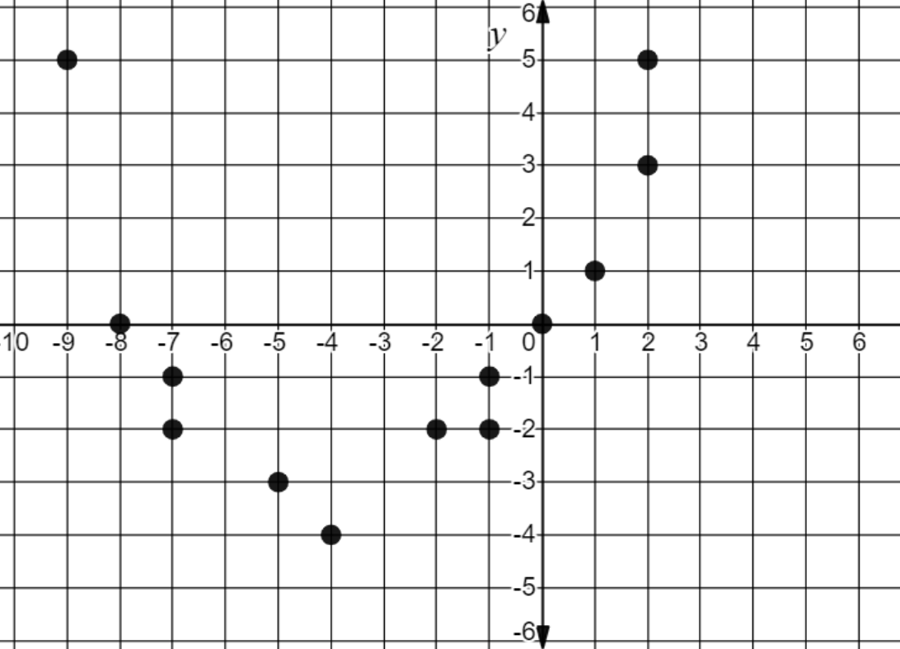
$$x$$

- Use a graphing utility to find the equation of the quadratic curve of best fit. Round to the nearest hundredth.
- Add one additional point to the scatterplot shown above that would be located on or near the curve you calculated in part a) Write the ordered pair here: ( ____ , ____ )
- Predict the value(s) of x when the y-value is 6.

SOL AII.9 - Just in Time Quick Check Teacher Notes
Common Errors/Misconceptions and their Possible Indications

- The chart below shows the profits earned per week by a business during the first 7 weeks after opening.
Week | 1 | 2 | 3 | 4 | 5 | 6 | 7
Profit (in thousands of dollars) | 4.1 | 0.8 | 0 | 1.1 | 5 | 8.5 | 16.7
- Write a regression equation to model the situation. Explain why you chose this particular model.
A common error some students may make is to calculate a line of best fit. This may indicate that the students incorrectly assume that profits would increase at a constant rate and therefore follow a linear model, without first graphing the data to examine the pattern. A potential teaching strategy is to give students data from multiple contexts emphasizing the graphing process as a first step to analyze the type of pattern created by the data points.
- If your profits continue to grow in the same manner, in what week would you expect your profits to reach $30,000?
A common error that some students may make is to substitute the given value as the independent versus dependent variable. This may indicate that the students are not using the context of the problem to interpret the meaning of the data. As a strategy to determine the reasonableness of the prediction, encourage students to graph the ordered pair using a graphing utility to ensure that it follows the pattern of the given data set.

- The table below shows the U.S. population (measured in millions) for various years since 1800.
Years since 1800 | 0 | 10 | 20 | 30 | 40 | 50 | 60
Population (in millions) | 5.31 | 7.24 | 9.64 | 12.87 | 17.07 | 23.19 | 31.44
- Marcus thinks that this data would best be modeled by a linear function. Trena thinks that an exponential model would be a better model. With whom do you agree? Justify your thinking.
A common misconception that some students may have is to assume that the data pattern is linear since the independent values are increasing at a constant rate. This could indicate that students may not recognize that the changes in both the independent and dependent values must be considered when determining a model that might best fit a set of data. A potential teaching strategy would be to use a graphing utility to graph the data points and have students determine what parent function best models the graph. Once they have done this, then sketch a curve that students think may best fit the data, and then calculate the actual equation to check the fit.
- Calculate a curve of best to fit to model the data and use it to predict the U.S. population in 1836.
A common error that some students may make is to calculate the curve of best fit using Desmos and incorrectly input the exponential model equation. This may indicate that students are not familiar with the function families and how the parameters affect the form of the equation. Teachers may wish to have students explore scatterplots of data and sort them by which curve of best fit may best be used to model the data. Students can then, by trial and error, change the parameters of the parent function to best fit each set of data.

A common error other students may make is to think they should use 1836 for the x-value to calculate the prediction. This indicates students understand that they are predicting the y-value (population) but are unfamiliar with the context of “years since 1800.” Students may benefit from a discussion of the numbers of years that have elapsed and what year it would be in each instance. Having students use the given data and predict that the population will be between 12.87 amd 17.07 million will also build their conceptual understanding of the problem and help them check their answer.

- The set of data shown in the scatterplot is provided in the table below:

$$x$$ | $$y$$
-9 | 5
-8 | 0
-7 | -1
-7 | -2
-5 | -3
-4 | -4
-2 | -2
-1 | -2
-1 | -1
0 | 0
1 | 1
2 | 5
2 | 3
$$x$$

- Use a graphing utility to find the equation of the quadratic curve of best fit. Round each value to the nearest hundredth.
- Add one additional point to the scatterplot shown above that would be located on or near the curve you calculated in part a) Write the ordered pair here: ( ____ , ____ )
- Predict the value(s) of x when the y-value is 6.
A common error that some students may make is to estimate the qudratic curve of best fit versus using a graphing utility, possibly using (-4, -4) as the vertex. Students may then add an additional value to the scatterplot using this estimate. For part c, some students may only indicate the positive value of x, forgetting that in a quadratic two different x values may have the same y value.
This may indicate that students need additional practice using Desmos to calculate curves of best fit and how to use the equation of the curve to predict other points that might fall on that curve. Teachers may wish to utilize the Desmos Regression Activity to allow students practice in using Desmos to create data tables and calculate curves of best fit.

