Just In Time Quick Check
Standard of Learning (SOL) AII.8
Strand: Functions

Standard of Learning (SOL) AII.8
The student will investigate and describe the relationships among solutions of an equation, zeros of a function, x-intercepts of a graph, and factors of a polynomial expression.

Grade Level Skills:
- Define a polynomial function in factored form, given its zeros.
- Determine a factored form of a polynomial expression from the x-intercepts of the graph of its corresponding function.
- For a function, identify zeros of multiplicity greater than 1 and describe the effect of those zeros on the graph of the function.
- Given a polynomial equation, determine the number and type of solutions.

Just in Time Quick Check

Just in Time Quick Check Teacher Notes

Supporting Resources:
- VDOE Mathematics Instructional Plans (MIPS)
  - AII.8 – Factors, Zeros, and Solutions (Word) / PDF Version
- VDOE Word Wall Cards: Algebra II (Word) | (PDF)
  - Zero-Product Property
  - Solutions and Roots
  - Zeros
  - x-Intercepts
- Desmos Activity
  - Polynomial Equation Challenges
  - Polygraph: Polynomial Functions
  - Polygraph: Polynomials
  - Polygraph: Polynomial Pandemonium
  - Polygraph: Characteristics of Polynomial Functions
  - Constructing Polynomials
Supporting and Prerequisite SOL: AII.1c, AII.3b, AII.6a, AII.7d, AII.7e, AII.7g, A.2c, A.4a, A.4b, A.7c, A.7d, A.7f, 8.17

SOL AII.8 - Just in Time Quick Check

- The graph of a function is shown. Write the equation that best represents this function.

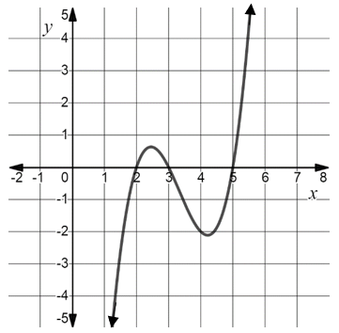

- What are the apparent zeros of this function? Explain your thinking.

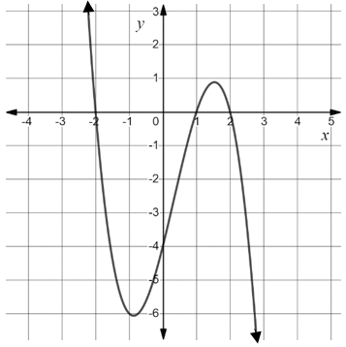

- How many real solutions does${ x}^{4}-5x^{3}+10x^{2}-20x+24=0$have? Justify your thinking.

- Create a polynomial function,$f(x)$, that has roots of -2, -1, and 1 with multiplicity 2.

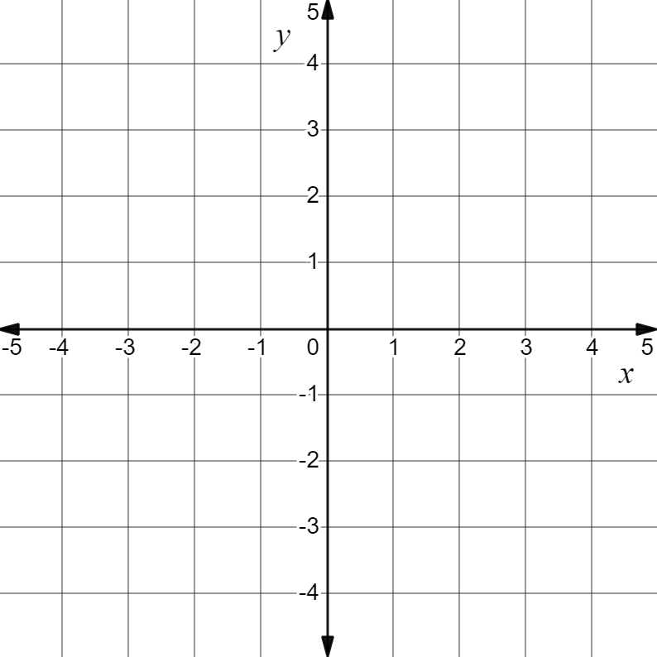

SOL AII.8 - Just in Time Quick Check Teacher Notes
Common Errors/Misconceptions and their Possible Indications

- The graph of a function is shown. Write the equation that best represents this function.

A common misconception some students may make is to indicate that the zeros are 2, 3, and 5 and the factors are (x + 2)(x + 3)(x + 5). This may indicate a misunderstanding that if k is a zero, then x + k is a factor. Students would benefit from a review of the Zero-Product Property and Factor Theorem. Teachers may wish to use the strategy of creating a polynomial function from given zeros. Throughout the process of creating the polynomial, have students make the connection between the given zeros and the factors. In addition, the use of Desmos would be beneficial for students to make the necessary connections between zeros and factors of a function.

- What are the apparent zeros of this function? Explain your thinking.

A common error that some students may make is to include the y-intercept as a zero of the function. This may indicate a misunderstanding that zeros are both x- and y-intercepts. Use of the Word Wall cards as an anchor chart would benefit some students. A strategy that could be used is to create a table of all the intercepts of the function. This table will support and show that f(x) = 0 only at values where the polynomial intercepts the x-axis.

- How many real solutions does${ x}^{4}-5x^{3}+10x^{2}-20x+24=0$have? Justify your thinking.

A common error some students may make is to identify the degree of the polynomail as the number of real solutions. This may indicate a misunderstanding that the degree is equal to the number of real solutions. The Fundamental Theorem of Algebra should be reviewed with the student. A strategy that could be used is to create a quadratic or cubic function with two imaginary solutions to show that the degree is equal to the number of all the solutions and not always the number of real solutions.

- Create a polynomial function,$f(x)$, that has roots of -2, -1, and 1 with multiplicity 2.

A common error would be for a student to draw this function so that it passes through the x-axis at -2, -1, and 1 creating a cubic polynomial fucntion. This may indicate a misunderstanding that an even multiplicity at x = 1 passes through the x-axis. Consider using Desmos to graph the same linear binomial factors raised to different positive exponents to explore the changes it has on the curve of the polynomial function. For example, a factor of (x + 1) would pass through the x-axis at 1 where the factor (x + 1)² touches the x-axis at 1 but does not pass through the x-axis. This may be beneficial for students to make the connection that even multiplicities are tangential to the x-axis.

