Just In Time Quick Check
Standard of Learning (SOL) AII.7j
Strand: Functions

Standard of Learning (SOL) AII.7j
The student will investigate and analyze linear, quadratic, absolute value, square root, cube root, rational, polynomial, exponential, and logarithmic function families algebraically and graphically. Key concepts include inverse of a function.

Grade Level Skills:
- Determine the inverse of a function (linear, quadratic, cubic, square root, and cube root).
- Graph the inverse of a function as a reflection over the line y = x.
- Investigate and analyze characteristics and multiple representations of functions with a graphing utility.

Just in Time Quick Check

Just in Time Quick Check Teacher Notes

Supporting Resources:
- VDOE Mathematics Instructional Plans (MIPS)
  - AII.7j – Inverse Functions (Word) / PDF Version
- VDOE Word Wall Cards: Algebra II (Word) | (PDF)
  - Inverse of a Function
Supporting and Prerequisite SOL: AII.6a, AII.6b, A.4c, A.6c, 8.7a

SOL AII.7j - Just in Time Quick Check

- Given: $f\left(x\right)={\left(x-2\right)}^{2}$

  - Find $f^{-1}\left(x\right)$.

  - What is the value of $f^{-1}\left(f(5\right))$?

- The graph of $f(x)$ is shown. Graph ${f(x)}^{-1}$on the same coordinate plane.

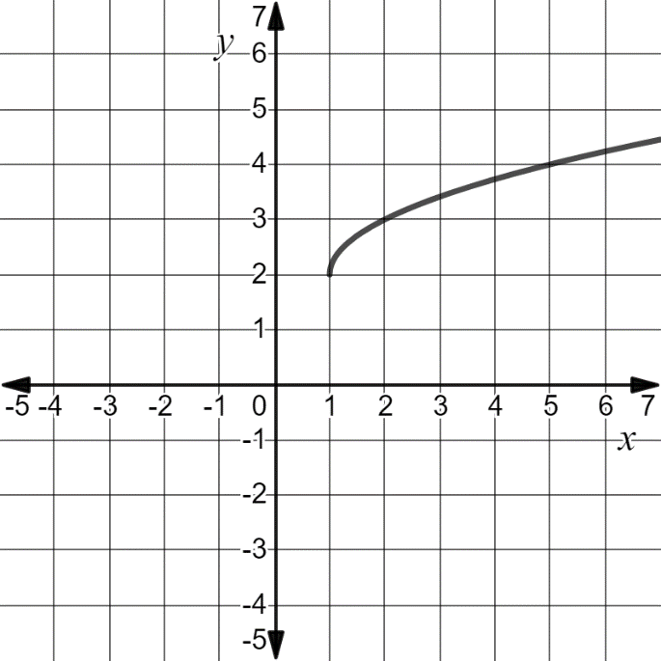
$$f(x)$$

- $f\left(x\right)=216x^{3}-5$, and $g\left(x\right)= \frac{\sqrt[3]{x+5}}{216}$. Are $f(x)$ and $g(x)$ inverses of each other? Justify your thinking.

SOL AII.7j - Just in Time Quick Check Teacher Notes
Common Errors/Misconceptions and their Possible Indications
1. Given: $f\left(x\right)={\left(x-2\right)}^{2}$

  - Find $f^{-1}\left(x\right)$.

  - What is the value of $f^{-1}\left(f(5\right))$?
A common error some students may make is to state that $f^{-1}=\sqrt{x+2}$. This may indicate that a student has a misunderstanding of the order of using inverse operations to solve an equation for a specific variable. In part b, students may indicate that $f^{-1}\left(x\right)=49$. This may indicate that students believe that $f(x)$ and $f^{-1}\left(x\right)$ are one and the same. To address both of these misconceptions, teachers may wish to have students create a table of values for the function $f(x)$. Discuss with students that a point on f is represented by the ordered pair $(x,y)$ and a point on $f^{-1}$ is represented by $(y,x)$. Creating a graph from the ordered pairs will help students visualize the reflection of these functions over the line $y=x$ and understand they are distinct functions. Seeing the graph will also help students think about the equation of the function and how the order of the operations impact the translation. Teachers may also wish to use the Mathematical Instructional Plan: 2A-7j to reinforce the definition of an inverse function and to use mappings to show the effects an inverse has on the domain and range of the original function.

2. The graph of $f(x)$ is shown. Graph ${f(x)}^{-1}$on the same coordinate plane.
$$f(x)$$

A common error that some students may make is to graph the function $f\left(x\right)=-\sqrt{x-1}-2$. This may indicate a misunderstanding that the inverse function is the same as making the function negative. Some students may benefit from the use of the VDOE Word Wall cards as an anchor chart. A strategy that could be used to help students understand the inverse of a function is to create a table of values of the function $(x)$ . Using this table of values, students may then create a table of values for the inverse function, ${f(x)}^{-1}$. The students should graph those points to form the graph of ${f(x)}^{-1}$. After graphing, the students could use their pencil to model the line y = x and see that the original function and the inverse function are mirror images. This would verify their graphs are correct.

$3. f\left(x\right)=216x^{3}-5$, and $g\left(x\right)= \frac{\sqrt[3]{x+5}}{216}$. Are $f(x)$ and $g(x)$ inverses of each other? Justify your thinking.

A common error some students may make is to claim that the functions are inverses citing that cubics and cube roots are inverse functions. This may indicate a misunderstanding that the numbers within the function have no bearing to the function nor its inverse. Students could graph each of the functions using Desmos to determine if the functions are mirror images of each other. If they are not, then $f(x)$ and$g(x)$ are not inverse functions. An algebraic approach would be to determine if $f\left(g\left(x\right)\right)=x$ and $g\left(f\left(x\right)\right)=x.$If either is not true, then they are not inverse functions of each other.

