Just In Time Quick Check
Standard of Learning (SOL) AII.7h
Strand: Functions

Standard of Learning (SOL) AII.7h
The student will investigate and analyze linear, quadratic, absolute value, square root, cube root, rational, polynomial, exponential, and logarithmic function families algebraically and graphically. Key concepts include end behavior.

Grade Level Skills:
- Describe the end behavior of a function.
- Investigate and analyze characteristics and multiple representations of functions with a graphing utility.

Just in Time Quick Check

Just in Time Quick Check Teacher Notes

Supporting Resources:
- VDOE Mathematics Instructional Plans (MIPS)
  - AII.7ah – Functions: Domain, Range, Continuity and End Behavior (Word) | PDF Version
- VDOE Word Wall Cards: Algebra II (Word) | (PDF)
- End Behavior
- Desmos Activity
  - Constructing Polynomials
  - Polygraph Rational Functions
  - Polygraph: Parent Functions
  - Polygraph: Polynomial Functions
Supporting and Prerequisite SOL: AII.6a, AII.6b, A.6a, 8.16a

SOL AII.7h - Just in Time Quick Check

- Describe the end behavior of $g\left(x\right)=\frac{1}{x+2}+7$ as x approaches negative infinity and positive infinity.
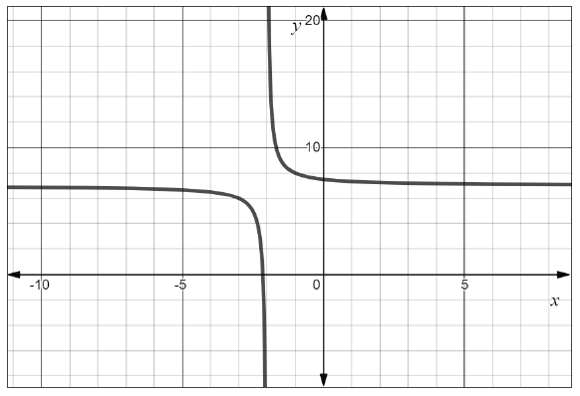
$$g(x)$$

$$As x→-∞, y → __________$$
$$As x→∞, y → __________$$

- Select all the true statements about the end behavior of the function $f\left(x\right)=-x^{4}-5x^{3}+5x+3$.
- As $x$ approaches positive infinity, f(x) approaches positive infinity
- As $x$ approaches negative infinity, f(x) approaches negative infinity
- As $x$ approaches positive infinity, f(x) approaches negative infinity
- As $x$ approaches negative infinity, f(x) approaches positive infinity

- Describe the end behavior of $f\left(x\right)=3{\left(\frac{1}{3}\right)}^{x}$ as $x$ approaches positive infinity.

SOL AII.7h - Just in Time Quick Check Teacher Notes
Common Errors/Misconceptions and their Possible Indications

- Describe the end behavior of $g\left(x\right)=\frac{1}{x+2}+7$ as x approaches negative infinity and positive infinity.
$$g(x)$$

$$As x→-∞, y → __________$$
$$As x→∞, y → __________$$
A common error some students may make is to answer $y→∞$ for the end behavior as x approaches $-∞$. This may indicate that the students are only looking at the upper half of the rational function. A possible teaching strategy would be to use the Mathematical Instructional Plan (MIP): AII.7ah, which provides students the opportunity to make connections between the graph of the function and the domain/range and end behavior. While discussing end behavior, have the students circle or highlight the right most end of the function’s graph and the left most end of the function’s graph. This should help the students focus on the parts of the function that they are describing.

- Select all the true statements about the end behavior of the function $f\left(x\right)=-x^{4}-5x^{3}+5x+3$.
- As $x$ approaches positive infinity, f(x) approaches positive infinity
- As $x$ approaches negative infinity, f(x) approaches negative infinity
- As $x$ approaches positive infinity, f(x) approaches negative infinity
- As $x$ approaches negative infinity, f(x) approaches positive infinity

A common error some students might make is to not select, “As $x$ approaches positive infinity, f(x) approaches negative infinity”. This may indicate a misconception that as $x$approaches infinity, f(x) always approaches positive infinity. A possible teaching strategy would be to have students create a table of values and evaluate the function at certain positions such as $x=5, x=50, x=100$ and$x=1000$. It would be beneficial for students to graph the function using a graphing utility so they can make the connection both algebraically and graphically to determine that as $x$gets larger, $f\left(x\right)$ will continue to decrease.
- Describe the end behavior of $f\left(x\right)=3{\left(\frac{1}{3}\right)}^{x}$ as $x$ approaches positive infinity.
A common error some students may make is to assume the graph would be approaching negative infinity since it is decreasing. This may indicate a misunderstanding that the end behavior of a function only approach positive or negative infinity. A possible teaching strategy would be to show the students using a table and Desmos sliders, as the value of $x$ increases, the function becomes closer and closer to zero.

