Just In Time Quick Check
Standard of Learning (SOL) AII.7g
Strand: Functions

Standard of Learning (SOL) AII.7g
The student will investigate and analyze linear, quadratic, absolute value, square root, cube root, rational, polynomial, exponential, and logarithmic function families algebraically and graphically. Key concepts include connections between and among multiple representations of functions using verbal descriptions, tables, equations, and graphs.

Grade Level Skills:
- Represent relations and functions using verbal descriptions, tables, equations, and graphs. Given one representation, represent the relation in another form.
- Investigate and analyze characteristics and multiple representations of functions with a graphing utility.

Just in Time Quick Check

Just in Time Quick Check Teacher Notes

Supporting Resources:
- VDOE Word Wall Cards: Algebra II (Word) | (PDF)
  - Multiple Representation of Functions
- VDOE Rich Mathematical Tasks: Wildfires
- AII.7afg Wildfires Task Template (Word) / (PDF)
- VDOE Rich Mathematical Task: Algae Attack
- AII.7g Algae Attack Task Template (Word) / (PDF)
- Desmos Activity
  - Avi and Benita's Repair Shop
  - Constructing Polynomials
  - Polygraph Rational Functions
  - Polygraph: Parent Functions
  - Polygraph: Polynomial Functions
  - Polynomial Equation Challenge
Supporting and Prerequisite SOL: AII.6a, AII.6b, AII.8, A.1a, A.6b, A.6c, A.7f, 8.16e

SOL AII.7g - Just in Time Quick Check

- Barry and Malik are each offered job opportunities for the summer. Barry has been offered $100 per day for a month with a $10 raise each day after day 1. Malik was offered an office job that will pay 1 cent on the first day but his pay will double every day from the previous day for one month. A sample table is provided to record the amount of money made on various days.
- Complete the table.
Day | Amount of Money Barry Made Each Day | Amount of Money  Malik Made Each Day
$$1$$
$$2$$
$$3$$
$$4$$
$$5$$
$$6$$
$$7$$
$$14$$
$$21$$
$$28$$

- Who will make more money on the 30th day of the month? How much will he make on the 30th day? Justify your answer.

- A company is selling wireless speakers. The profit, P, the company can earn by selling each speaker for x dollars is modeled by the function $P\left(x\right)=-x^{2}+60x+15$.
- Create a graphical representation of this function.
- The company wants to maximize profit. What should be the price of the wireless speaker to maximize profit? Explain your answer.
- The function $f\left(x\right)=\left\{\begin{aligned} \sqrt{x},\text{ if } x<4 \\ 2x, \text{if} 4≤x≤5 \\ {(x-5)}^{2}, \text{if} 5<x≤8\end{aligned}\right.$ is graphed below.
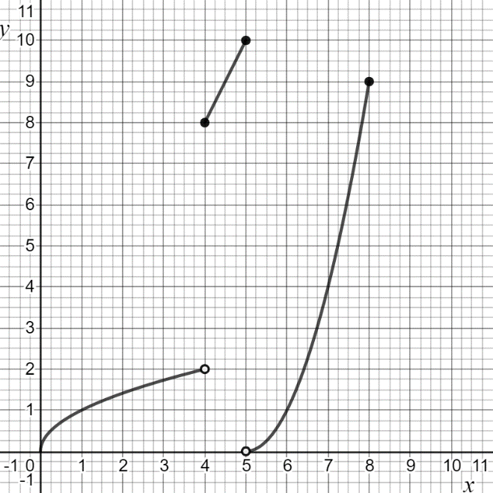
- Complete the table for this function.
$$x$$ | $$f(x)$$
0
1
4
7
8

SOL AII.7g - Just in Time Quick Check Teacher Notes
Common Errors/Misconceptions and their Possible Indications

- Barry and Malik are each offered job opportunities for the summer. Barry has been offered $100 per day for a month with a $10 raise each day after day 1. Malik was offered an office job that will pay 1 cent on the first day but his pay will double every day from the previous day for one month. A sample table is provided to record the amount of money made on various days.
- Complete the table.
Day | Amount of Money Barry Made Each Day | Amount of Money  Malik Made Each Day
$$1$$
$$2$$
$$3$$
$$4$$
$$5$$
$$6$$
$$7$$
$$14$$
$$21$$
$$28$$

- Who will make more money on the 30th day of the month? How much will he make on the 30th day? Justify your answer.
A common error is for some students to pick Barry. This may indicate that a student may be unable to extend the tabular representations of both the linear and exponential relationships between the number of days worked and the amount of money made each day. One strategy would be to use the Desmos calculator to represent the exponential relationship as a table of values and as a graph, which is part of the Desmos Activity “Avi’s and Benita’s Repair Shop.” Teachers may also wish to encourage the students to create an algebraic equation for each relationship. This may also be done in Desmos as a curve of best fit. This will help students make connections between a table of values, a graph, and the equation.
- A company is selling wireless speakers. The profit, P, the company can earn by selling each speaker for x dollars is modeled by the function $P\left(x\right)=-x^{2}+60x+15$.
- Create a graphical representation of this function.
- The company wants to maximize profit. What should be the price of the wireless speaker to maximize profit? Explain your answer.
A common error is for some students to state $60.25 since that is the point (other than zero) where the graph crosses the x-axis. This may indicate that students do not recognize the negative (downward opening) quadratic pattern and realize the vertex is the maximum value. The x-value at this point would represent the price of a speaker that would maximize the profit, y. One possible teaching strategy is to show the students multiple representations of this equation, graphically, as a table of values, and explaining the real-world meaning of each representation within the context of the situation that is modeled.

- The function $f\left(x\right)=\left\{\begin{aligned} \sqrt{x},\text{ if } x<4 \\ 2x, \text{if} 4≤x≤5 \\ {(x-5)}^{2}, \text{if} 5<x≤8\end{aligned}\right.$ is graphed below.
- Complete the table for this function.
$$x$$ | $$f(x)$$
0
1
4
7
8

A common error is that some students will pair the x-value of 4 with a y-value of 2. This would indicate the student is recognizing the open dot of a piecewise function as an included point. A possible teaching strategy would be to have the students review the meaning of the open circle and the effect it has on the domain. Another strategy would be to have the students graph the function using Desmos, then drag a point along the function’s graph to show the point is undefined for $f\left(x\right)=\sqrt{x}$, but the point does exist for $f\left(x\right)=2x$.

