Just In Time Quick Check
Standard of Learning (SOL) AII.7f
Strand: Functions

Standard of Learning (SOL) AII.7f
The student will investigate and analyze linear, quadratic, absolute value, square root, cube root, rational, polynomial, exponential, and logarithmic function families algebraically and graphically. Key concepts include values of a function for elements in its domain.

Grade Level Skills:
- For any x value in the domain of f, determine f(x).
- Investigate and analyze characteristics and multiple representations of functions with a graphing utility.

Just in Time Quick Check

Just in Time Quick Check Teacher Notes

Supporting Resources:
- VDOE Algebra Readiness Formative Assessments
  - A.7a,b,e (Word) / (PDF)
- VDOE Algebra Readiness Remediation Plans
  - Evaluating Algebraic Expressions (Word) / (PDF)
- VDOE Word Wall Cards: Algebra II (Word) | (PDF)
  - Function Notation
- VDOE Rich Mathematical Tasks: Wildfires
  - A2.7afg Wildfires Task Template (Word) / (PDF)
- Desmos Activity
  - Evaluating Functions with Function Notation
Supporting and Prerequisite SOL: AII.6a, AII.7a, A.1b, A.7b, A.7e, 8.14a

SOL AII.7f - Just in Time Quick Check

Find the values of the range of $f\left(x\right)=x^{3}-3x^{2}+x+1$ when the domain is $\{-1, 2, 4\}$.

- If $h\left(x\right)=\frac{2}{x-3}+4$, what is the value of $h(6)$?

- The graph of the function $g(x)$ is shown. What is the approximate value of $g(0)$?
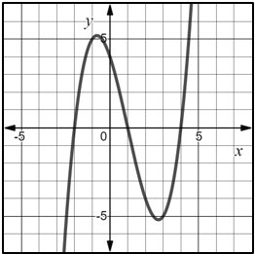
$$g(x)$$

- The graph of the function $k(x)$ is shown.
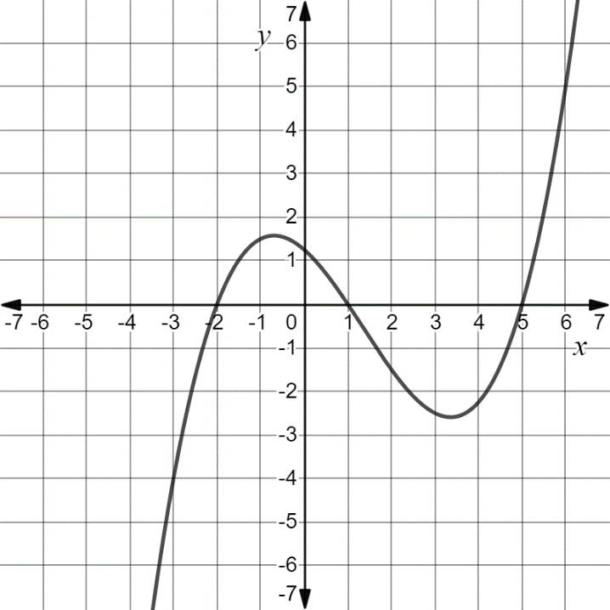
$$k(x)$$
Circle all values that appear to be positive.
$$k(-4)$$ | $$k(-2)$$ | $$k(-1)$$
$$k(2)$$ | $$k(5)$$ | $$k(6)$$

SOL AII.7f - Just in Time Quick Check Teacher Notes
Common Errors/Misconceptions and their Possible Indications

- Find the values of the range of $f\left(x\right)=x^{3}-3x^{2}+x+1$ when the domain is $\{-1, 2, 4\}$.
A common error that some students may make is to substitute multiple domain values at one time. For example, a student may write and evaluate ${(-1)}^{3}-3{\left(2\right)}^{2}+(4)+1$. This may indicate a student does not understand that each input value will have one corresponding output value. A strategy is to rewrite the question as $f\left(-1\right), f\left(2\right), f(4)$ to show that three different domain elements are given and that three corresponding range values need to be calculated. It might be helpful for students to utilize a graphing utility or Desmos to create a visual representation and verify their solutions for the domain values provided.

- If $h\left(x\right)=\frac{2}{x-3}+4$, what is the value of $h(6)$?
A common error some students may make is to replace h(x) with the value of 6 resulting in the equation,
$6= \frac{2}{x-3}+4$. This may indicate that some students think 6 is the value of h(x) instead of the value of x. A strategy that may be helpful for students to make the connection that x is to be replaced by the value of 6 is to have students highlight both x and 6 in h(x) and h(6). Students should be encouraged to rewrite the function as $h\left(6\right)= \frac{2}{6-3}$ + 4 and evaluate the right side of the equation.

- The graph of the function $g(x)$ is shown. What is the approximate value of $g(0)$?
$$g(x)$$
A common error some students may make is to think $g\left(0\right)=1$. This may indicate that a student interprets finding the value of a function as finding the zero of the function when given a graph. Since $g(0)$ means to find the value of the function when$x=0$, a strategy that might be helpful for students is to draw a vertical line representing $x=0$ and determine the y-coordinate of the point where the vertical line intersects the graph of the function provided.

- The graph of the function $k(x)$ is shown.
$$k(x)$$
Circle all values that appear to be positive.
$$k(-4)$$ | $$k(-2)$$ | $$k(-1)$$
$$k(2)$$ | $$k(5)$$ | $$k(6)$$

A common misconception that some students may have is to circle all function values that contain a positive value, representing x when written in $k\left(x\right)$format, i.e. $k\left(2\right), k\left(5\right),\text{ and} k\left(6\right).$ This may indicate that students are not basing their decision on a location of the graph of $k(x)$and whether its range value is greater than zero. A strategy that may be helpful for students is to draw vertical lines through the curve at each x-value representing $k(x)$, i.e. x = 2, and record the y-value at each of these intersection points. Another strategy that would be beneficial is to have students trace the portions of the curve that are above the x-axis using a colored pencil or marker since the function is only positive in those locations. Students may then select any of the six function values provided that lie on the curve that has been color-coded.

