Just In Time Quick Check
Standard of Learning (SOL) AII.7a
Strand: Functions

Standard of Learning (SOL) AII.7a
The student will investigate and analyze linear, quadratic, absolute value, square root, cube root, rational, polynomial, exponential, and logarithmic function families algebraically and graphically. Key concepts include domain, range, and continuity.

Grade Level Skills:
- Identify the domain and range of a function presented algebraically or graphically, including graphs with discontinuities.
- Describe a function as continuous or discontinuous.
- Investigate and analyze characteristics and multiple representations of functions with a graphing utility.

Just in Time Quick Check

Just in Time Quick Check Teacher Notes

Supporting Resources:
- VDOE Mathematics Instructional Plans (MIPS)
  - AII.7ah -Functions: Domain, Range, Continuity and End Behavior (Word) / PDF Version
- VDOE Algebra Readiness Formative Assessments
  - A.7a,b,e (Word) / (PDF)
- VDOE Algebra Readiness Remediation Plans
  - Relations, Functions, Domain and Range (Word) / (PDF)
- VDOE Word Wall Cards: Algebra II (Word) | (PDF)
  - Domain, Range
  - Continuity
  - Discontinuity (asymptotes)
  - Discontinuity (removable or point)
- VDOE Rich Mathematical Tasks: Function of a Ride
  - A2.6 Function of a Ride Task Template (Word) / (PDF)
  - A2.7afg Wildfires Task Template (Word) / (PDF)
- Desmos Activity
  - Finding Domain and Range
Supporting and Prerequisite SOL: AII.6a, A.7b, 8.15b

SOL AII.7a - Just in Time Quick Check

- What appears to be the domain of the relation shown? Use set or interval notation.

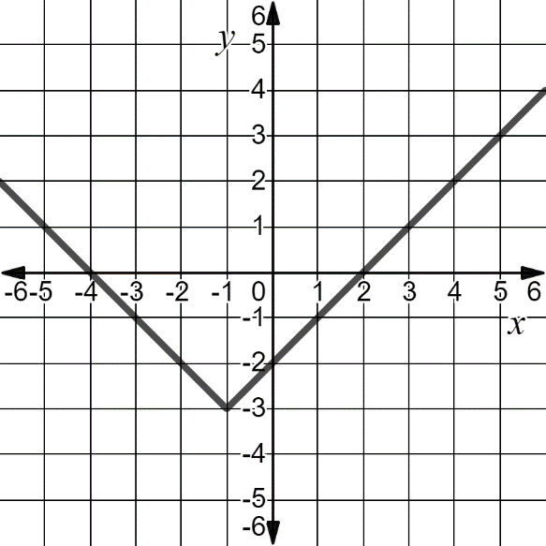

- What appears to be the domain and range of the relation shown? Use set or interval notation.
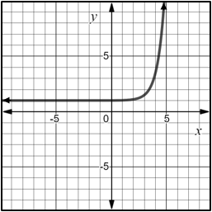

- What appears to be the domain of the relation shown? Use set or interval notation.
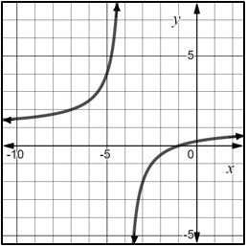

- What appears to be the domain of the function shown? Use interval notation to express your answer.

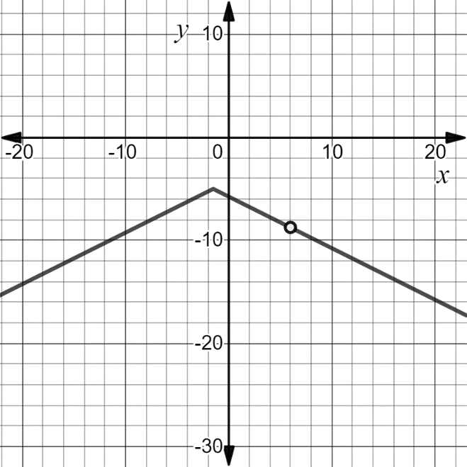

- What is the range of the function $\left(x\right)=\sqrt{x-2}$ ? Use interval notation.

- What is the domain of the function $\left(x\right)=\frac{2x^{3}+5x^{2}-12x}{x+4}$ ?

AII.7a - Just in Time Quick Check Teacher Notes
Common Errors/Misconceptions and their Possible Indications

- What appears to be the domain of the relation shown? Use set or interval notation.

A common error that some students may make is to list the domain as $\left\{x | -4≤x≤2\right\}$ or as $\left[-4, 2\right].$ This may indicate that a student only considers the domain to represent the values between and including the x-intercepts. The teacher should review with the student that while x-intercepts are part of the domain, the domain is the set of all possible values of the independent variable. Listing additional ordered pairs from the graph in a set or table may help the -4student to visualize this.

- What appears to be the domain and the range of the relation shown? Use set or interval notation.

A common error that some students may make is to confuse the domain with the range and list the domain as $\{y│1<y<∞\}$ and the range as$\{x│-∞<x<∞\}$. This may indicate that a student has a misconception in associating domain with the dependent variable (y-values) and range with the independent variables (x-values). A strategy that could be used is to have the student practice with discrete points in identifying the domain and range, and then continue to practice with continuous graphs.

Other students may think the domain is all real numbers and not realize there is an asymptote at x=5. These students would benefit from the exploration of asymptotes and what they mean algebraically and how they appear graphically. A strategy that may help solidify students’ understanding is a matching activity where students match the equation, graph, domain, and range.

- What appears to be the domain of the relation shown? Use set or interval notation.

A common error that some students may make is to list the domain as all real numbers when it is a function with a vertical asymptote. This may indicate that a student has a misconception in thinking that the domain just pertains to the beginning and ending values of the function’s domain. A strategy that could be used is to have the student practice graphing rational functions with asymptotes and holes by hand using a table of values that shows the values that are not in the domain. Students may also trace the curve beginning from the left-hand side, and determine if there is any part of the curve that is discontinuous. A teacher may want to ask a student the following questions-- Can you trace the entire curve without picking up your pencil? What might this indicate about the domain of the function?

- What appears to be the domain of the function shown? Use interval notation to express your answer.

A common error students make is to overlook the point of discontinuity in a graph when stating the domain. Some students may also have difficulty expressing the domain in interval notation. These students may realize$x≠6$, but are unsure how that translates to interval notation. Students may benefit from a review of what discontinuity in a graph means and visual and algebraic representations of functions that have discontinuity. A strategy that could help some students is to have them match interval notation with its corresponding solution set notation. This could be expanded to include the graphical and algebraic representation of the function.

- What is the range of the function $\left(x\right)=\sqrt{x-2}$ ? Use interval notation.

A common error that some students may make is to list the range as $(0, ∞)$ when there is an endpoint to the function. This may indicate that a student has a misconception in thinking that the range is expressed as an open interval. A strategy that could be used is to have the student review the meanings of the parentheses and brackets with regards to interval notation. Students may benefit from a reminder of how interval notation connects back to graphing inequalities on a number line using open and closed circles to indicated included/non-included values. Graphing the function on Desmos to show that the point exists will also provide students with a visual representation.

- What is the domain of the function $\left(x\right)=\frac{2x^{3}+5x^{2}-12x}{x+4}$ ?

A common misconception for students is to express the domain as all real numbers. This may indicate the student is only looking at the graphical representation of the function. When graphed, g(x) appears as a parabola and the discontinuity is not apparent. The students would benefit from a discussion of what happens to values of x when x appears in the denominator of a function. Students may also trace the function with their cursor in Desmos and look at the y value when x= -4.

