Just In Time Quick Check
Standard of Learning (SOL) AII.11c
Strand: Statistics

Standard of Learning (SOL) AII.11c
The student will apply properties of normal distributions to determine probabilities associated with areas under the standard normal curve.

Grade Level Skills:
- Represent probability as area under the curve of a standard normal distribution.
- Use the graphing utility or a table of Standard Normal Probabilities to determine probabilities associated with areas under the standard normal curve.
- Use a graphing utility to investigate, represesnt, and determine relationships between a normally distributed data set and its descriptive statistics.

Just in Time Quick Check

Just in Time Quick Check Teacher Notes

Supporting Resources:
- VDOE Mathematics Instructional Plans (MIPS)
  - AII.11abc Normal Distribution (Word) / PDF Version
- VDOE Word Wall Cards: Algebra II (Word) | (PDF)
  - Statistics Notation
  - Mean, Median, Mode, Variance
  - Standard Deviation (Definition)
  - Standard Deviation (Graphic)
  - z-Score (Definition), z-Score (Graphic)
  - Empirical Rule, and Elements within One Standard Deviation (σ) of the Mean (µ) (Graphic)
Supporting and Prerequisite SOL: N/A

SOL AII.11c - Just in Time Quick Check

- Jose’s teacher announces that the scores on their most recent Algebra test were normally distributed. The mean score was 72 and the standard deviation was 8. When Jose receives his score, he earned a 75. What percentage of students scored lower than Jose? Show your work and write your answer in a complete sentence.

- Sam’s Pizza advertises that their delivery times are the best in town. If their delivery times are normally distributed with mean 30 minutes and standard deviation 5 minutes, what is the probability that your pizza from Sam’s will take more than 37 minutes to be delivered? Justify your answer.

- The number of hours a certain type of battery will last is distributed normally with a mean of 500 minutes. The standard deviation is 50 minutes. Out of 240 batteries tested, how many batteries would you expect to still be working after 580 minutes?

- Cell phone covers are shipped from a warehouse where the data representing shipping costs over the past year are normally distributed with a mean of $5.00 and a standard deviation $0.20.
Use the graph provided to shade the area representing the data values falling within the lowest 25% of shipping costs over the past year. Determine the value below which 25% of the shipping values fell. Label the x-axis provided on the graph and justify your solution.

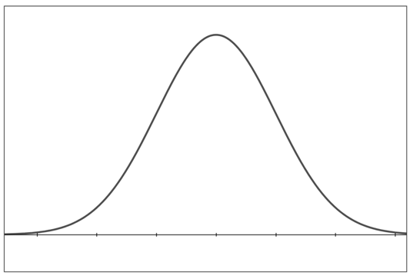

SOL AII.11c - Just in Time Quick Check Teacher Notes
Common Errors/Misconceptions and their Possible Indications

- Jose’s teacher announces that the scores on their most recent Algebra test were normally distributed. The mean score was 72 and the standard deviation was 8. When Jose receives his score, he earned a 75. What percentage of students scored lower than Jose? Show your work and write your answer in a complete sentence.

A common error that some students may make is to confuse the z-score of 0.375 associated with Jose’s score of 75 as representing 37.5% of students scored lower than Jose on the test. This may indicate that students do not understand the association between the area under a normal curve and probability. Potential teaching strategies could include asking students to explain in context what a z-score represents and practice using the Standard Normal Distribution table. Teachers could also point out situations where the z-score is out of the possible range of probability values.
- Sam’s Pizza advertises that their delivery times are the best in town. If their delivery times are normally distributed with mean 30 minutes and standard deviation 5 minutes, what is the probability that your pizza from Sam’s will take more than 37 minutes to be delivered? Justify your answer.

A common error that some students may make is to report the probability to the left of the z-score, either by using the Table of Standard Normal Probabilities or a graphing utility. This may indicate that students do not recognize that the area under the normal curve to the right of the z-score will represent the probability that the pizza will take more than 37 minutes to be delivered. A potential teaching strategy could include requiring students to sketch the normal curve with the area in question shaded and then asking students to make predictions of reasonable values prior to using the table. Another potential teaching strategy could include using the VDOE Vocabulary Word Wall card related to the Empirical Rule to emphasize the symmetry of the normal distribution.
- The number of hours a certain type of battery will last is distributed normally with a mean of 500 minutes. The standard deviation is 50 minutes. Out of 240 batteries tested, how many batteries would you expect to still be working after 580 minutes?

A common error that some students may make is to calculate the percentage of batteries that last 580 minutes but fail to convert that to the number out of 240 total batteries. This may indicate that students may recognize how to find a z-score for a given data value using a graphing utility or a Table of Standard Normal Probabilities to convert it to a percentage, but lack the problem solving skills needed to answer the question posed by the context of the problem. A possible teaching strategy is to have students think about the type of answer being requested by the context of various problems related to normal distribution prior to performing calculations. A potential teaching strategy could include asking students to break the problem into parts where they first must find the percentage of batteries to last 580 minutes and then must determine how many of the 240 batteries represent that percentage.

- Cell phone covers are shipped from a warehouse where the data representing shipping costs over the past year are normally distributed with a mean of $5.00 and a standard deviation $0.20.
Use the graph provided to shade the area representing the data values falling within the lowest 25% of shipping costs over the past year. Determine the value below which 25% of the shipping values fell. Label the x-axis provided on the graph and justify your solution.

A common error that some students may make is to fail to calculate the corresponding z-score below which 25% of the values would fall prior to shading the area under the curve. This may indicate that students do not recognize how the area under the normal curve is related to the z-score. A potential teaching strategy could include asking students to estimate reasonable solutions based on the distribution and scale drawn. Another possible teaching strategy would be for students to guess a value and determine the percentage of values below that cost. Students could repeat this process with the goal of increasing accuracy toward the 25% cutoff.

