Just In Time Quick Check
Standard of Learning (SOL) AII.11a
Strand: Statistics

Standard of Learning (SOL) AII.11a
The student will identify and describe properties of a normal distribution.

Grade Level Skills:
- Identify the properties of a normal distribution.
- Describe how the standard deviation and the mean affect the graph of the normal distribution.
- Use a graphing utility to investigate, represesnt, and determine relationships between a normally distributed data set and its descriptive statistics.

Just in Time Quick Check

Just in Time Quick Check Teacher Notes

Supporting Resources:
- VDOE Mathematics Instructional Plans (MIPS)
  - Calculating Measures of Dispersion (Word)/ PDF version
  - Normal Distributions (Word) / PDF Version
- VDOE Word Wall Cards: Algebra II (Word) | (PDF)
  - Statistics Notation,
  - Mean, Median, Mode
  - Variance
  - Standard Deviation (Definition)
  - Standard Deviation (Graphic)
  - z-Score (Definition), z-Score (Graphic)
  - Empirical Rule, and Elements within One Standard Deviation (σ) of the Mean (µ) (Graphic)
Supporting and Prerequisite SOL: N/A

SOL AII.11a - Just in Time Quick Check

- The graphs of two different normal distributions, Distribution A and Distribution B, are shown below.
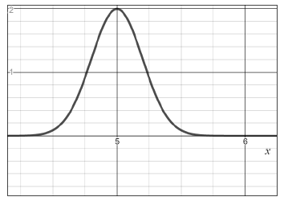
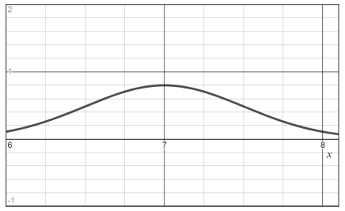
Distribution B
Distribution A

- Identify which of these distributions, A or B, appears to have a greater mean. Explain your reasoning.

- Identify which of these distributions, A or B, appears to have a greater standard deviation. Explain your reasoning.

- The value of the mode of a normally distributed set of data is: (circle one)
- Always greater than the value of the mean
- Approximately the same as the value of the mean
- Always less than the value of the mean
The value of the median of a normally distributed set of data is: (circle one)
- Always greater than the value of the mean
- Approximately the same as the value of the mean
- Always less than the value of the mean
- What appears to be the total area under the curve of the normal distribution shown below?

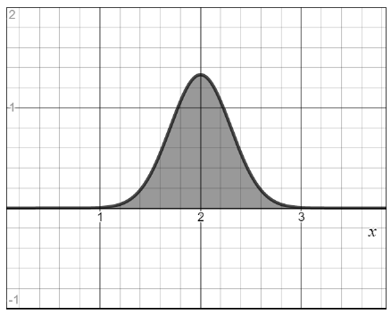

- The weights of watermelons at a store are normally distributed. If 95% of the weights were centered between 10 and 18 pounds, what is the best estimate of the mean and standard deviation, in pounds, of this sample?

SOL AII.11a - Just in Time Quick Check Teacher Notes
Common Errors/Misconceptions and their Possible Indications

- The graphs of two different normal distributions, Distribution A and Distribution B, are shown below.
Distribution B
Distribution A

- Identify which of these distributions, A or B, appears to have a greater mean. Explain your reasoning.

- Identify which of these distributions, A or B, appears to have a greater standard deviation. Explain your reasoning.

In part a) A common error that some students may make is to choose Distribution A as having the larger mean. This may indicate that students interpreted the curve that appears to be “taller” as having a larger mean. Students may interpret vertical height at the top of the curve as representing the mean, versus the vertical line of symmetry of the normal distribution falls at the mean. In part b) A common error that some students may make is to choose Distribution A as having a greater standard deviation than Distribution B. This may indicate that the students may not recognize that the standard deviation is a measure of the spread and the greater the standard deviation, the wider the distribution of data. A potential teaching strategy may be to have students explore how changing the parameters of the normal distribution affect the curve using Desmos (the distribution function) to graph them on the same axes.

- The value of the mode of a normally distributed set of data is: (circle one)
- Always greater than the value of the mean
- Approximately the same as the value of the mean
- Always less than the value of the mean
The value of the median of a normally distributed set of data is: (circle one)
- Always greater than the value of the mean
- Approximately the same as the value of the mean
- Always less than the value of the mean

A common error that some students may make is to assume that the values of the mode and/or median are different than the value of the mean of a normally distributed set of data. This may indicate that students are unfamiliar with the properties of a normal distribution curve where the median and mode are approximately equivalent to the mean and located at the center of the distribution. Students have typically worked with very small data sets up to this point and might benefit from exploring examples that illustrate the symmetry of a normal distribution curve based on data sets with larger n values.

- What appears to be the total area under the curve of the normal distribution shown below?

A common misconception is for students to believe they need to use the units of the graph to determine the area under the curve of a normal distribution. This may indicate that students do not recognize that the normal curve is a probability distribution and the total area under the curve is 1. A potential teaching strategy is to use the Table of Standard Normal Probabilities to help emphasize the symmetry of the curve; and to help students make the connection between probabilities and areas under a density curve.

- The weights of watermelons at a store are normally distributed. If 95% of the weights were centered between 10 and 18 pounds, what is the best estimate of the mean and standard deviation, in pounds, of this sample?

A common error some students may make is to state the standard deviation is 4 pounds and correctly state the mean is 14 pounds. This may indicate that a student believes the standard deviation is found by dividing the difference of the two stated values by 2 instead of 4. A possible teaching strategy is to have students draw the normal distribution curve according to the information provided and label the mean and the values representing 1 SD and 2 SD from the mean. In addtion, students should reference the Word Wall card displaying the Empirical Rule when creating this normal distribution curve.

