Just In Time Quick Check
Standard of Learning (SOL) AII.7d
Strand: Functions

Standard of Learning (SOL) AII.7d
The student will investigate and analyze linear, quadratic, absolute value, square root, cube root, rational, polynomial, exponential, and logarithmic function families algebraically and graphically. Key concepts include zeros.

Grade Level Skills:
- Identify the domain, range, zeros, and intercepts of a function presented algebraically or graphically, including graphs with discontinuities.
- Investigate and analyze characteristics and multiple representations of functions with a graphing utility.

Just in Time Quick Check

Just in Time Quick Check Teacher Notes

Supporting Resources:
- VDOE Mathematics Instructional Plans (MIPS)
  - AII.7adei - Intercepts, Asymptotes, and Discontinuity of Functions (Word) / PDF Version
- VDOE Word Wall Cards: Algebra II (Word) | (PDF)
  - Zeros
- Desmos Activity
  - Polygraph: Parent Functions
  - Polygraph: Polynomial Functions
  - Polynomial Equation Challenge
Supporting and Prerequisite SOL: AII.1c, AII.6a, AII.7a, AII.8, A.2c, A.4a, A.4b, A.7c, 8.17

SOL AII.7d - Just in Time Quick Check

- The graph of $f\left(x\right)=x^{3}+x^{2}-5x+3$ is shown. What are the apparent zeros of $f(x)$?

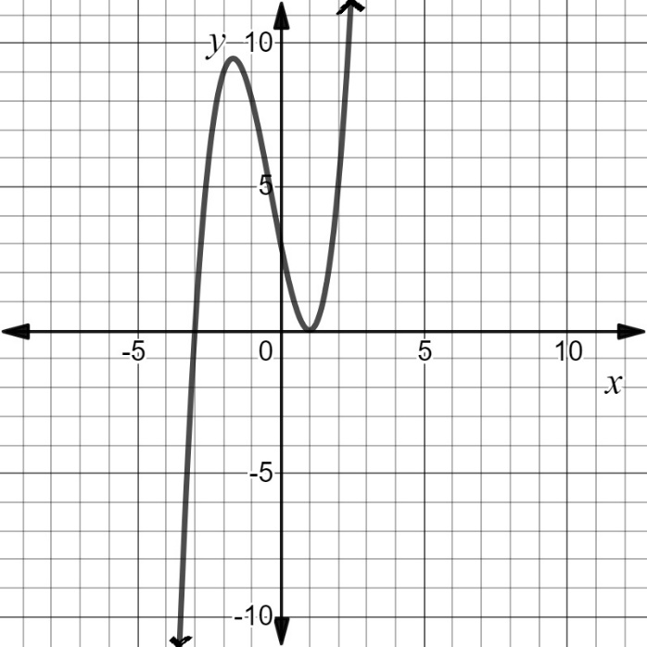

- What are the zeros to the function $f\left(x\right)=\frac{\left(x+2\right)\left(x-3\right)\left(2x+5\right)}{\left(x+4\right)\left(x+1\right)}$?

- What appears to be the zero of the function $f\left(x\right)=log⁡(2x-5)$?

- Determine the zeros of the function $f\left(x\right)=x^{2}+4x+5.$Explain your thinking.

SOL AII.7d - Just in Time Quick Check Teacher Notes
Common Errors/Misconceptions and their Possible Indications

1. The graph of $f\left(x\right)=x^{3}+x^{2}-5x+3$ is shown. What are the apparent zeros of $f(x)$?
A common error some students may make is to include 3, the y-intercept (0,3), as a zero of the function. This may indicate students misinterpreted the word zero to be a location anywhere the function crosses an axis. Students may benefit from using the Word Wall cards as an anchor chart to visually see that the zeros are the solutions or roots of the equation, and they are located at the x-intercept(s). Have students highlight the x-intercepts and then express the values as x-intercepts, zeros, and roots/solutions.

2. What are the zeros to the function $f\left(x\right)=\frac{\left(x+2\right)\left(x-3\right)\left(2x+5\right)}{\left(x+4\right)\left(x+1\right)}$ ?

A common error some students may make is to list the zeros of this function as $-3, 2, and \frac{5}{2}$. This may indicate that some students are approaching this algebraically but not setting the expressions x + 2, x – 3, and 2x + 5 equal to zero to find the zeros of this function. Some students may have solved for the zeros correctly, but also included -4 and -1 as zeros. This may indicate that students realize that these values are associated with the domain and values of x, but have not made the connection that these values are undefined. Students may benefit from identifying the domain of various functions and explore how the domain is connected to the zeros of a function, but is not necessarily a zero.

3. What appears to be the zero of the function $f\left(x\right)=log⁡(2x-5)$?
A common error some students may make is to state the zero of the function is located at $\left(\frac{5}{2},0\right)$. This may indicate these students set the expression 2x – 5 equal to zero and solved to find the zero of x =$\frac{5}{2}$ and have the misconception that the value of a zero is always determined from the quantity located within a set of parentheses. Teachers are encouraged to have students graph the function using Desmos or a graphing utility to provide a visual representation of the function and its characteristics.

4. Determine the zeros of the function $f\left(x\right)=x^{2}+4x+5.$Explain your thinking.

Some students may indicate there are no zeros for this function. This would indicate a misconception that since the roots are nonreal and the graph does not intersect the x-axis that students think there are no zeros. Students would benefit from a discussion on how zeros are the roots or solutions of the equation. When they are real, the roots are located at the x-intercept. When the roots to a function are nonreal or complex, they exist, but the function does not cross or touch the x-axis. Students may benefit from substituting complex solutions into a quadratic equation to emphasize that they do still make the function equal to zero algebraically.

