Just In Time Quick Check
Standard of Learning (SOL) AII.7c
Strand: Functions

Standard of Learning (SOL) AII.7c
The student will investigate and analyze linear, quadratic, absolute value, square root, cube root, rational, polynomial, exponential, and logarithmic function families algebraically and graphically. Key concepts include extrema.

Grade Level Skills:
- Identify the location and value of absolute maxima and absolute minima of a function over the domain of the function graphically or by using a graphing utility.
- Identify the location and value of relative maxima or relative minima of a function over some interval of the domain graphically or by using a graphing utility.
- Investigate and analyze characteristics and multiple representations of functions with a graphing utility.

Just in Time Quick Check

Just in Time Quick Check Teacher Notes

Supporting Resources:
- VDOE Mathematics Instructional Plans (MIPS)
  - AII.7bc - Functions: Extrema, Intervals Increasing and Decreasing (Word) / PDF Version
  - AII.7c - Extrema (Word) / PDF Version
- VDOE Word Wall Cards: Algebra II (Word) | (PDF)
  - Extrema
- VDOE Rich Mathematical Tasks: Function of a Ride
  - A2.6 Function of a Ride Task Template (Word) / PDF Version
- Desmos Activity
  - Extrema of Polynomials
Supporting and Prerequisite SOL: AII.6a, AII.7a, AII.7b

SOL AII.7c - Just in Time Quick Check

1. The graph of function f is shown. What appears to be the value of the relative minimum of function f on the interval (4, 8)?

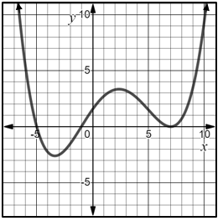

2. Given: $f\left(x\right)=x^{3}-x^{2}-5x+2$, on what interval is the local maximum of $f\left(x\right)?$

3. The graph of function f is shown. Does the graph of the function f have an absolute minimum, absolute maximum, or both? Explain your reasoning.
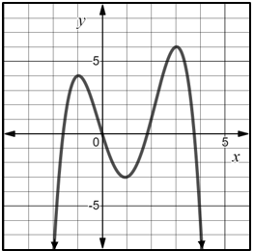

SOL AII.7c - Just in Time Quick Check Teacher Notes
Common Errors/Misconceptions and their Possible Indications

1. The graph of function f is shown. What appears to be the value of the relative minimum of function f on the interval (4, 8)?

A common error some students may make is to provide a value of 7. This may indicate that some students have a misunderstanding that the value of the relative minimum is the x-value of the point where the function changes from decreasing to increasing. Students may benefit from thinking about finding the values in an input/output table. When finding the “value” of a function at a certain point, students are substituting the x-value to find the corresponding y-value. When working with a graphical representation, it is the same concept, but students are looking at the graph for the x-coordinate, and the corresponding y-value. Students may benefit from exposure to the different ways in which questions could be asked and to which values those questions are referring. Examples would include:
- What is the value of the extrema? – This question refers to the y-values.
- What is the interval where the extrema occur? – This question refers to x-values.

2. Given: $f\left(x\right)=x^{3}-x^{2}-5x+2$, on what interval is the local maximum of $f\left(x\right)?$
A common error that some students may make is to list an interval of the domain that is continuously increasing or continuously decreasing. This may indicate the student has a misunderstanding that the local maximum occurs where the function changes from increasing to decreasing. The local maximum must occur over some interval of the domain where f(a) is the largest value of f on that interval. A strategy that may benefit students is to practice identifying important characteristics of graphs and explaining what those characteristics mean about the function and its graph.

3. The graph of function f is shown. Does the graph of the function f have an absolute minimum, absolute maximum, or both? Explain your reasoning.
f

A common error that some students may make is to say the value of the absolute maximum is 4. Another common error that some students may make is to indicate the function has both an absolute maximum and an absolute minimum. These errors may indicate the student has a misconception between an absolute extrema and relative extrema of a function. The teacher should review the definitions of relative and absolute extrema using the Word Wall Cards and have students find the domain and range of functions prior to finding the extrema to ensure students are using definitions correctly and finding values correctly.

