Just In Time Quick Check
Standard of Learning (SOL) AII.7b
Strand: Functions

Standard of Learning (SOL) AII.7b
The student will investigate and analyze linear, quadratic, absolute value, square root, cube root, rational, polynomial, exponential, and logarithmic function families algebraically and graphically. Key concepts include intervals in which a function is increasing or decreasing.

Grade Level Skills:
- Given the graph of a function, identify intervals on which the function (linear, quadratic, absolute value, square root, cube root, polynomial, exponential, and logarithmic) is increasing or decreasing.
- Investigate and analyze characteristics and multiple representations of functions with a graphing utility.

Just in Time Quick Check

Just in Time Quick Check Teacher Notes

Supporting Resources:
- VDOE Mathematics Instructional Plans (MIPS)
  - AII.7ah -Functions: Domain, Range, Continuity and End Behavior (Word) / PDF Version
- VDOE Word Wall Cards: Algebra II (Word) | (PDF)
  - Increasing/Decreasing
- VDOE Rich Mathematical Tasks: Algebra II
  - AII.6 Function of a Ride Task Template (Word) / (PDF)
- Desmos Activity
  - Polygraph: Polynomial Functions
Supporting and Prerequisite SOL: AII.6a, AII.7a, A.6a, 8.16a

SOL AII.7b - Just in Time Quick Check

- Sketch the graph of a function $g\left(x\right)$ that is:
- decreasing throughout the interval $(-∞,2)$
- increasing throughout the interval $(2,3)$
- decreasing throughout the interval $(3,∞)$.
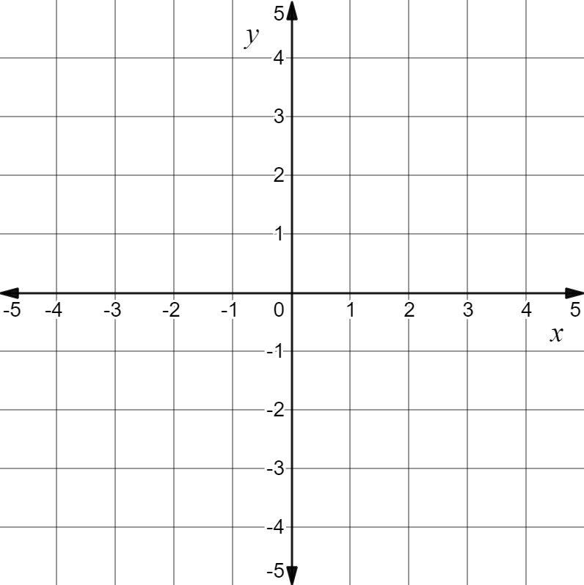

- The function $f\left(x\right)=-{\frac{1}{4}x}^{4}+2x^{3}$ is shown.

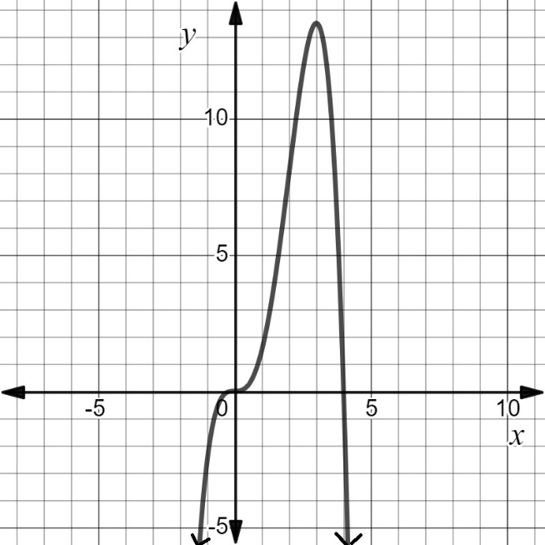
Write the intervals where the graph is:
- only decreasing
- only increasing.
Decreasing Interval | Increasing Interval

- Identify the intervals on which the function $f\left(x\right)=\left(x-1\right)(x+2)^{2}$ appears to be always increasing. Select all correct intervals.
$$4<x<8$$ | $$-2<x<0$$ | $$-∞<x<-2$$ | $$-∞<x<∞$$

SOL AII.7b - Just in Time Quick Check Teacher Notes
Common Errors/Misconceptions and their Possible Indications

- Sketch the graph of a function $g\left(x\right)$ that is:
- decreasing throughout the interval $(-∞,2)$
- increasing throughout the interval $(2,3)$
- decreasing throughout the interval $(3,∞)$.

A common error some students may make is to have the graph turning at points (x, 2) and (x, 3). This may indicate a misunderstanding in using the y-values to name intervals when describing whether a function is increasing or decreasing. A strategy that may benefit some students is to draw vertical lines through the turning points intersecting the x-axis to indicate parts of the domain that are used in naming the intervals in which the graph is increasing/decreasing. Desmos would be beneficial to use for illustrating the given function and drawing vertical lines at turning point locations to emphasize that the domain values are associated with increasing/decreasing intervals.

- The function $f\left(x\right)=-{\frac{1}{4}x}^{4}+2x^{3}$ is shown.
Write the intervals where the graph is:
- only decreasing
- only increasing.
Decreasing Interval | Increasing Interval

A common error some students might make is to state an increasing interval of $-∞<x<3$. This may indicate a misunderstanding that (0, 0) is included in the interval however, f(x) is not consistently increasing over the entire interval from $-∞<x<3$ . A possible teaching strategy would be to remind students to read graphs from left to right when describing increasing/decreasing intervals. Using a highlighter to indicate where the graph is rising (consistently increasing) may help some students. In addition, the students could examine what is happening to the y-values as the x values are increasing. Use the Desmos slider feature to visually show students the results as the x-values increase, what is happening to the corresponding y-values. Ask students questions like - At what value does the function begin to decrease? At what value(s) does the function not consistently increase or consistently decrease?

- The function$f\left(x\right)=\left(x-1\right)(x+2)^{2}$ is increasing throughout which intervals, select all that apply -
$$4<x<8$$ | $$-2<x<0$$ | $$-∞<x<-2$$ | $$-∞<x<∞$$

A common error some students might make is not selecting $4<x<8$ as an increasing interval. This misconception may happen because some students only recognize intervals that connect turning points. A possible teaching strategy is to show students that the y-value is increasing at each x-value from 4 to 8 by using an input/output table.

