Just In Time Quick Check
Standard of Learning (SOL) AII.6b

Strand: Functions

Standard of Learning (SOL) AII.6b
For absolute value, square root, cube root, rational, polynomial, exponential, and logarithmic functions, the student will use knowledge of transformations to convert between equations and the corresponding graphs of functions.

Grade Level Skills:
- Identify the graph of a function from the equation.
- Write the equation of a function given the graph.
- Graph a transformation of a parent function, given the equation.
- Identify the transformation(s) of a function. Transformations of exponential and logarithmic functions, given a graph, should be limited to a single transformation.
- Investigate and verify transformations of functions using a graphing utility.

Just in Time Quick Check

Just in Time Quick Check Teacher Notes

Supporting Resources:
- VDOE Mathematics Instructional Plans (MIPS)
  - AII.6 Transformational Graphing (Word) / PDF Version
- VDOE Word Wall Cards: Algebra II (Word) | (PDF)
  - Parent functions
    - Linear, Quadratic
    - Absolute Value, Square Root
    - Cubic, Cube Root
    - Rational
    - Exponential, Logarithmic
  - Transformations of Parent Functions
    - Translation
    - Reflection
    - Dilation
  - Multiple Representations of Functions
- VDOE Rich Mathematical Tasks: Function of a Ride Task
  - Function of a Ride Task Template (Word) / (PDf)
- Desmos Activity
  - Marbleslides: Exponentials
  - Card Sort: Transformations
  - Exploring Quadratic Functions
  - Marbleslides: Rationals
  - Match My Function
  - Match My Parabola
  - Parabola Equation Writing
  - Transformations Practice
  - Function Transformations: Practice with Symbols
Supporting and Prerequisite SOL: A.6a, A.6c, A.7f, 8.7a, 8.16d, 8.16e

SOL AII.6b - Just in Time Quick Check
- A graph of the function $f\left(x\right)= x^{3}$, and the function after being transformed $g(x)$, are shown.
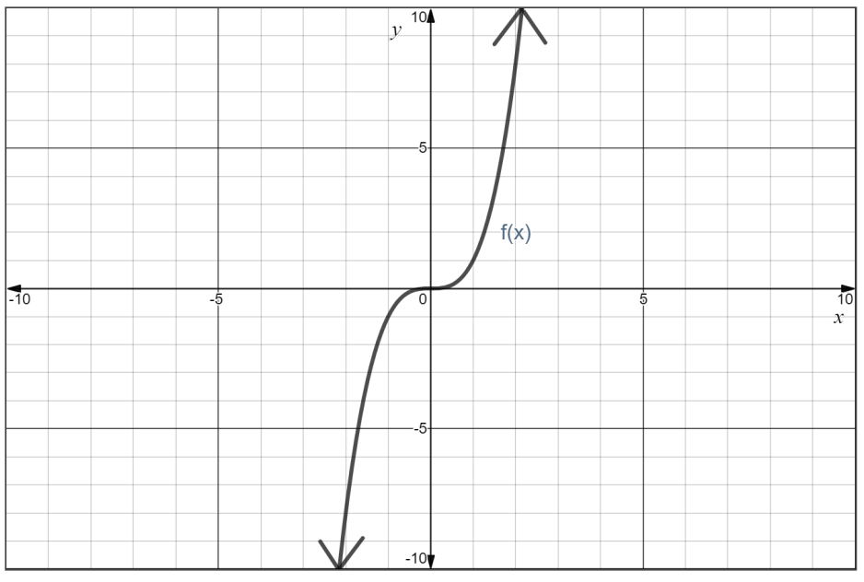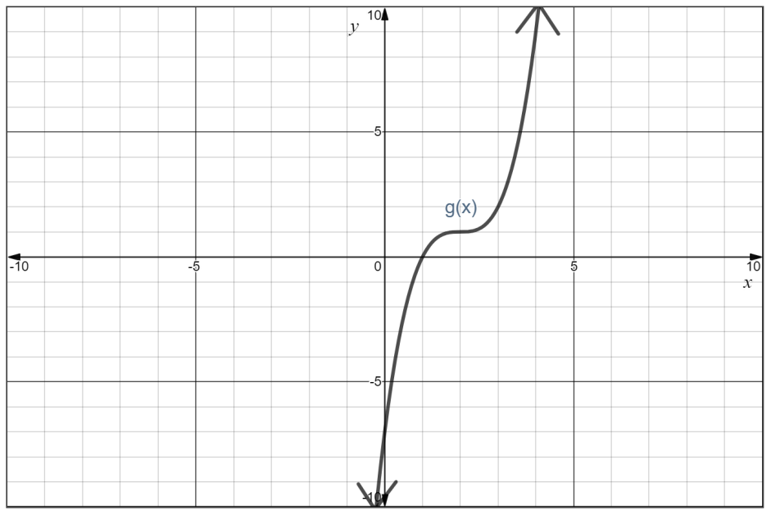
  - In your own words, describe the transformation of $f\left(x\right)$ to produce $g\left(x\right)$.

  - Write the equation to represent the graph of $g\left(x\right)$.

- Graph the equation $g\left(x\right)= \sqrt{4-x}$ .
  - Label at least three points with integral coordinates.
  - Explain how the graph of function $g\left(x\right)= \sqrt{4-x}$ differs from the parent function $f\left(x\right)= \sqrt{x}$.
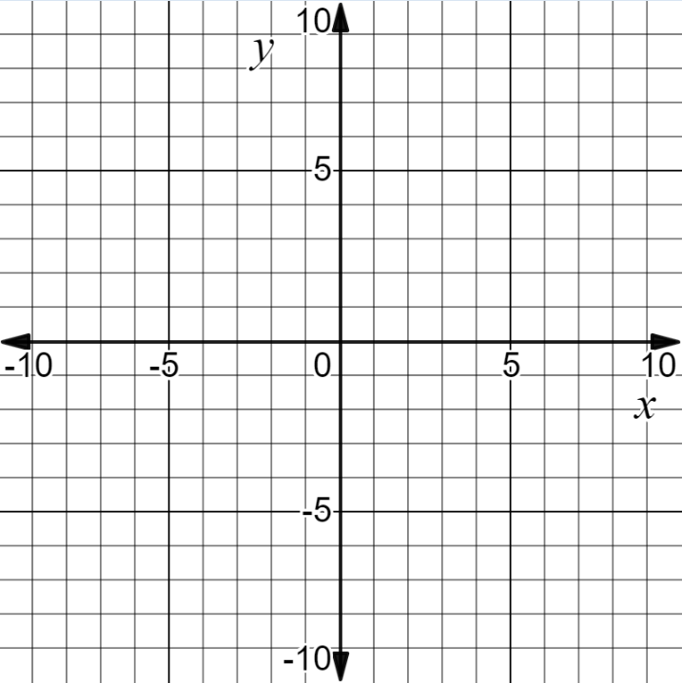

- The graph of $f(x)$ is shown.
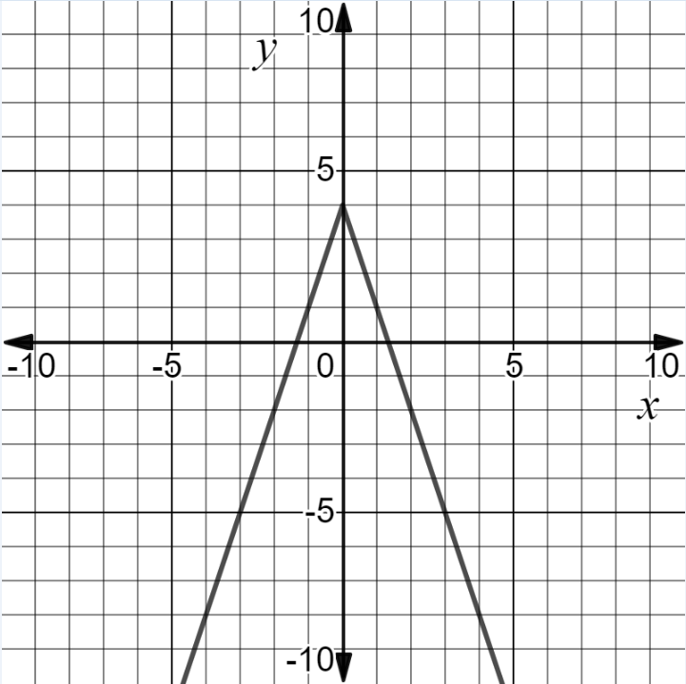
f(x)
  - Identify the parent function.

  - Sketch the graph of the parent function on the grid provided.

  - Write the equation of $f(x)$. Justify your thinking.

- The graph of the logarithmic function $f\left(x\right)=\log{x }$is shown.
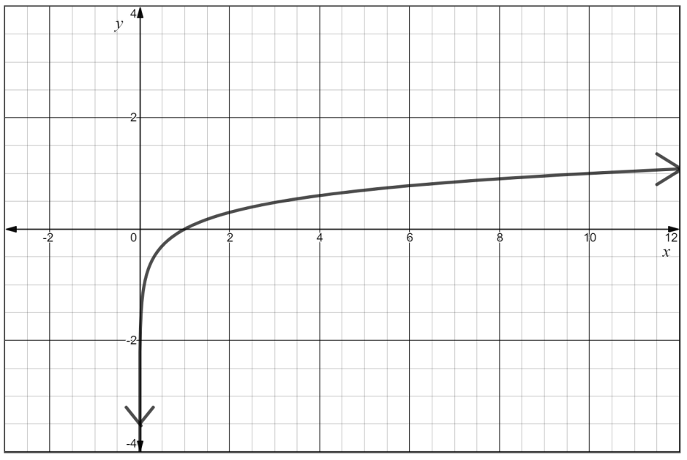

  - Use the grid below to graph the function $g\left(x\right)=log⁡(x-2)$.

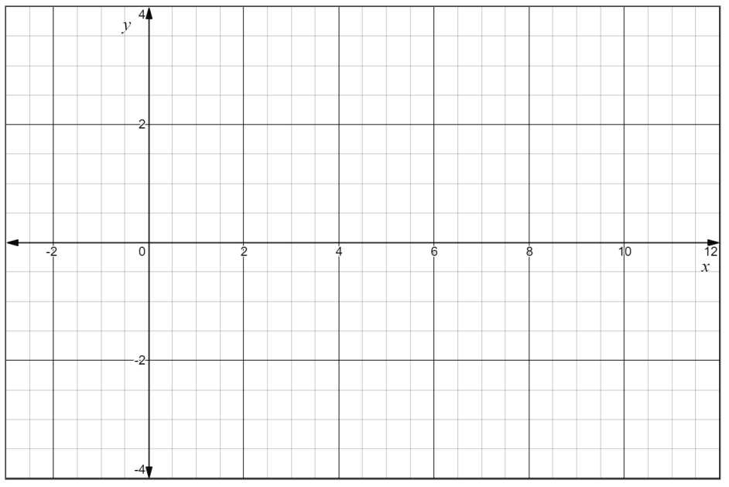

SOL AII.6b - Just in Time Quick Check Teacher Notes
Common Errors/Misconceptions and their Possible Indications

- A graph of the function $f\left(x\right)= x^{3}$, and the function after being transformed $g(x)$, are shown.
  - In your own words, describe the transformation of $f\left(x\right)$ to produce $g\left(x\right)$.

  - Write the equation to represent the graph of $g\left(x\right)$.

A common misconception that some students may have is to misinterpret how the parameters of the equation of a transformed function are affected by a horizontal translation. This may indicate that students do not understand the relationship between the graphical and symbolic representations of functions. For example, a student who creates a new function $g\left(x\right)={(x+2)}^{3}+1$ has mistaken a horizontal translation right with a positive addend for x. One potential teaching strategy would be using Desmos to graph a function $f\left(x\right)= {(x+a)}^{3}+b$, creating a and b as sliders, and then allowing students to explore the translation results as the value of the slider changes. Students could use Desmos to explore the relationship of x and y using a table. They could also be encouraged to examine the roles of a and b separately to see which is related to each type of translation (horizontal versus vertical).

- Graph the equation $g\left(x\right)= \sqrt{4-x}$ .
  - Label at least three points with integral coordinates.
  - Explain how the graph of function $g\left(x\right)= \sqrt{4-x}$ differs from the parent function $f\left(x\right)= \sqrt{x}$.
A common misconception that some students may have is to misinterpret how the parameters of the equation of a transformed function are related to a reflection across the y-axis. This may indicate that students do not recognize how applying a negative coefficient to the x-value in a square root function results in a reflection over the y-axis versus a reflection over the x-axis. There may also be difficulty in performing the correct horizontal translation. Some students may do the reflection and translation in the wrong order. A potential teaching strategy would be for students to explore graphs of the equations $y= \sqrt{- x}$ and $y= - \sqrt{x}$ using Desmos. A discussion of the domain for each of these functions and creating a table of values might help students recognize/distinguish between the graphs/equations and the transformation that is occurring. Students may also benefit from using the VDOE Word Wall cards to make connections.

- The graph of $f(x)$ is shown.
f(x)

- Identify the parent function.

- Sketch the graph of the parent function on the grid provided.
- Write the equation of $f(x)$. Justify your thinking.

A common misconception that some students may have is to misinterpret how the reflection of a function over the x-axis and/or a dilation affects the equation of that function. Students may recognize that this is a function from the absolute value family but mistakenly believe the dilation results in a coefficient between 0 and – 1 when the function is reflected over the x-axis. Students may benefit from verbally describing the transformations that are evident in the graph. Once they are able to describe the transformation, then transition to writing the equation of the graph.

- The graph of the logarithmic function $f\left(x\right)=\log{x }$is shown.
  - Use the grid below to graph the function $g\left(x\right)=log⁡(x-2)$.
A common misconception for some students is to misunderstand the direction of translations. Students who sketch g(x) with a left translation or a downward translation do not understand the role of the constant grouped with x. Students may benefit from using Desmos to explore translations of the function y = log (x – a) with a slider a.

