Just In Time Quick Check
Standard of Learning (SOL) AII.6a
Strand: Functions

Standard of Learning (SOL) AII.6a
For absolute value, square root, cube root, rational, polynomial, exponential, and logarithmic functions, the student will recognize the general shape of function families.

Grade Level Skills:
- Recognize the general shape of function families.
- Recognize graphs of parent functions.
- Investigate and verify transformations of functions using a graphing utility.

Just in Time Quick Check

Just in Time Quick Check Teacher Notes

Supporting Resources:
- VDOE Mathematics Instructional Plans (MIPS)
  - Transformational Graphing (Word)/ PDF Version
- VDOE Word Wall Cards: Algebra II (Word) | (PDF)
  - Parent Functions (Rational)
  - Parent Functions (Exponential, Logarithmic)
  - Transformations of Parent Functions (Translation)
  - Transformations of Parent Functions (Reflection)
  - Multiple Representations of Functions
- Desmos Activity
  - Polygraph: Twelve Functions
  - Marbleslides: Exponentials
  - Card Sort: Transformations
  - Avi and Benita's Repair Shop
  - What Comes Next?
Supporting and Prerequisite SOL: A.7f, 8.16e

SOL AII.6a - Just in Time Quick Check

- The graph of f(x) is shown. Determine whether f(x) appears to be a square root function or a logarithmic function. Explain your thinking.

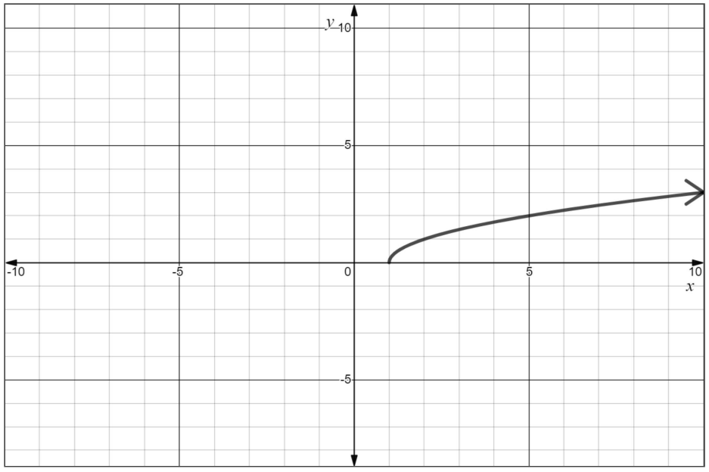

- Identify the function family to which each graph appears to belong. Justify your answers.

  - b)
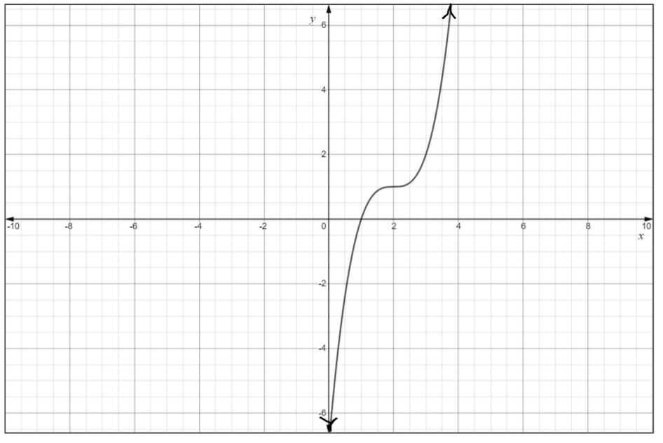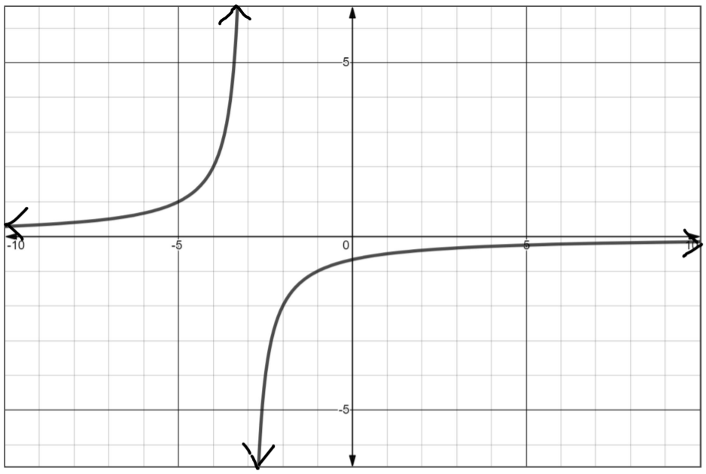

- Create the graph of an exponential function g(x) that is transformed from the parent function. Label at least three points on the graph. Write the equation of g(x).

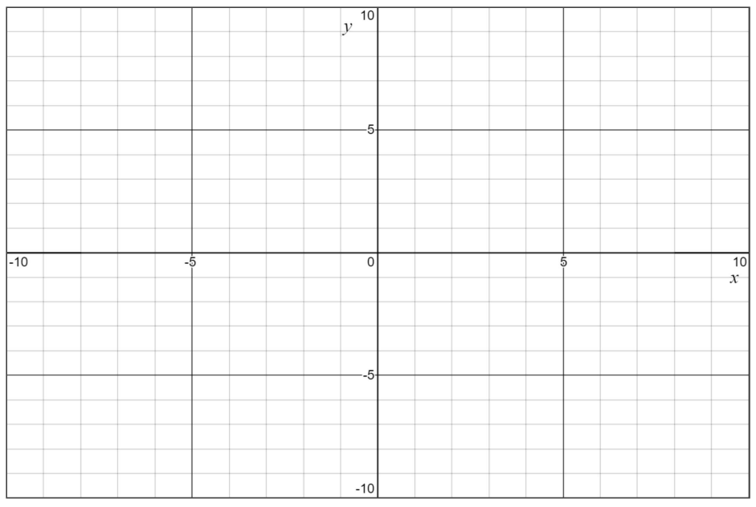

4. The graph of f(x) is shown. Select each function that belongs to this same family.
$$g\left(x\right)=2x^{3}+5$$
$$h\left(x\right)=x^{1/3}-4$$
$$k\left(x\right)=x^{3}+x^{2}-x+3$$
$$m\left(x\right)=\sqrt[3]{x+7}$$
$$p\left(x\right)=\sqrt{x-2}$$
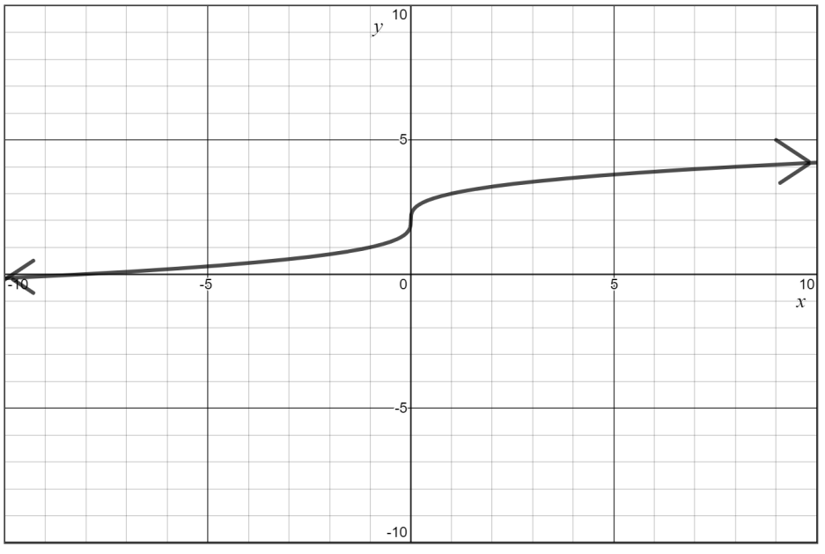

SOL AII.6a - Just in Time Quick Check Teacher Notes
Common Errors/Misconceptions and their Possible Indications

1. The graph of f(x) is shown. Determine whether f(x) appears to be a square root function or a logarithmic function.
Explain your thinking.

A common misconception is that some students may believe that logarithmic functions have a restricted range. This could indicate that students don’t really understand the definition of a logarithm and its inverse relationship with exponential functions. A potential strategy is to ask students to make a table of values for the graph and see which function family will best fit the values – square root or logarithmic.

- Identify the function family to which each graph appears to belong. Justify your answers.

  - b)

A common misconception is that some students have difficulty recognizing the similarities and differences among function families. Although students may have an idea of potential equations for graphs, they are much less likely to see the polynomial and rational functions as separate families. Some students may benefit from the use of the Vocabulary Word Wall cards as an anchor chart and find the visual representation of each function family helpful. Also, an increased emphasis on regular use of the approppriate vocabulary may benefit students in this type of recognition.
- Create the graph of an exponential function g(x) that is transformed from the parent function. Label at least three
points on the graph. Write the equation of g(x).

A common misconception is for students to confuse polynomial functions with exponential functions. A student may graph a quadratic function because they confuse the role of the variable exponent in an exponential function. It may be helpful to use the Algebra II Vocabulary Word Wall cards to reinforce the general shape and important features of exponential functions in a visual representation. It may also be helpful to give students practice analyzing various exponential functions and comparing their common features (domain, range, intercept, asymptote, and end behaviors).

4. The graph of f(x) is shown. Select each function that belongs to this same family.

$$g\left(x\right)=2x^{3}+5$$
$$h\left(x\right)=x^{1/3}-4$$
$$k\left(x\right)=x^{3}+x^{2}-x+3$$
$$m\left(x\right)=\sqrt[3]{x+7}$$
$$p\left(x\right)=\sqrt{x-2}$$
A common misconception is for students to confuse cubic and cube root functions. A student may select functions g(x) and k(x). This could indicate the student didn’t consider the differing rates at which these functions increase. A potential strategy would be for students to identify points on the graph and then make a table of values for several of these functions.

